**THE THERMAL BEHAVIOR OF MATTER**

**Exercises**

**Section 17.1 Gases**

**17.** **Interpret** This problem involves the ideal-gas law, which we can use to find the volume of 1 mol of Martian atmosphere given its temperature and pressure.

**Develop** Apply Equation 17.2 *PV* = *nRT* with *P* = 0.01*P*E, *T* = 215 K, *n* = 1.0 mol, and *R* = 8.314 J/K.

**Evaluate** Solving the ideal-gas law for the volume and inserting the given quantities gives

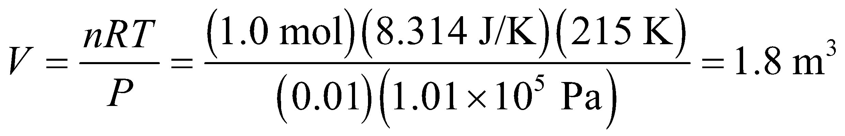

**Assess** The dimensions of this expression are

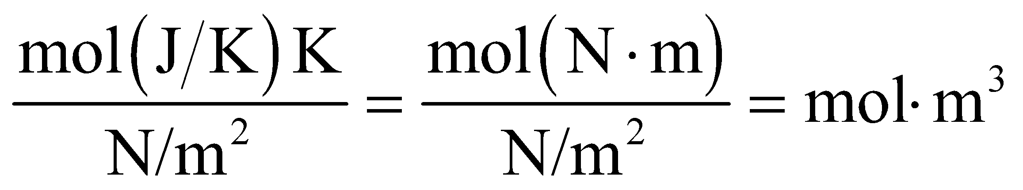

but a mole is a dimensionless number, so the final dimensions are m3, as expected for a volume.

**18. Interpret** We are dealing with an ideal gas. Given the pressure, temperature, and volume we are to find the number of gas molecules.

**Develop** We shall use the ideal-gas law, *pV* = *NkT* (Equation 17.1), to find the number of molecules *N*.

**Evaluate** Inserting the given quantities gives

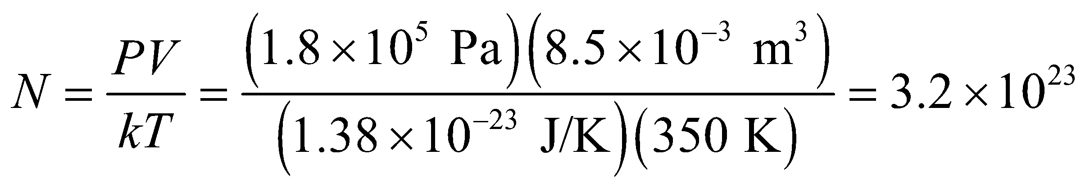

**Assess** One mole has 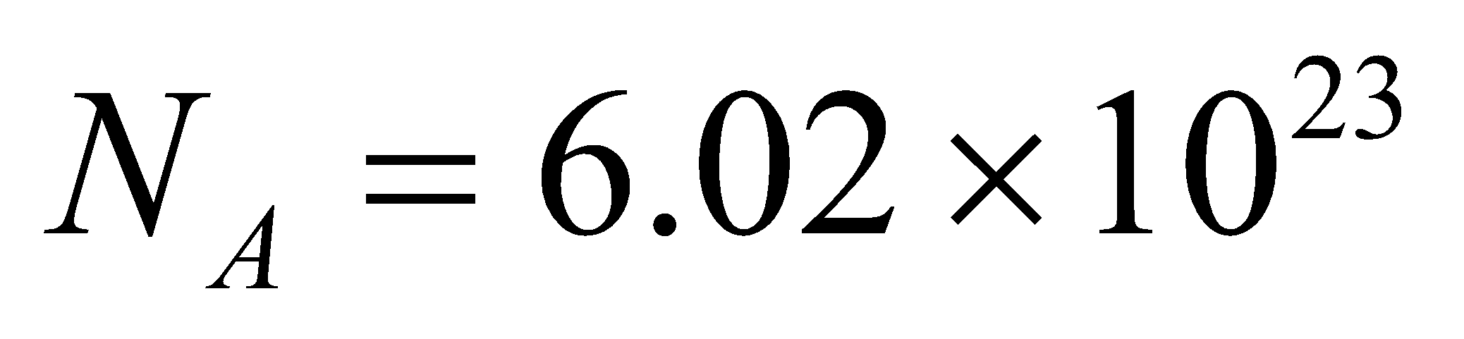 molecules. Thus, we have about 0.5 mole of molecules in the system.

**19.** **Interpret** This problem involves an ideal gas, so we can apply the ideal-gas law to find the pressure of the gas at the given temperature and volume.

**Develop** In terms of moles, the ideal-gas law is given by Equation 17.2, *PV* = *nRT*. The volume is *V* = 2.0 L = 2.0 × 10−3 m3, and *T* = −150°C = 123 K.

**Evaluate** Solving for the pressure and inserting the given quantities gives

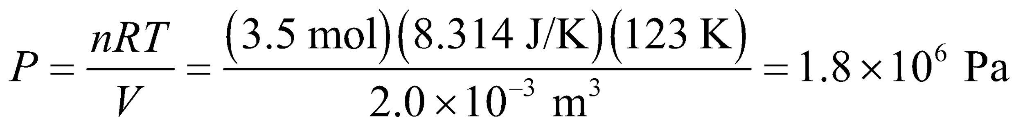

**Assess** This is about 20 times standard atmospheric pressure.

**20. Interpret** You want to verify that the tank you purchased contains the amount of argon that it is supposed to. You can treat it as an ideal gas.

**Develop** You know the volume, the temperature and the pressure of the gas. Using the ideal-gas law (Equation 17.2), you can find the number of moles in the tank: 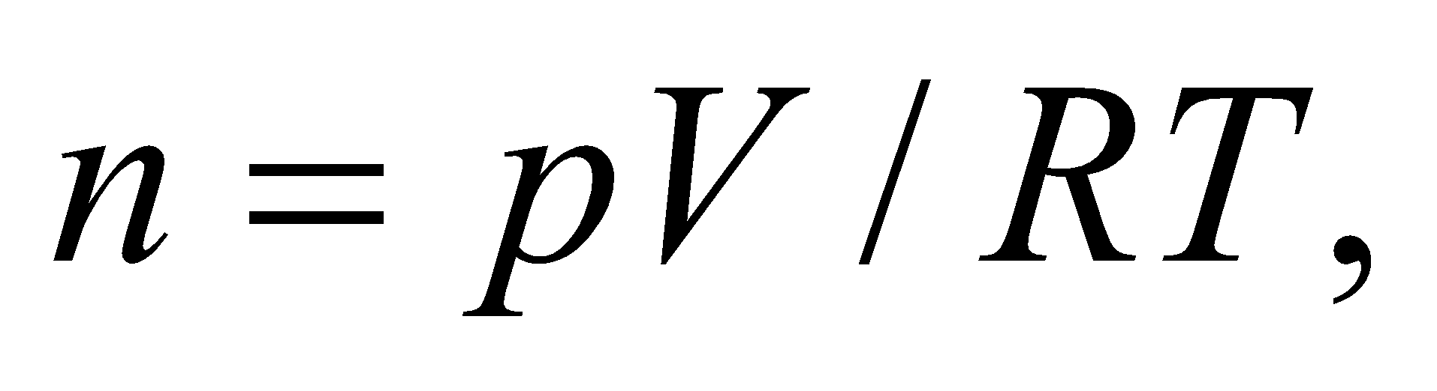where 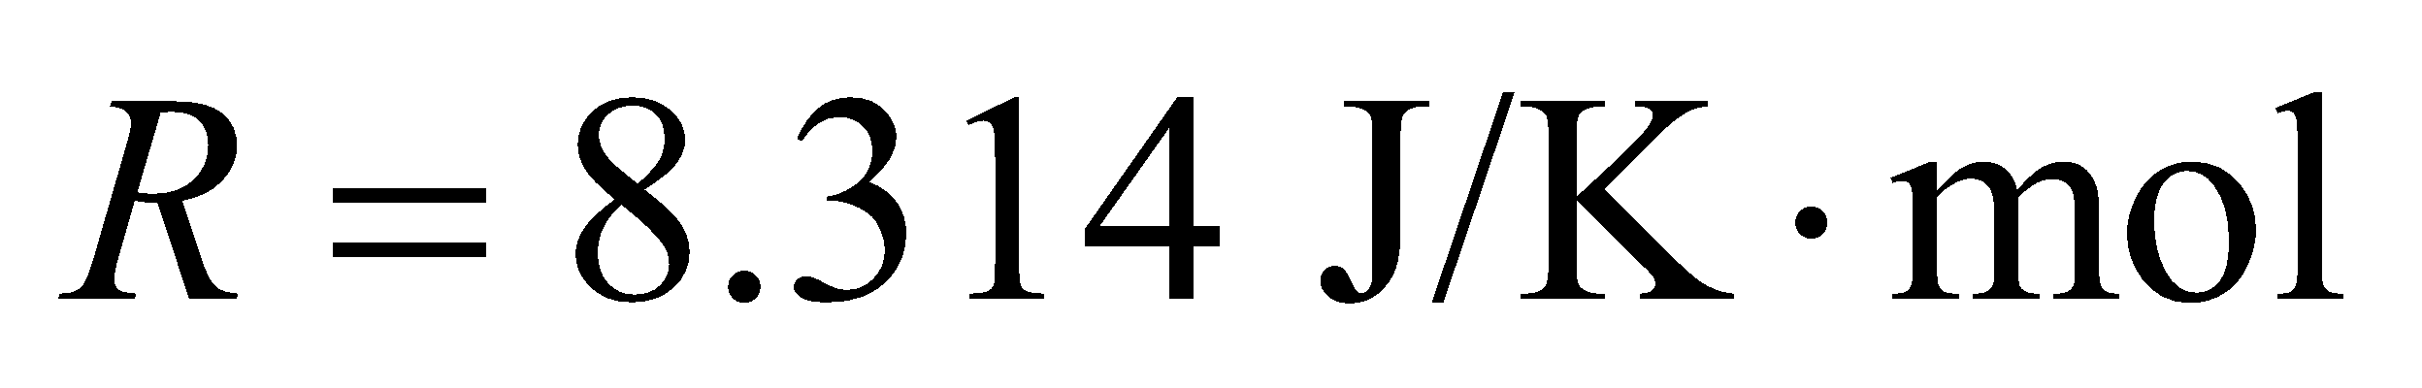is the universal gas constant.

**Evaluate** Remembering that the temperature needs to be in Kelvin and the volume needs to be in 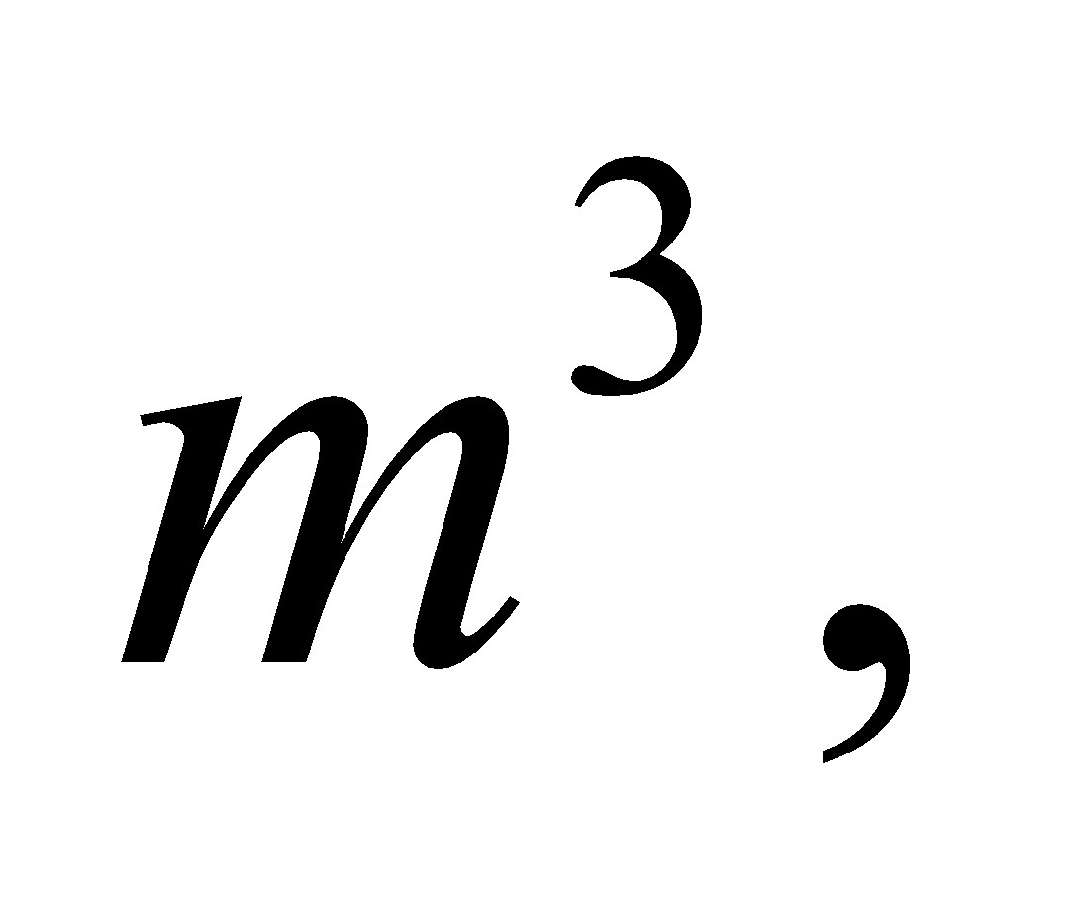the number of moles is:

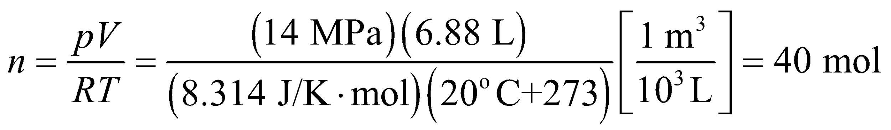

This is 5 mol less than the vendor claimed, so you did not get your money's worth.

**Assess** If the right amount of gas were in the tank, then you would have measured a pressure of nearly 16 MPa. Notice that at no point did we have to consider the specific properties of argon. The ideal-gas law applies to any gas. The units work out since 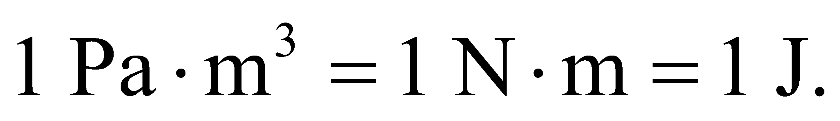

**21.** **Interpret** This problem involves an ideal gas, so we can apply the ideal-gas law. We are to find the volume of an ideal gas given its temperature and pressure, then find its new temperature if the pressure is increased and the volume is cut in half.

**Develop** In terms of moles, the ideal-gas law takes the form of Equation 17.2, *pV* = *nRT*. For part (a), *p* = 1.5 atm = 1.5 × 1.01 × 105 Pa = 1.515 ×105 Pa, *T* = 250 K, and *n* = 2.0. For part (b), we can take the ratio of the ideal-gas law applied to part (a) an that applied to part (b) to get

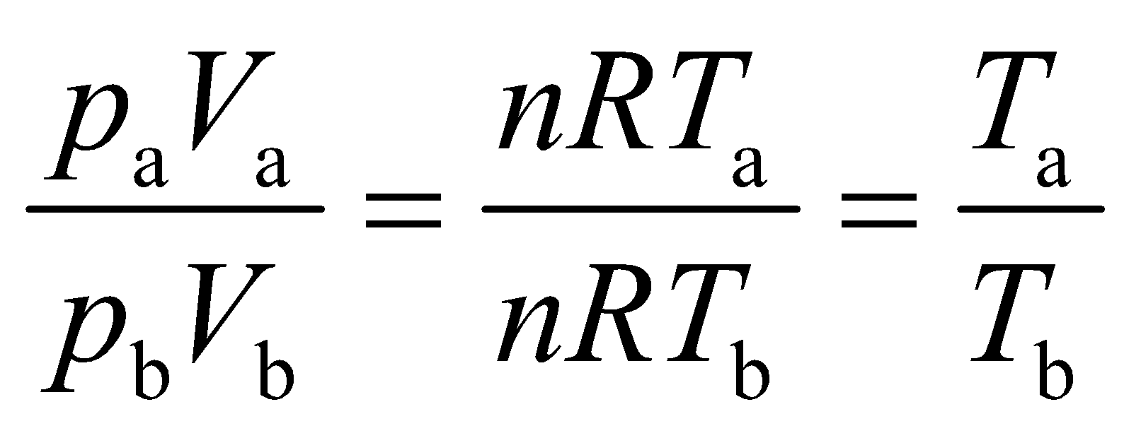

which we can solve for *T*b given that *V*b = *V*a/2 and *P*b = 4.0 atm. Note that we have used the fact that the number of moles does not change.

**Evaluate** (a) The volume *V*a of the gas is

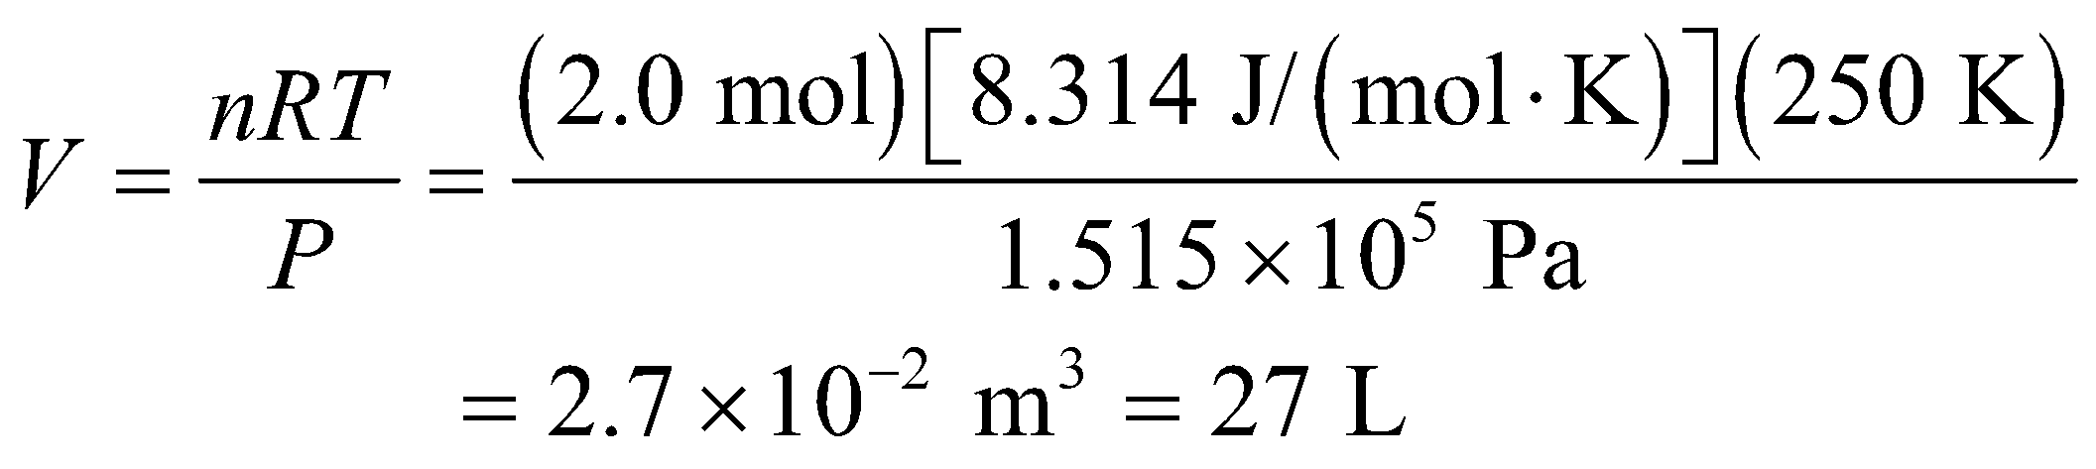

(b) Upon compressing the gas and increasing its pressure, the new temperature is

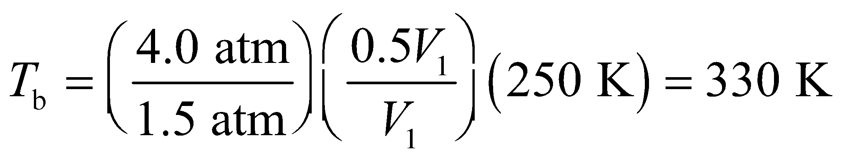

to two significant figures.

**Assess** As expected, the temperature increases if we compress the gas.

**22. Interpret** We treat air molecules as ideal gas. Given the pressure, temperature, and volume, we want to find the number of air molecules.

**Develop** We shall use the ideal-gas law,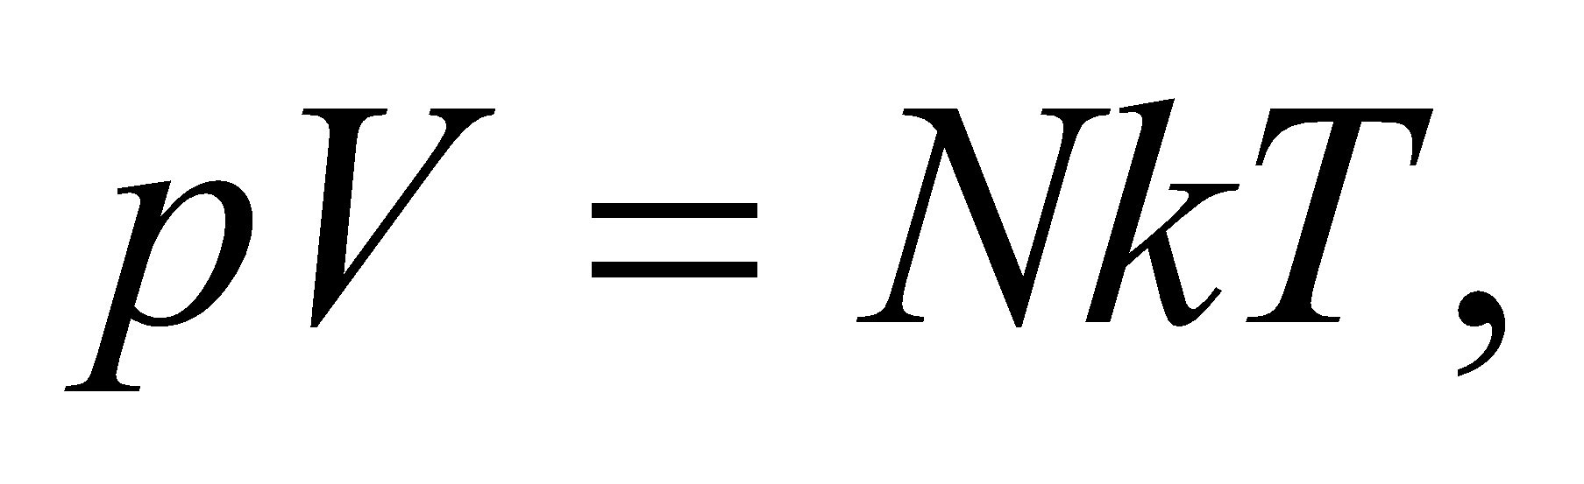given in Equation 17.1, to find the number of molecules.

**Evaluate**The number of air molecules is

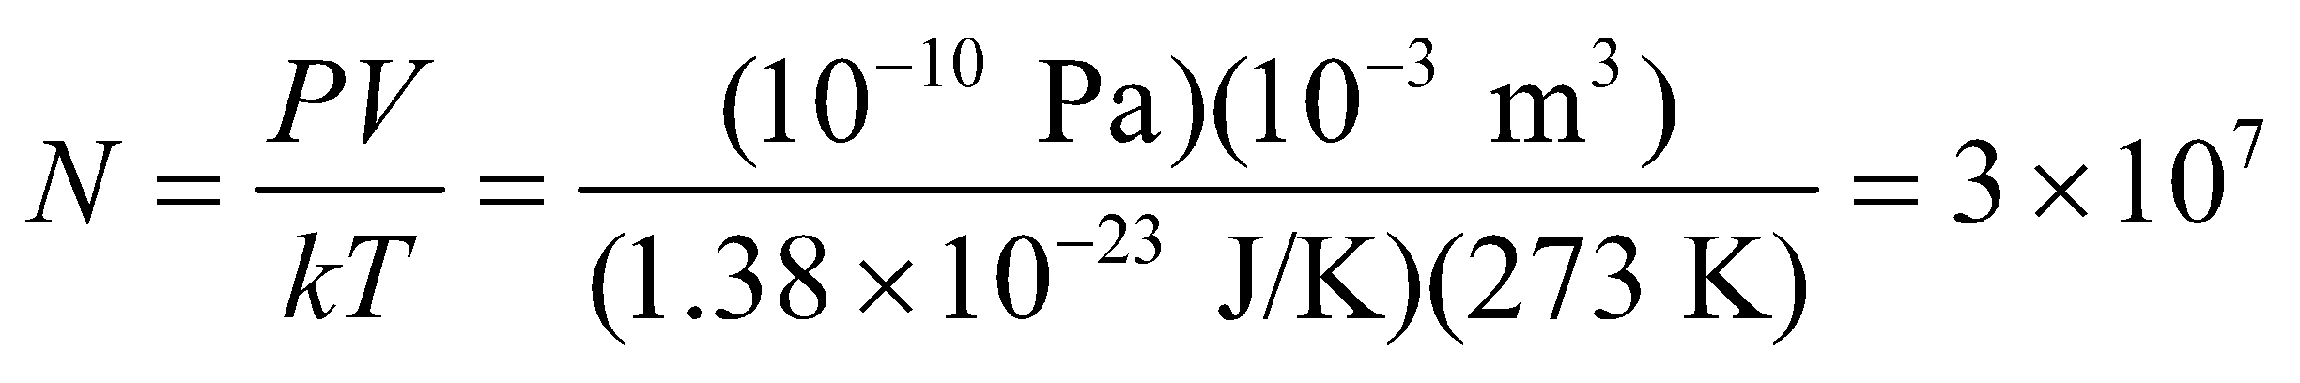

**Assess** One mole hasmolecules. Thus, we have about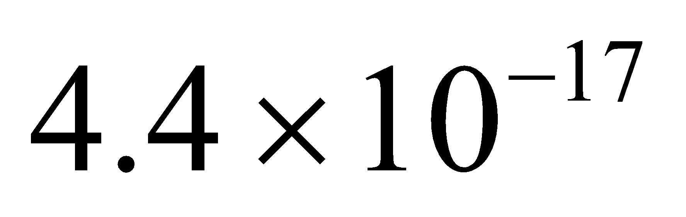mole of molecules in the system.

**23.** **Interpret** This problem in an exercise in calculating the thermal speed of ideal-gas molecules at a given temperature.

**Develop** The thermal speed (also called the rms, or root-mean-square speed) is, from Equation 17.4, 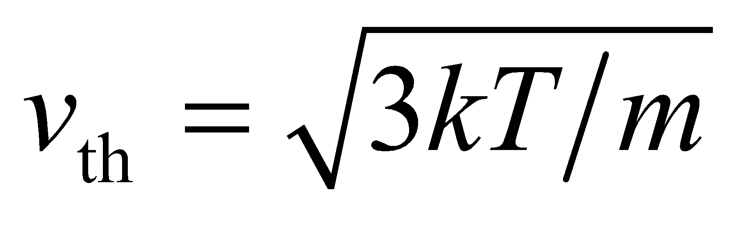, where *m* is the mass of a molecule. From Appendix C we estimate the mass of a H2 molecule to be 2 × 1.66 × 10−27 kg.

**Evaluate** Inserting the given quantities into Equation 17.4 gives

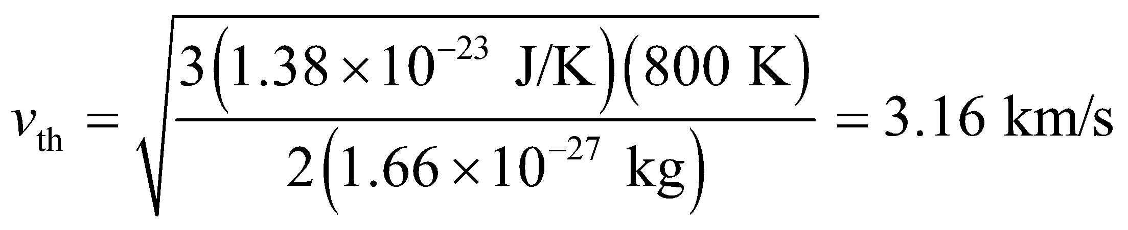

**Assess** This is about 100 times faster than the standard speed of sound (343 m/s).

**24. Interpret** In this problem we want to compare the thermal speeds of two different molecules that are at different temperatures.

**Develop** The thermal speed of a molecule is given by Equation 17.4:

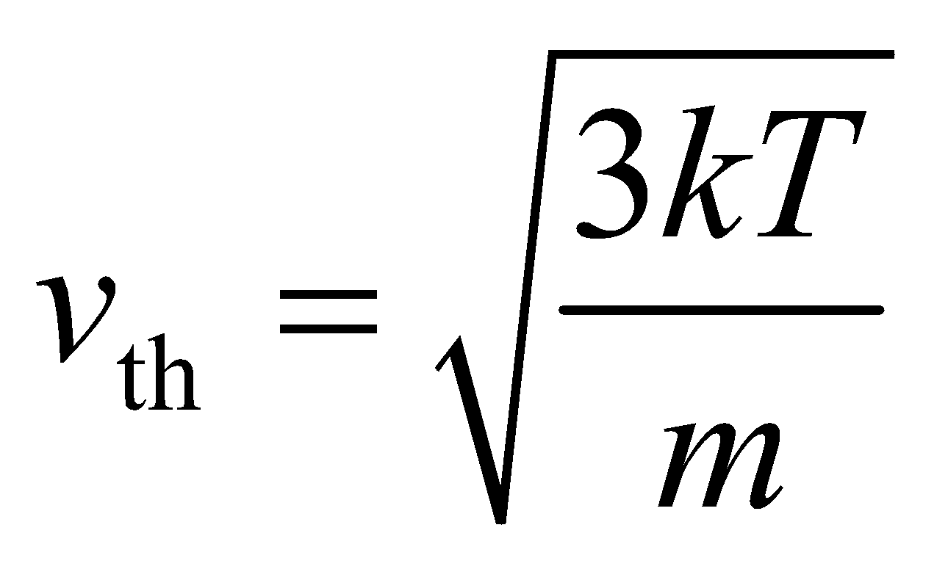

where *T* is the temperature and *m* is the mass of the gas molecule. We can use this to compare the thermal speeds of the two molecules in question.

**Evaluate** Comparing the thermal speeds for H2 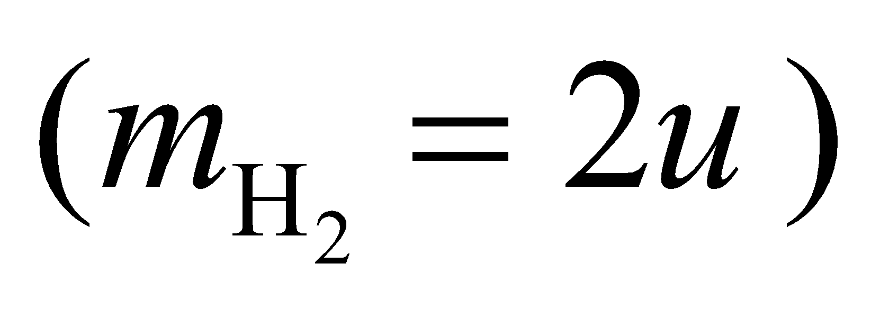 and SO2 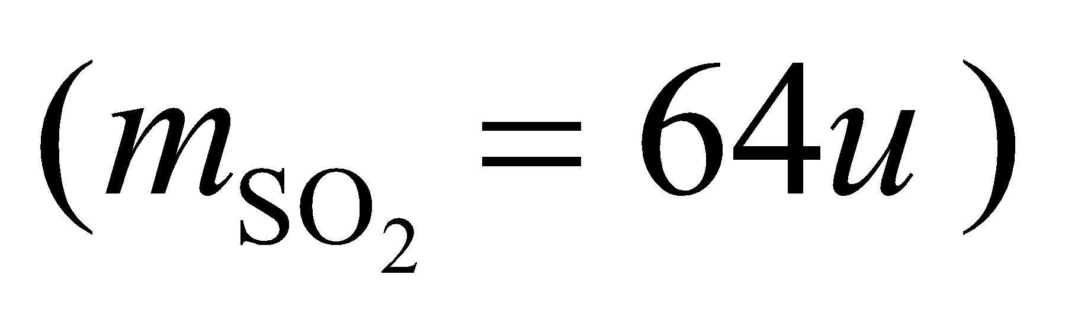 at the given temperatures, we find

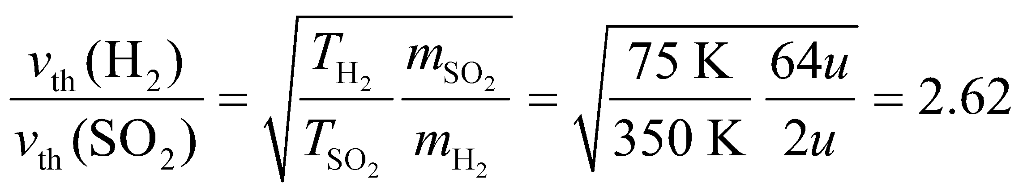

So hydrogen is faster.

**Assess** The thermal speed of a gas molecule is proportional to 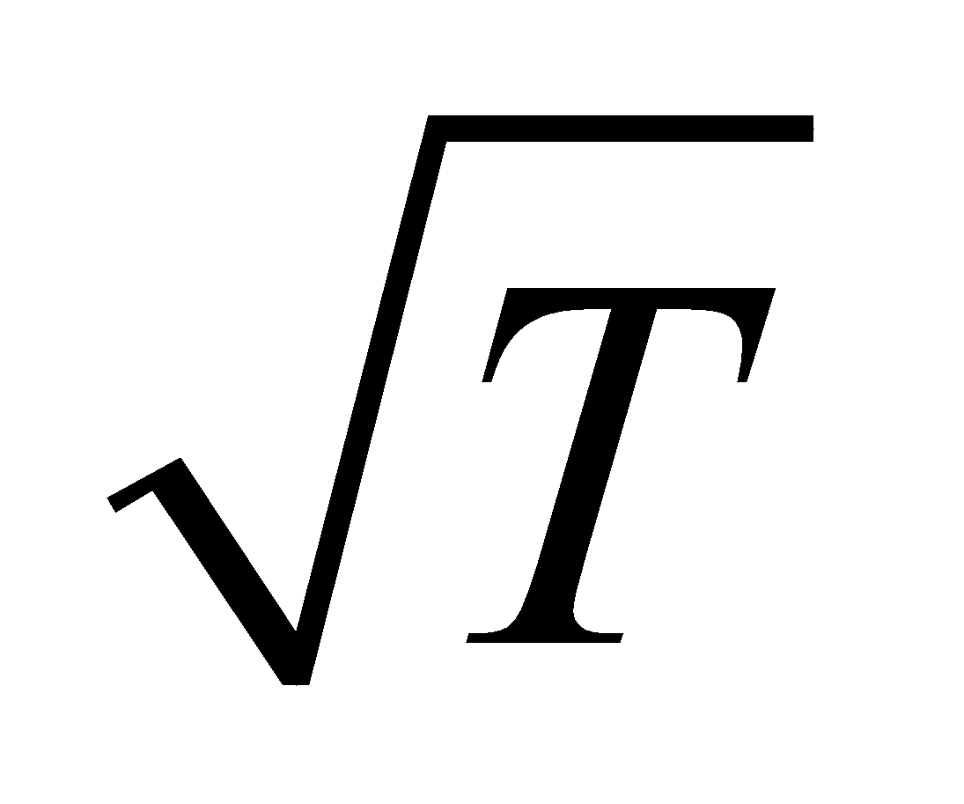 and inversely proportional to 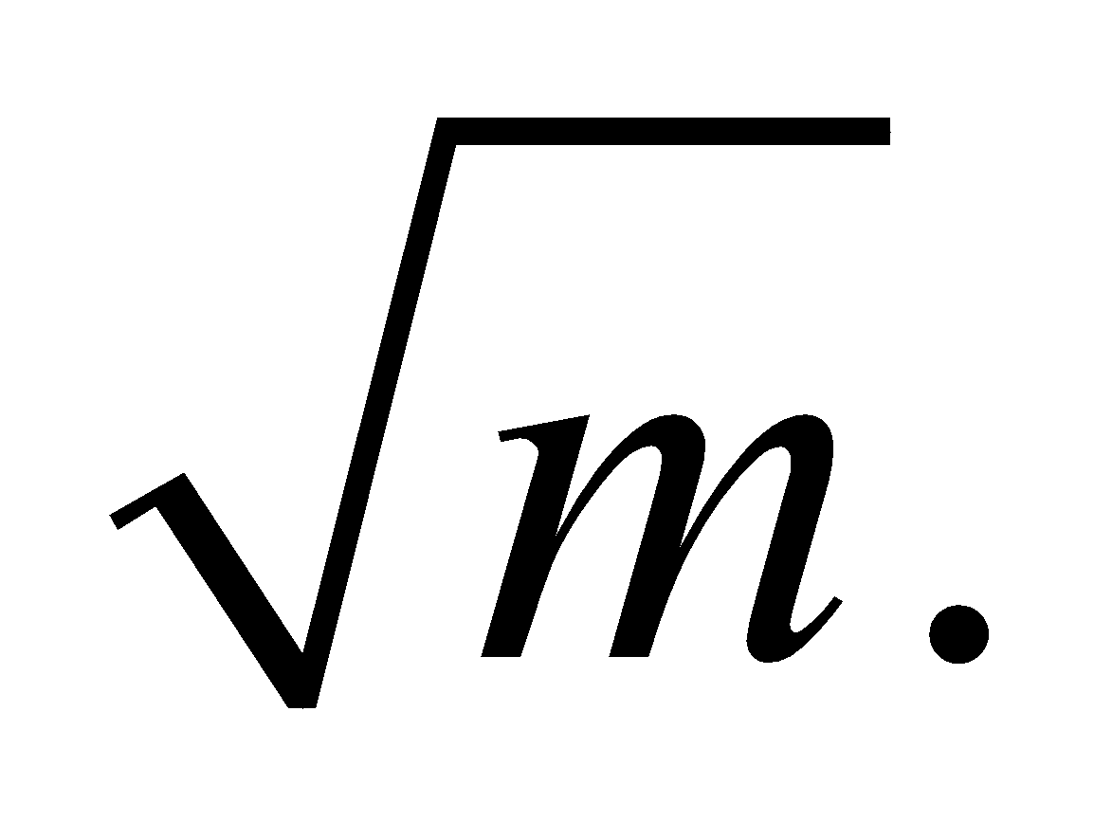

**Section 17.2 Phase Changes**

**25.** **Interpret** This problem involves the latent heat of fusion, which is the energy it takes to liberate the molecules that compose the ice to form water. We are asked to find the energy required to melt a 65-g ice cube.

**Develop** The energy required for a solid-liquid phase transition at the normal melting point of water (0°C) is (Equation 17.5) *Q* = *mL*f, where m = 0.065 kg and *L*f = 334 kJ/kg (from Table 17.1).

**Evaluate** The heat required to melt the ice cube is



**Assess** This is equivalent to 5.2 kcal.

(See Table 17.1 for the heats of transformation.)

**26. Interpret** This problem is about melting, and it involves the heat of fusion. We want to identify the substance in question given its mass and the energy required to melt it.

**Develop** Using Equation 17.5, we find the heat of transformation from solid to liquid to be

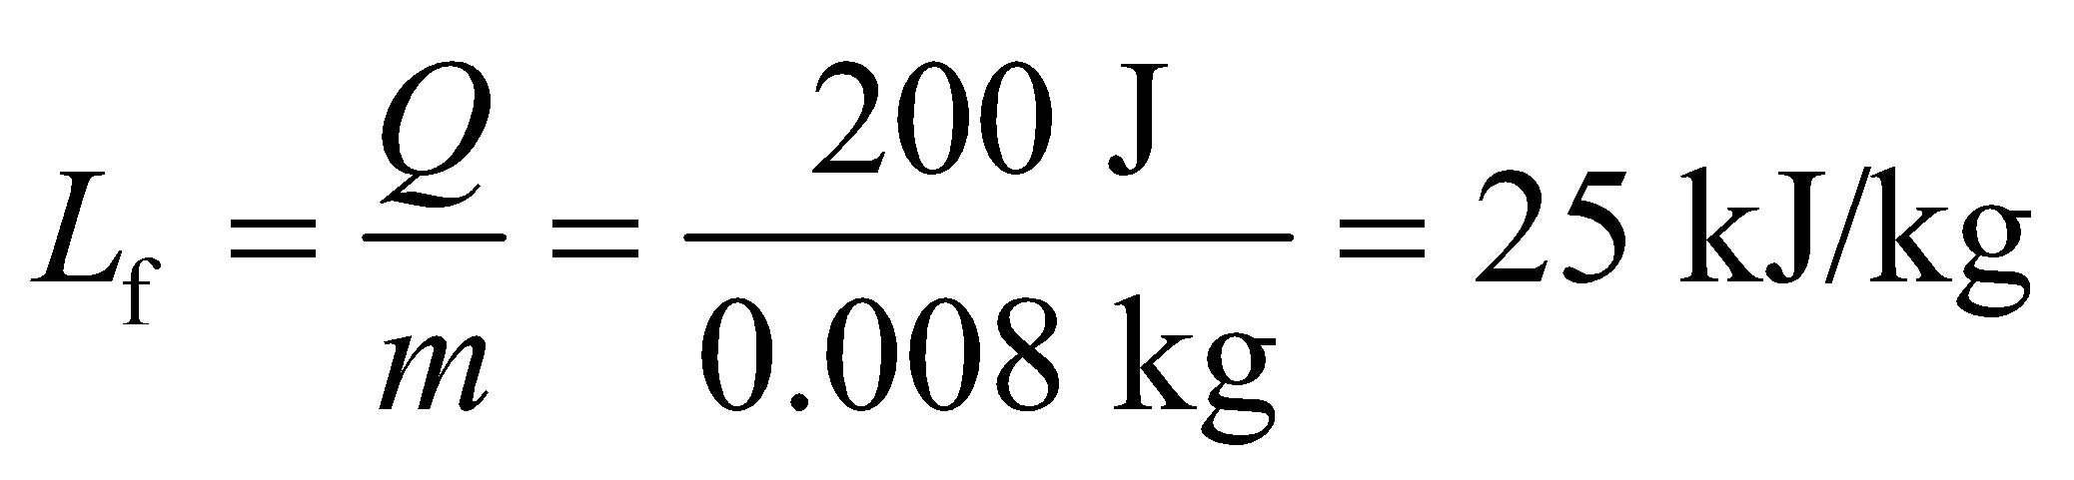

Compare this result with the data given in Table 17.1 to determine the substance.

**Evaluate** The closest figure in Table 17.1 is the heat of fusion for lead *L*f = 25 kJ/kg, so the substance is lead.

**Assess** The heat of fusion *L*f is a chemical property of a material. Thus, knowing *L*f allows us to identify the material.

**27.** **Interpret** This problem involves the latent heat of vaporization, which is the energy required to pass from the liquid to the gas phase. Given the latent heat of vaporization (Table 17.1) and the energy required to vaporize the substance, we are to calculate the mass of the substance.

**Develop** Assuming the vaporization takes place at the normal boiling point for oxygen at atmospheric pressure, we may use Equation 17.5, *Q* = *L*v*m*, where *L*v = 213 kJ/kg (from Table 17.1) and *Q* = 840 kJ.

**Evaluate** The mass of oxygen in the sample is

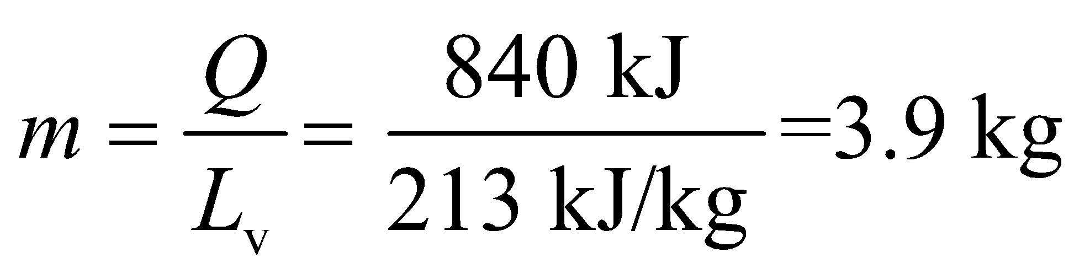

**Assess** Given that O2 is approximatley 32 g/mol, this corresponds (at standard temperature and pressure) to a volume of

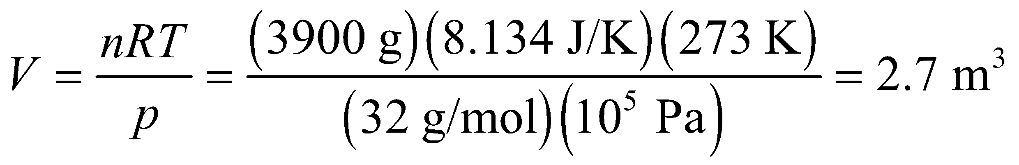

**28. Interpret** This problem is about phase change of CO2 from gas to solid. We are asked to find the heat (i.e., thermal energy) that must be extracted from the given amount of CO2 to solidify it, which is the same as the heat required to sublime it (turn it from solid into gas).

**Develop** The relevant latent heat of transformation in this process is the latent heat of sublimation, which is Ls = 573 kJ/kg. Use this in Equation 17.5 to find the heat needed to solidify CO2.

**Evaluate** Equation 17.5 gives 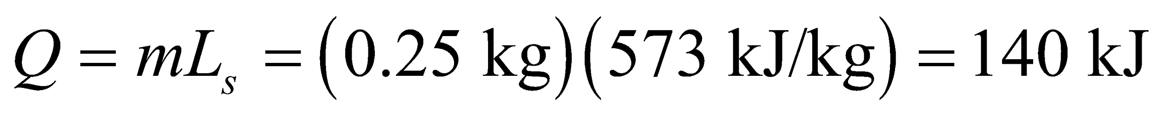 to two significant figures.

**Assess** This is the heat that must be extracted to turn CO2 gas into frozen CO2, or dry ice. To revert back to the gaseous state, the same amount of heat must be absorbed.

**29.** **Interpret** This problems involves the phase transformation of a liquid to a gas, so the latent heat of vaporization comes into play. Because the liquid is at its boiling point, any heat added to the liquid will cause vaporization instead of a temperature rise.

**Develop** From Table 17.1, the latent heat of vaporization for O2 is 213 kJ/kg. Use this in Equation 17.5, *Q* = *L*v*m*, to find the heat needed to vaporize 28 kg of O2.

**Evaluate** Inserting the given quantities into Equation 17.5 gives 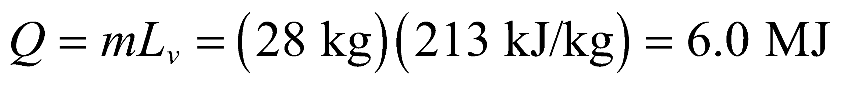 to two significant figures.

**Assess** At standard temperature and pressure (STP, *T* = 273.15 K, *p* = 105 Pa), 28 kg of O2 would occupy a volume of

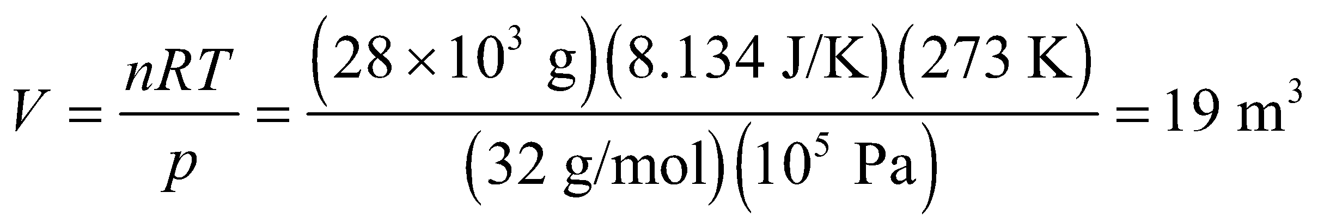

**Section 17.3 Thermal Expansion**

**30. Interpret** This is a thermal expansion problem: we are given the length of a wire and the temperature, and we wish to know the change in length at a higher temperature.

**Develop** Thermal expansion is given by Equation 17.7,

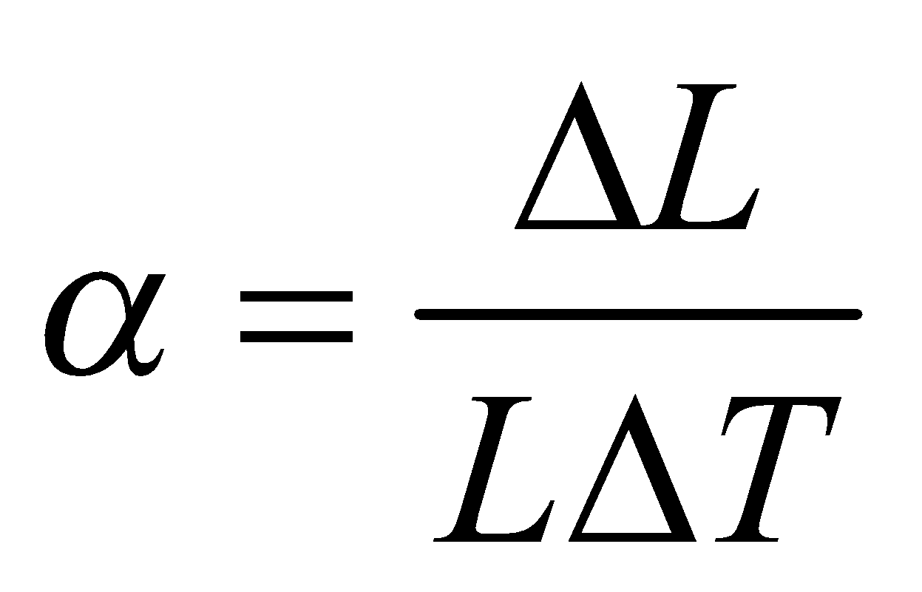

The wire is made of copper, and 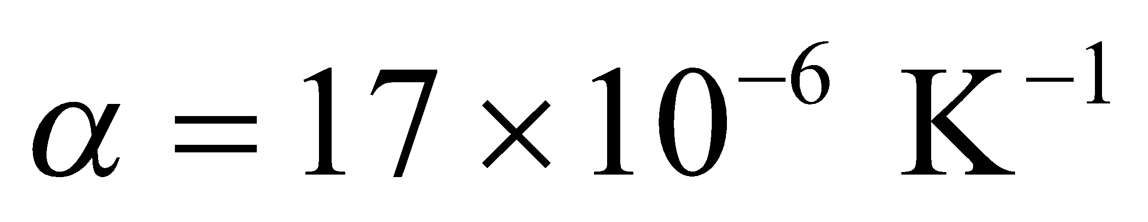 for copper (see Table 17.2). The temperature change is *ΔT* = 38 K and the initial length is L = 20 cm.

**Evaluate** Inserting the given quantities gives



**Assess** A small change, but enough that power and phone lines sag noticeably on hot days.

**31. Interpret**This is a problem in thermal expansion. We know the initial volume, the material, and the change in temperature, and we need to find the new volume.

**Develop**The change in volume is given by Equaiton 17.6,

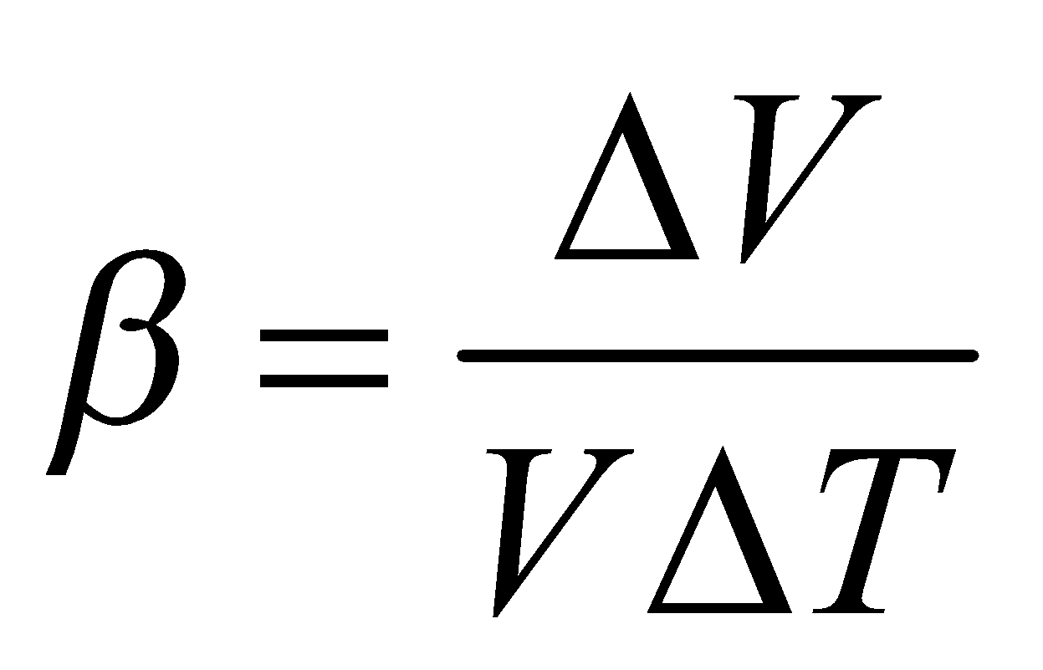

The initial volume is *V* = 1.00 L. The material is ethyl alcohol, which has a volume coefficient of expansion of 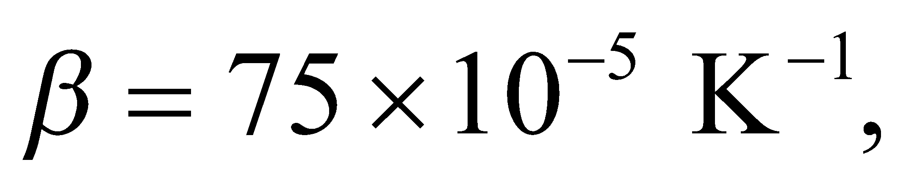 and the change in temperature is *ΔT* = −18 K. The new volume *V*′ of the liquid is

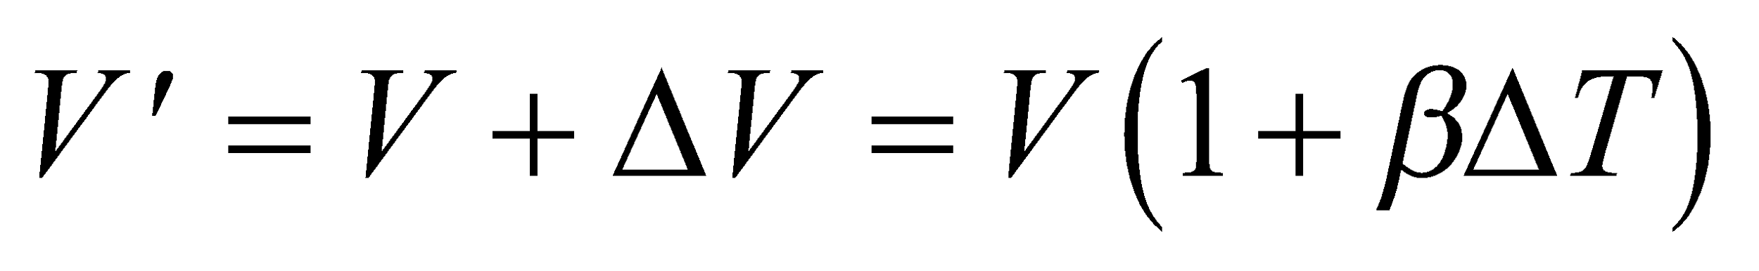

**Evaluate**Inserting the given quantities gives



**Assess**This is enough to observe in your own refrigerator: Seal a volume of liquid at room temperature, put it in the refrigerator, and observe the deformation of the container when it cools.

**32.** **Interpret** This problem involves thermal expansion (volume expansion in this case). We are given the diameter of a Pyrex sphere and are to find its new diameter due to a given temperature change.

**Develop** The volume *V* of the marble is related to its radius *r* by *V* = 4*πr*3/3. The change in volume is given by Equation 17.6,



where *β* = 3.2 × 10−6 K−1 (see Table 17.2) and *ΔT* = 65 C° = 65 K. The new volume is



so the new diameter will be

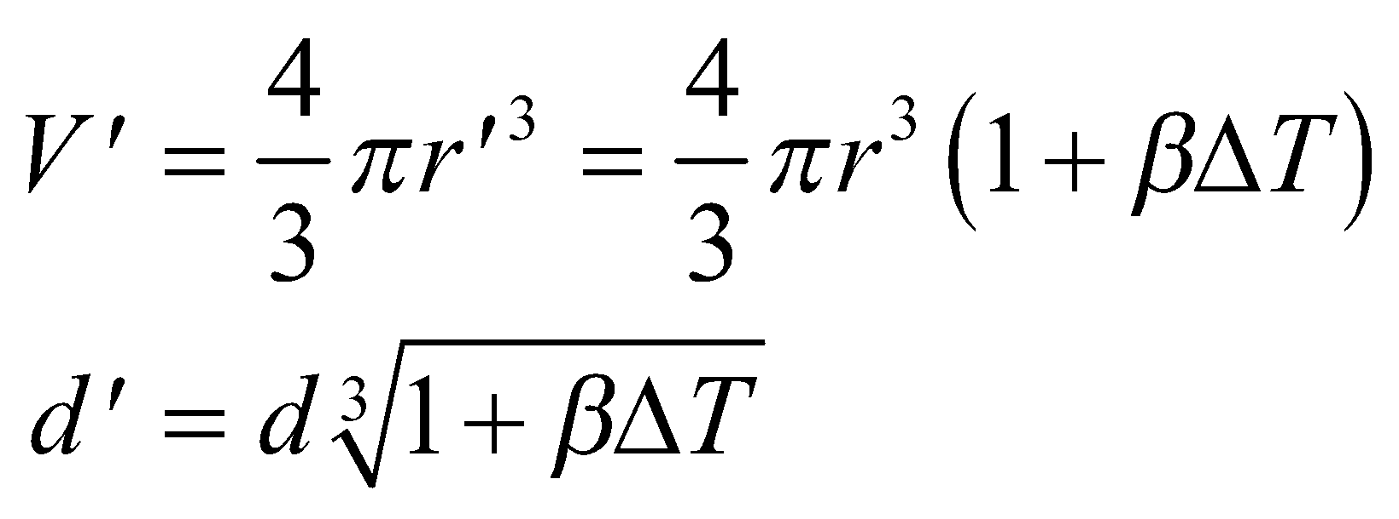

where we have used *d* = 2*r*.

**Evaluate** Inserting the given quantities into the expression above gives



**Assess** Because we are dealing with a sphere (as opposed to a one-dimensional object), we need to use the volume expansion expression. Had we used the linear expansion expression, we would get d = 1.0021, which is incorrect.

**33. Interpret** This problem deals with thermal expansion of a steel washer. The quantity of interest is the diameter of the washer, so the relevant quantity is the coefficient of linear expansion, *α*.

**Develop** The coefficient of linear expansion is defined as (see Equation 17.7):

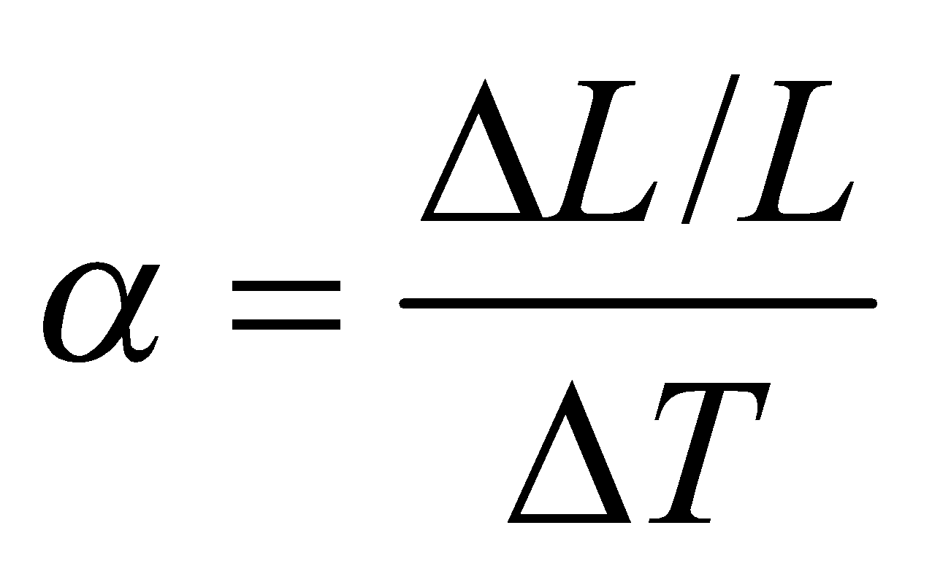

For steel, its value is (see Table 17.2) 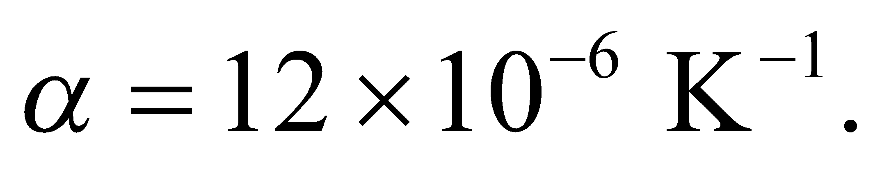 Solve this equation for *ΔT*.

**Evaluate** From the equation above, we get

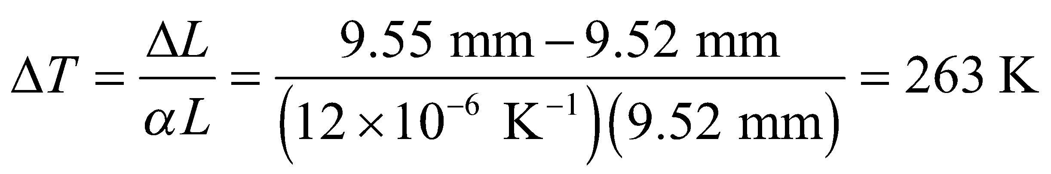

Since the initial temperature is 0°C we must heat the washer to 263°C.

**Assess** Since *α* is very small, a large increase in temperature results in a small increase in the washer’s diameter.

**34.** **Interpret** This problem involves the thermal expansion of a one-dimensional object, so we can use the linear expansion formula to find the total distance a 5000-km rail would expand for a 60 C° temperature change.

**Develop** Equation 17.7,



gives the relationship between temperature change and linear expansion. For steel, *α* = 12 × 10−6 K−1 and the temperature change is *DT* = 40°C − (−25°C) = 65C° = 65 K.

**Evaluate** Solving the expression for *ΔL* and inserting the given quantities gives



**Assess** This is a significant expansion, but it is spread over the 5000-km distance.

**Problems**

**35. Interpret** The system of interest is the solar corona, which we treat as an ideal gas. The quantity of interest is the number density of air molecules.

**Develop** The number density implied by the ideal-gas law (Equation 17.1) is

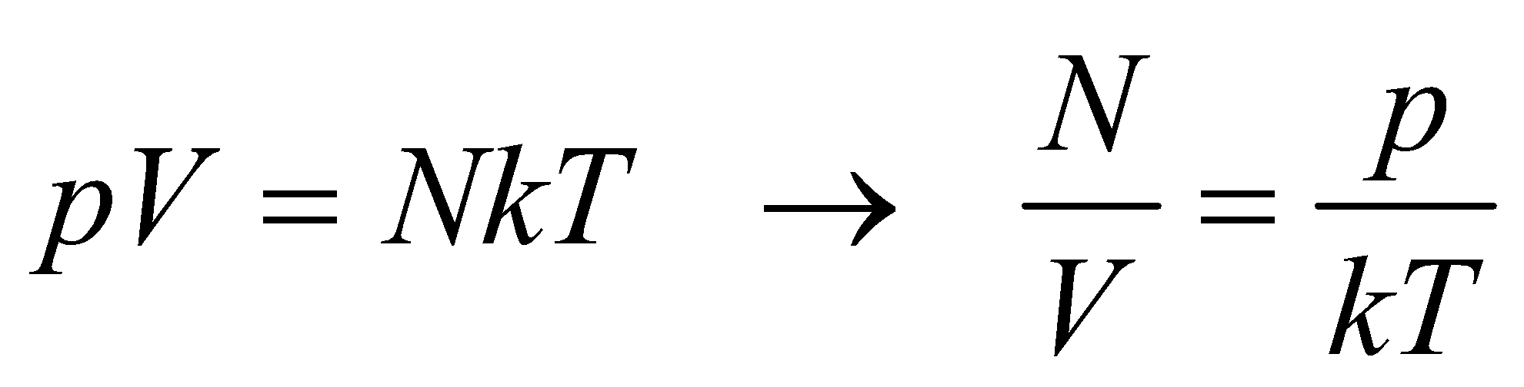

**Evaluate** Applying the above equation to the solar corona, we obtain

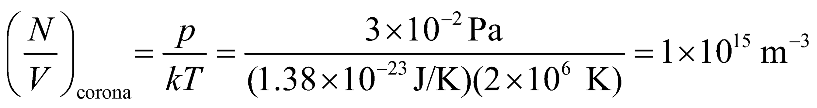

If we assume the Earth's atmosphere has standard temperature and pressure, the particle density is

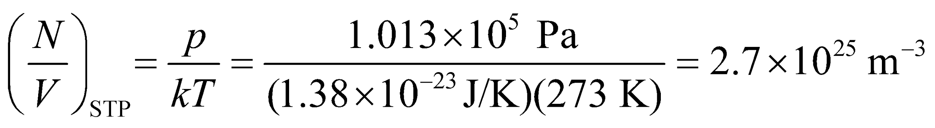

So the corona is over 10 billion times less dense than on Earth.

**Assess** Scientists are still not entirely certain how the corona ends up being so hot.

**36. Interpret** We're asked to figure out how much a balloon expands as it rises to an altitude of lower pressure and temperature.

**Develop** We'll neglect the tension in the balloon material, so the helium gas will expand until its outward pressure on the balloon matches the inward pressure from the surrounding air. The balloon's temperature will also come into equilibrium with its surroundings. The helium obeys the ideal-gas law at both the initial and final altitudes, and since the number of molecules is constant, we have:

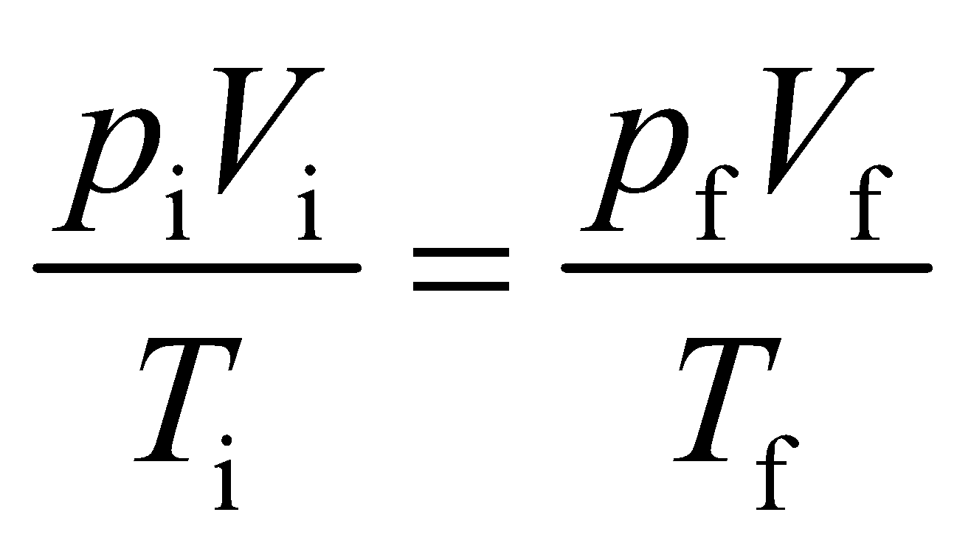

**Evaluate** Solving for the final volume,

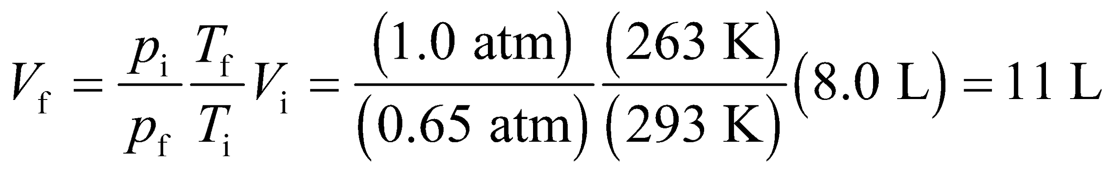

**Assess** If the balloon's pressure and temperature are in equilibrium with its surroundings, you might wonder why it rises. By Archimedes' principle from Chapter 15, the balloon will rise until its weight is equal to the weight of air it displaces. If we neglect the contribution from the balloon material, the final volume will be 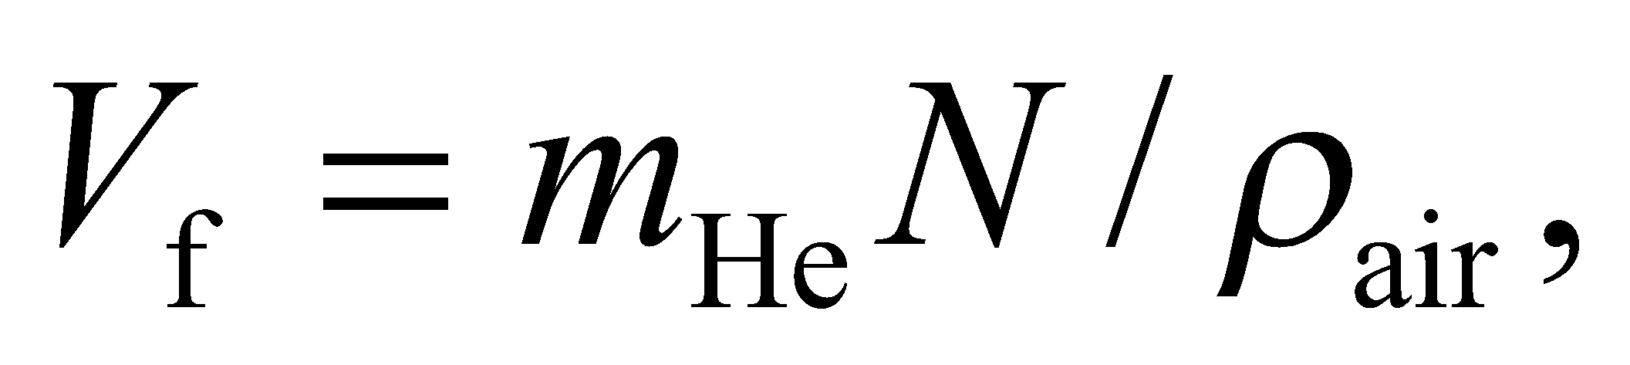 where 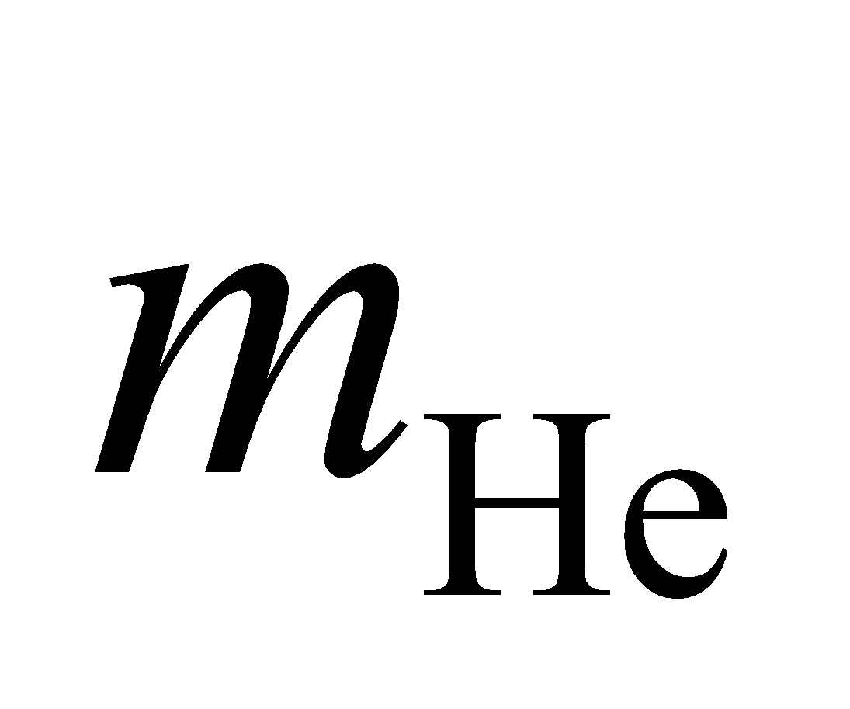is the mass of a single helium atom, is the total number of helium atoms and 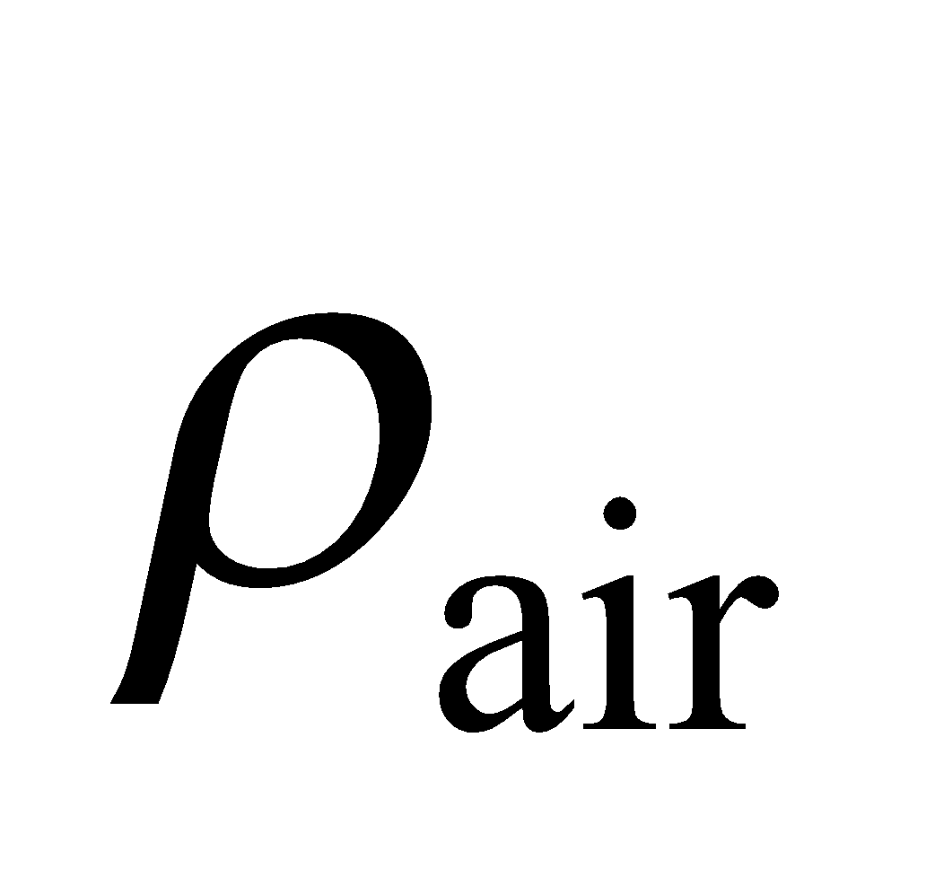 is the air density, which depends on altitude.

**37. Interpret** The object of interest is the cylinder compressed with air. We are given the pressure, temperature, and volume, and want to find the number of moles (i.e., the number of air molecules) in the cylinder.

**Develop** We shall treat the air as an ideal gas (although this is somewhat risky at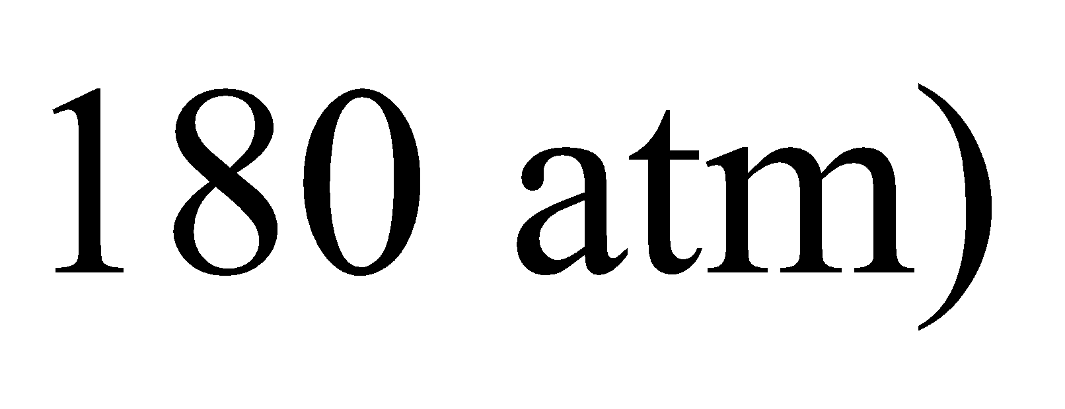and use the ideal-gas law *PV* = *nRT* given in Equation 17.2, to find the number *n* of moles. The volume of the cylinder is

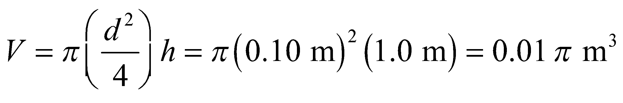

**Evaluate** **(a)** Applying the ideal-gas law gives

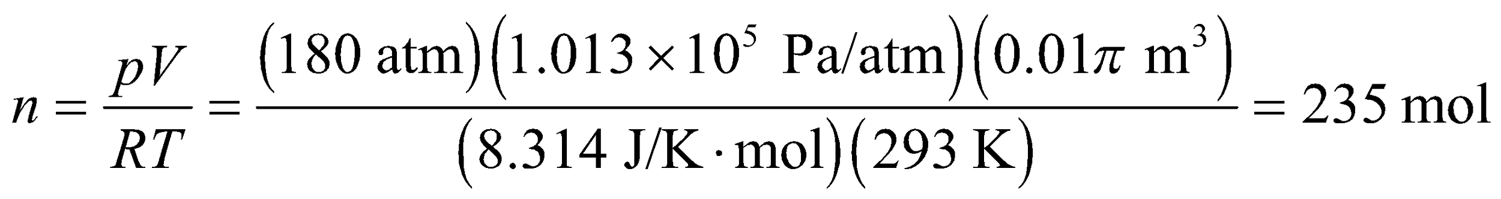

where we have used *T* = 20°C = 293 K as the room temperature.

**(b)** If the pressure is *p*′ = 1 atm, then the volume would be

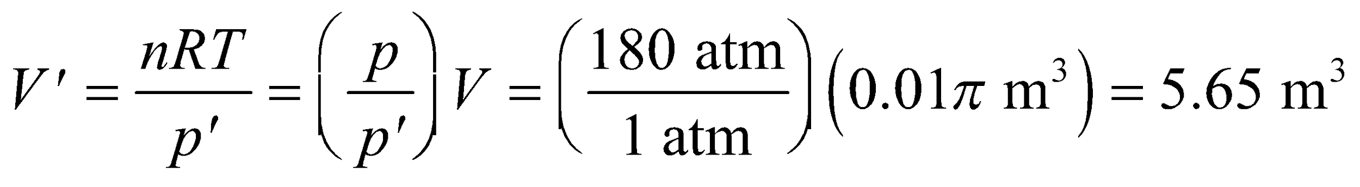

**Assess** When temperature is held constant, *PV* = constant for an ideal gas. Therefore, decreasing the pressure increases the volume in a proportional amount.

**38. Interpret** You're arguing that a whipped cream can exploded because of an error on the part of the manufacturer.

**Develop** It's true that the pressure is the relevant parameter, not the temperature. You can assume that the can is in danger of exploding when the pressure is above the value 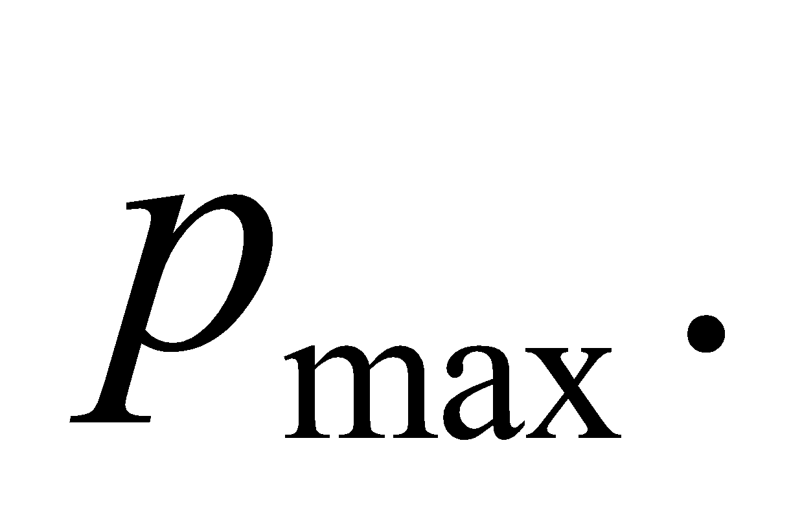You can estimate this value from the manufacturer's claim that a full can should not exceed a temperature of 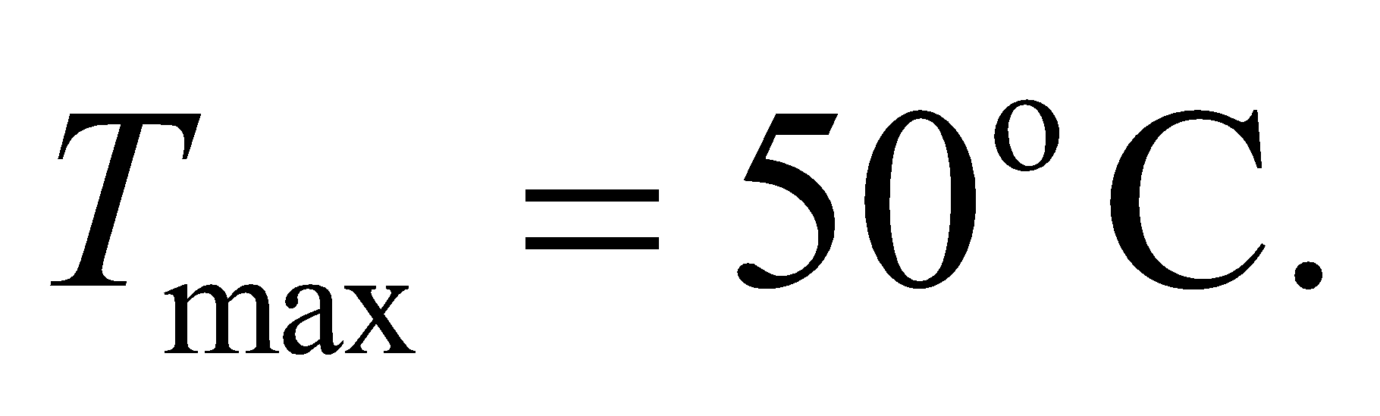By the ideal-gas law, the maximum pressure is related to this temperature, as well as the initial volume and initial number of moles of the propellant:

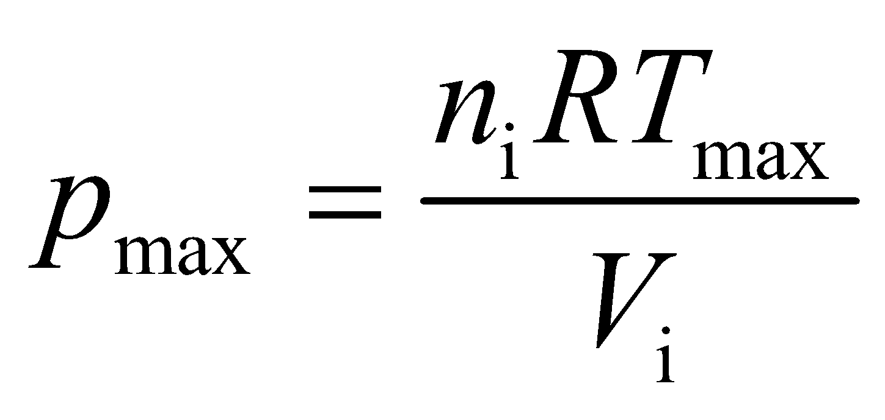

You can't calculate the maximum pressure, but you can compare it to pressure, *p*, of the can that exploded, which had 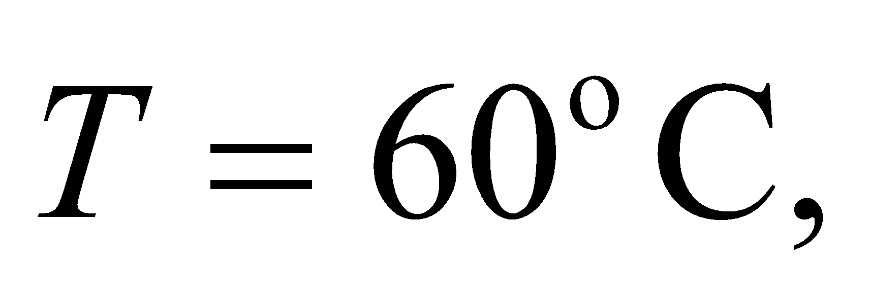 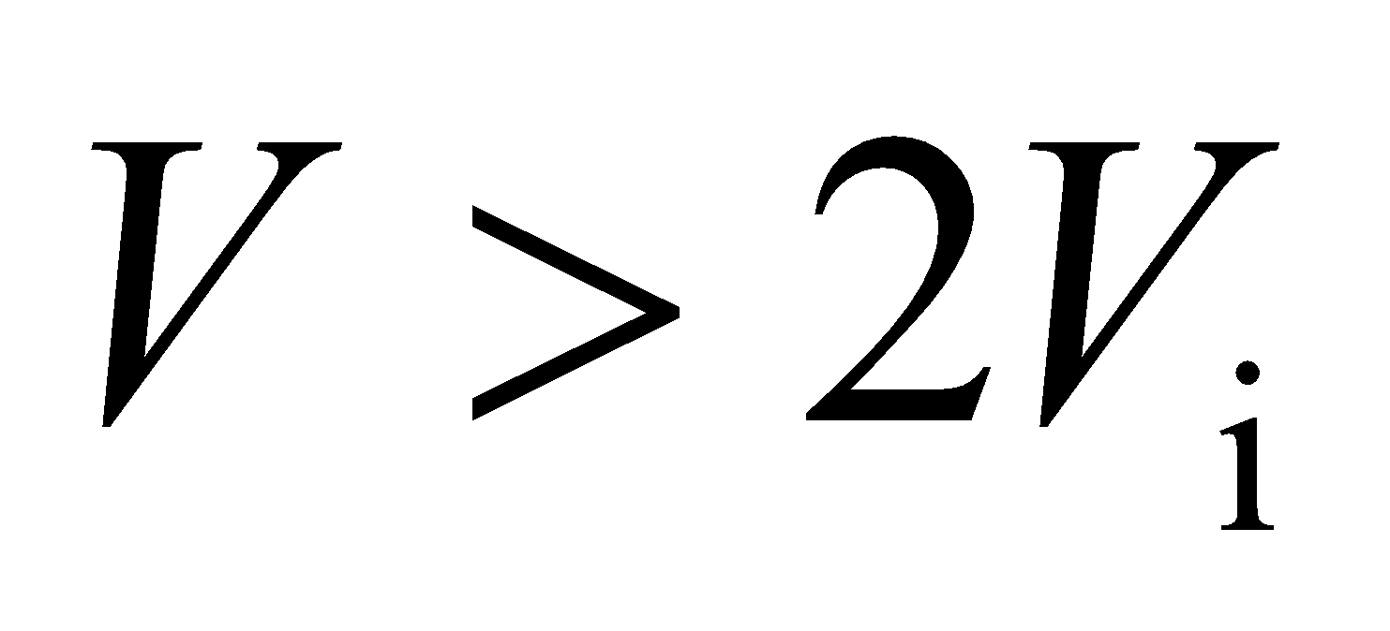 and 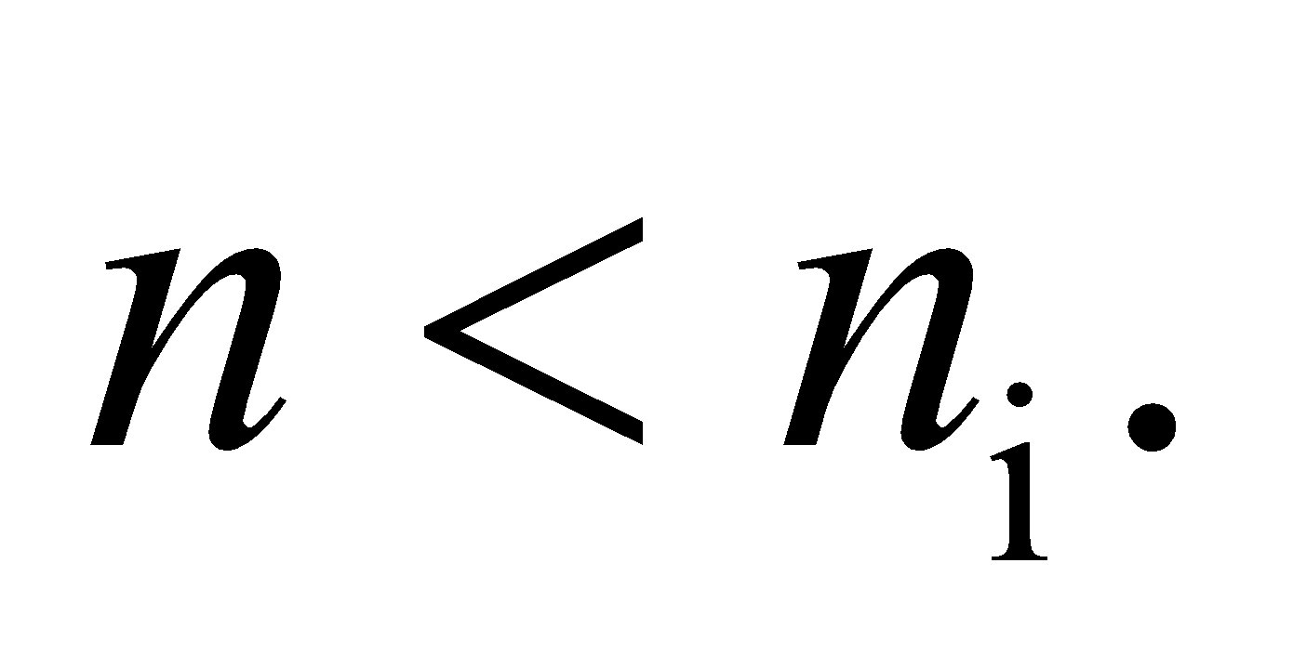

**Evaluate** The ratio of the pressure to the maximum pressure is

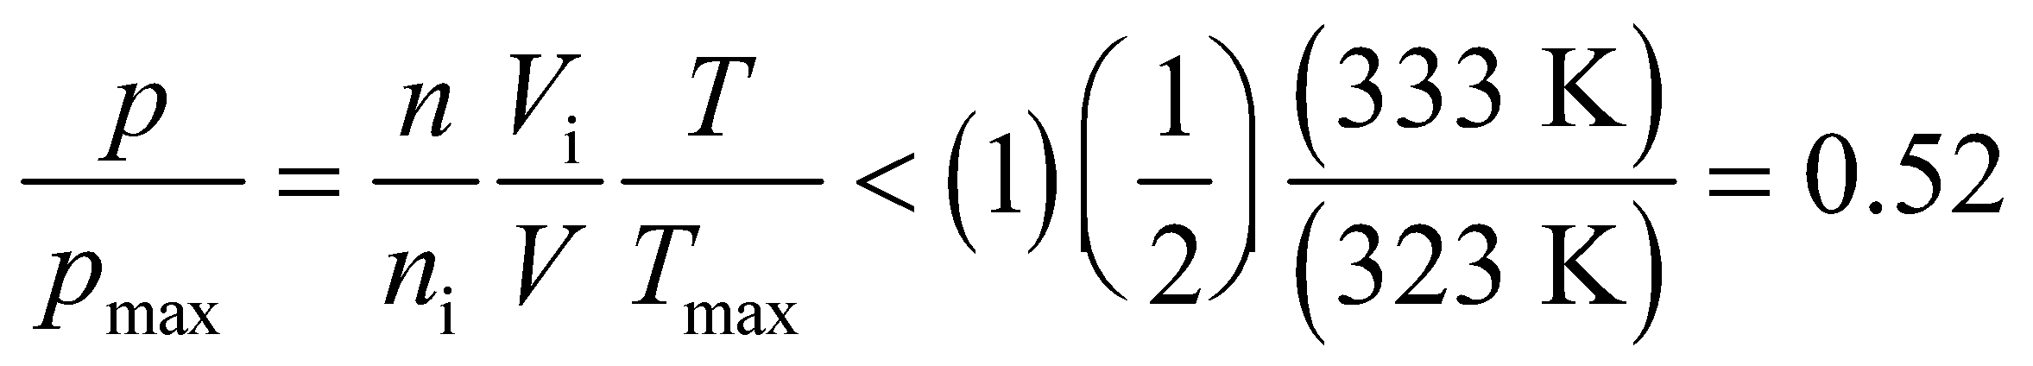

The can exploded when its pressure was about half the maximum pressure, so the manufacturer appears to be at fault.

**Assess** By the above reasoning, a half-full can could supposedly withstand temperatures as high as about 370°C. However, at such a high temperature the whipped cream will vaporize, thus adding its pressure to that of the propellant.

**39. Interpret** The object of interest is the flask filled with air, which we treat as an ideal gas. We explore the effect of changing temperature and pressure. The maximum pressure in the flask will occur when the gas inside the flask, which is initially at STP, is heated to the boiling point of water (100°C). To find the number of moles that escape when the flask is opened, we consider that the gas escapes so fast that the temperature of the gas can be considered to be constant on this timescale.

**Develop** When the flask is immersed in boiling water, its volume remains fixed. Therefore, the ideal-gas law

*pV* = *nRT* (Equation 17.2) applied at each temperature gives

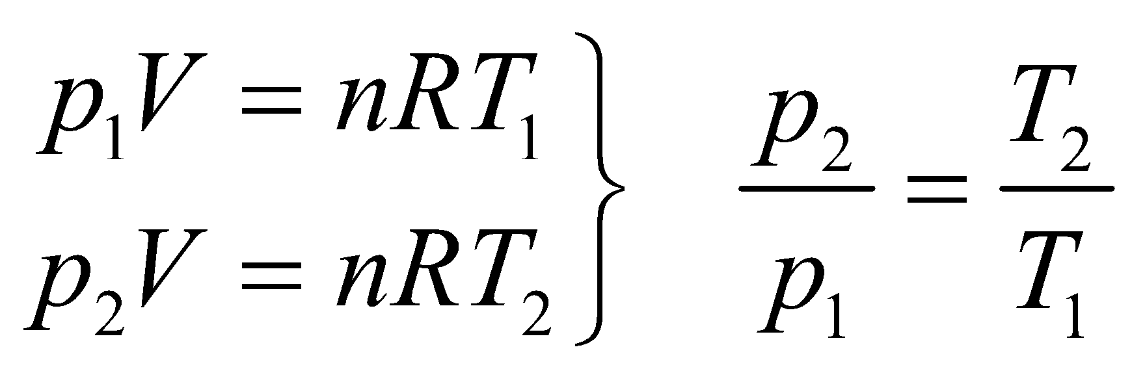

The initial conditions of the gas are *p*1 = 1 atm, *V* = 3.00 L = 3.00 × 10−3 m3, and *T*1 = 293 K. The maximum pressure in the flask occurs when *T*2 = 100°C = 373 K. For part (b), we first calculate the number of moles of gas initially in the flask. Again applying the ideal-gas law, we find the number of molecules to be

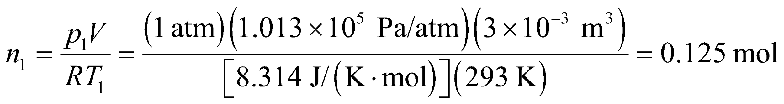

When the flask is opened at *T*2 = 373 K the pressure rapidly decreases to *p*2 = 1 atm, so the quantity of gas remaining in the flask is

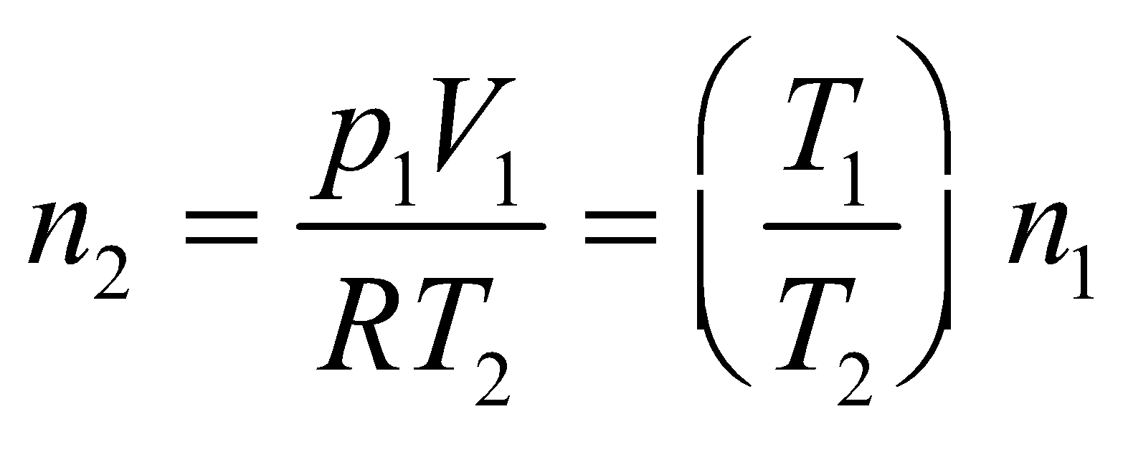

so the number of moles that escaped from the flask is *Δn* = *n*1 − *n*2. After the flask is closed and cooled back down to *T*3 = 20°C = 293 K, we again apply the ideal-gas law using *n*2 to find the new pressure. This gives

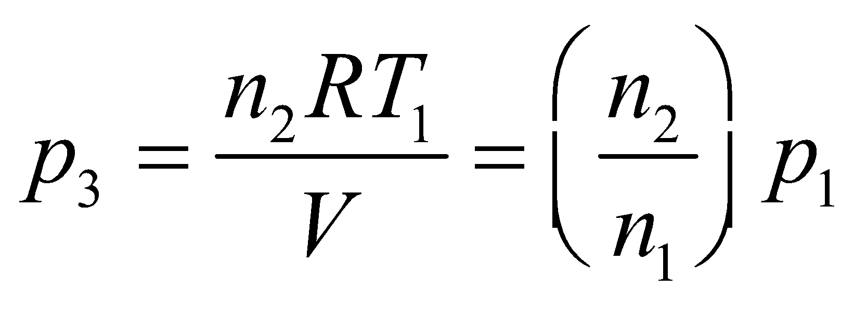

**Evaluate** **(a)** From the equation above, we find the maximum pressure reached in the flask to be

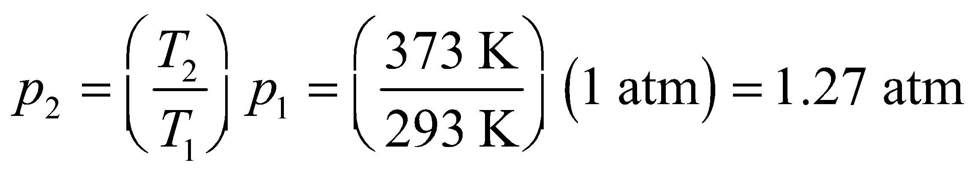

**(b)** After opening the flask the quantity of gas left in the flask is

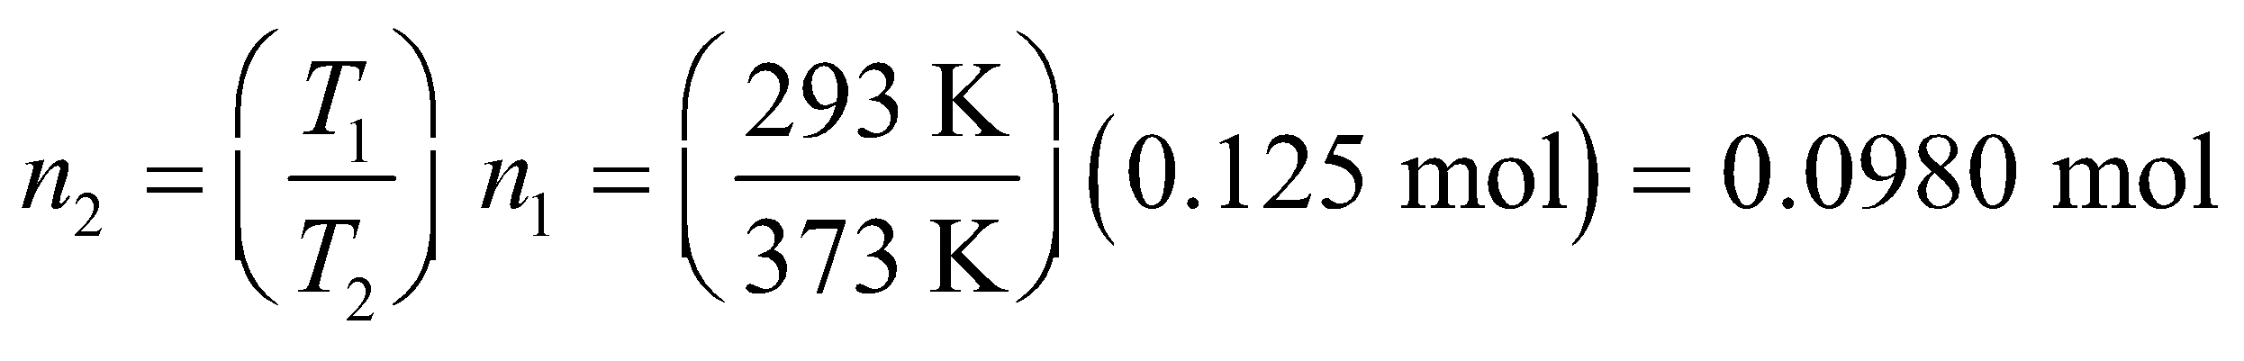

Therefore, the amount that escaped is 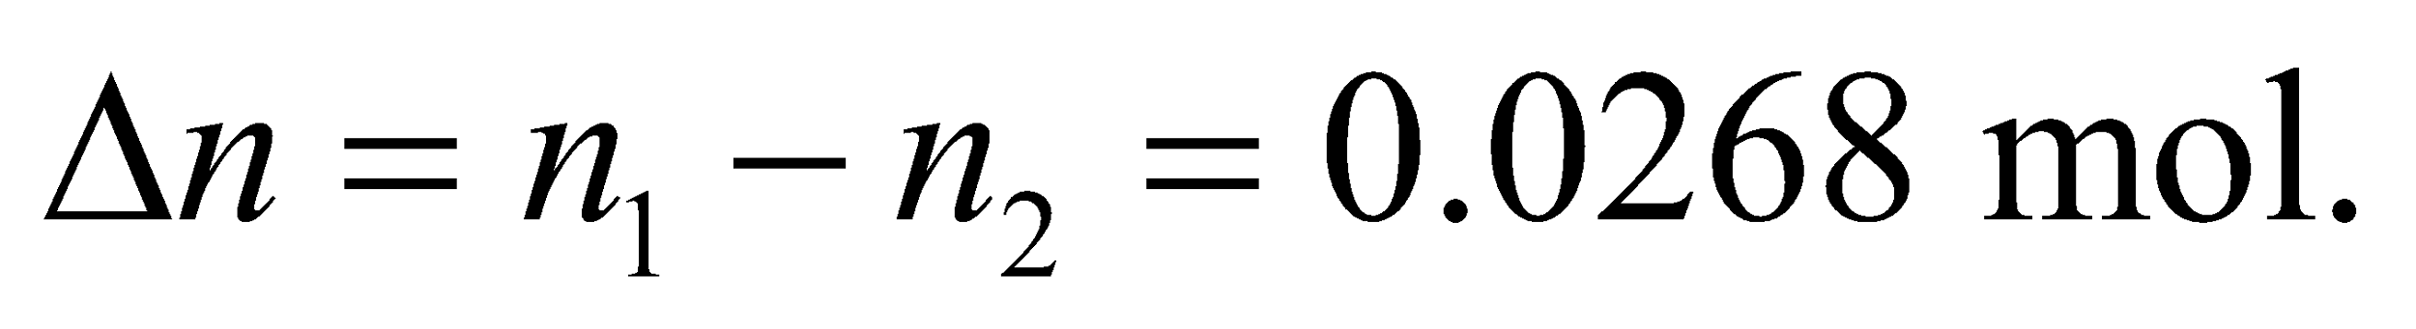

**(c)** After sealing the flask and cooling it to 293 K, the pressure of the gas in the flask is

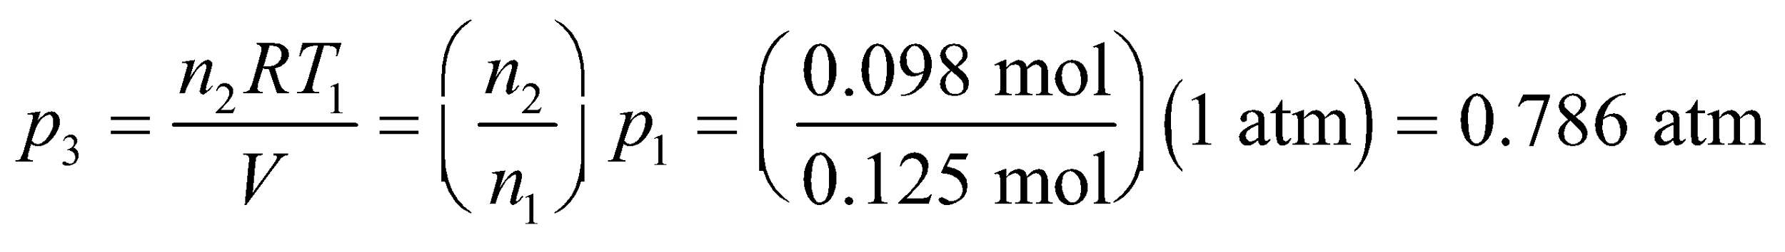

**Assess** As expected, the pressure in the flask is greatest for part (a), when the temperature is highest and there are the most moles of gas in the flask, and the pressure is the lowest for part (c), when the reverse is true. Pressure is proportional to the number of molecules in the volume, so after some gas molecules escape from the flask, the pressure decreases.

**40. Interpret** We want to know how long it will take to warm up a frostbitten hand. We can calculate the total energy needed and divide by the rate that energy is absorbed from the water bath.

**Develop** We model the frostbitten hand as pure ice with mass *m*. A certain amount of heat will be needed to first melt the ice: 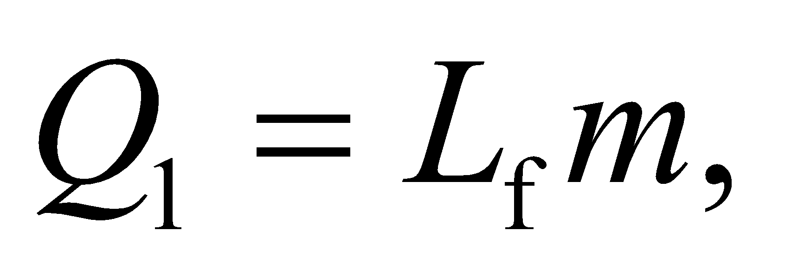 which is Equation 17.5 with 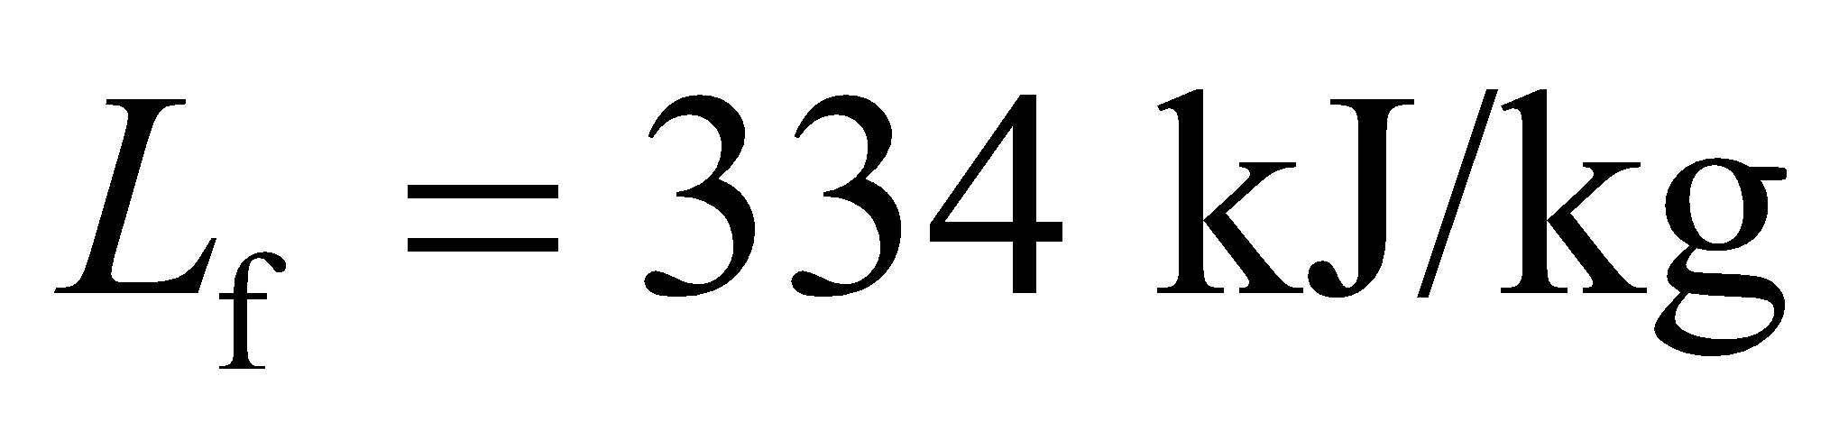for water. Afterwards, the water will have to be warmed from the freezing temperature 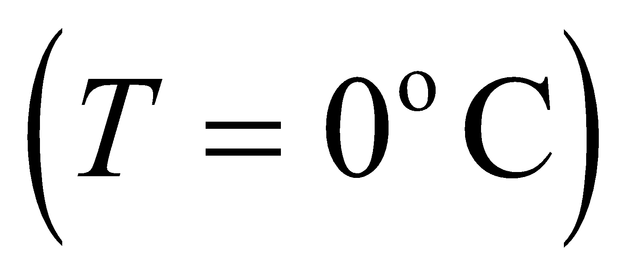 to the normal body temperature 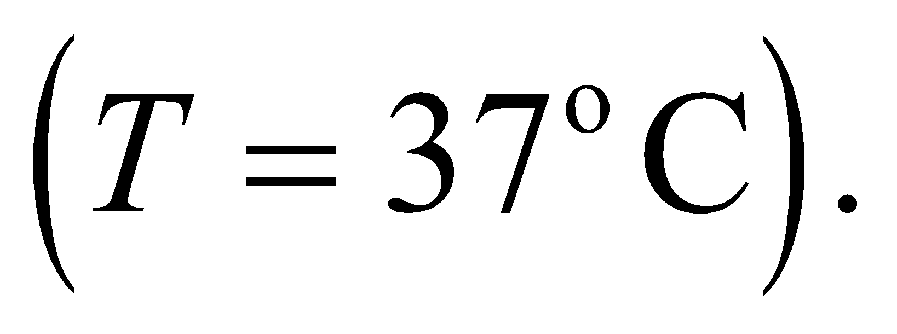This will require 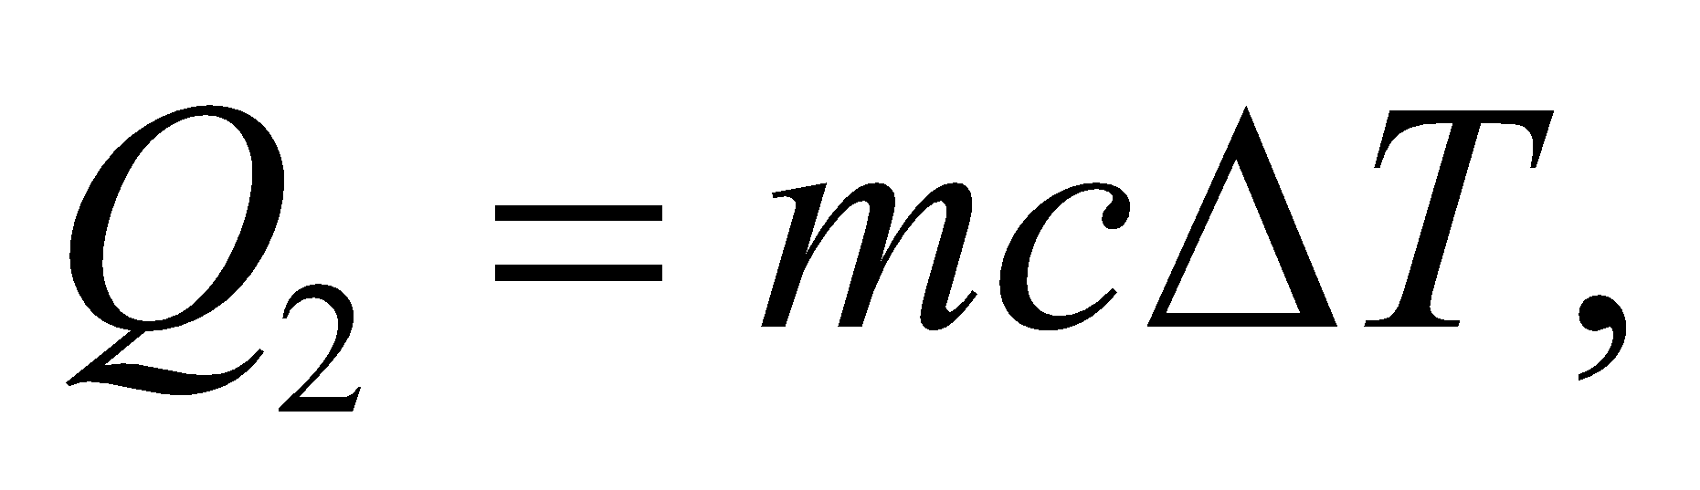where 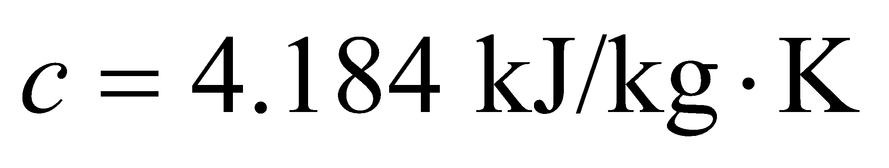from Table 16.1. The time to supply the full heat will be: 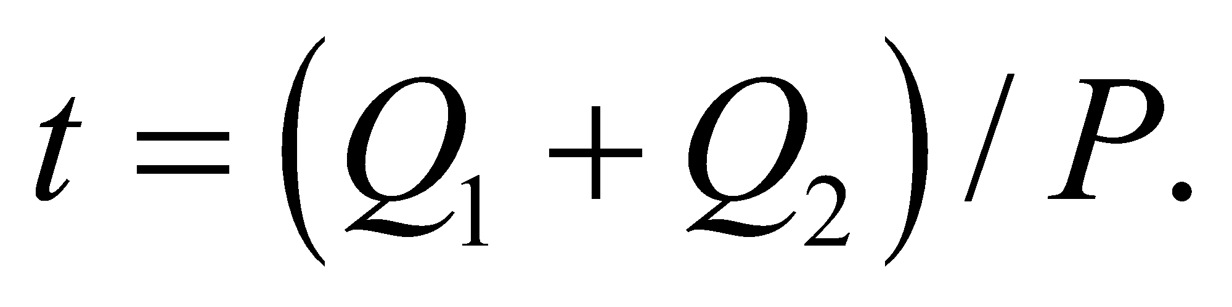

**Evaluate** The melting and warming steps will require energies of:

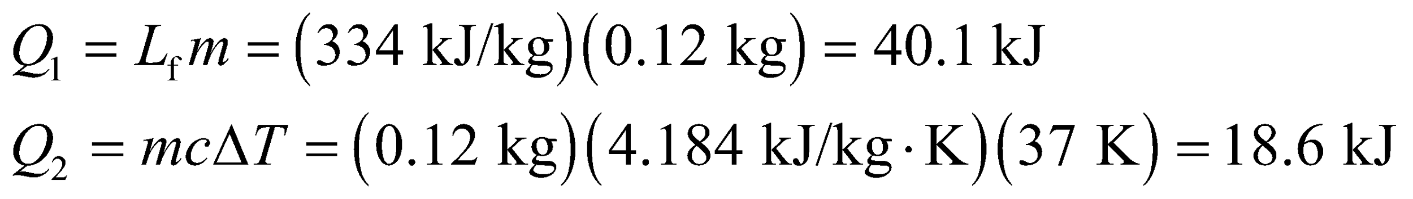

Using the rate that heat is conducted into the hand,

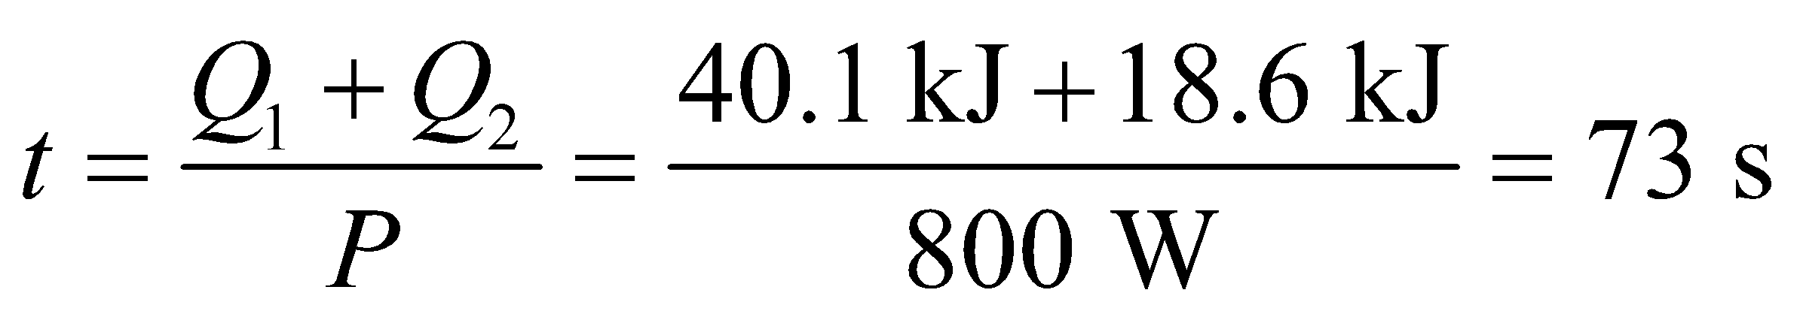

**Assess** This seems reasonable, assuming the bath supplies heat to the hand at a constant rate. In fact, the outside of the hand will come into near temperature equilibrium with the surrounding water, thus slowing the rate of heat flow to the inner part of the hand.

**41.** **Interpret** This problem involves finding the time required to transform the given amount of 100-°C water to gas with the given rate of heating.

**Develop** From Equation 17.5, the energy absorbed during the vaporization of water at its boiling point is *Q* = *L*v*m*. If this energy is supplied at in a time *t*, then the power must be *P* = *Q*/*t*, so *t* = *Q*/*P*. Given that *P* = 1500 W, we can solve for the time *t*.

**Evaluate** The time it takes to boil away the water is

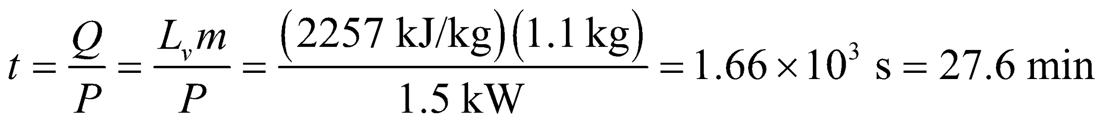

**Assess** This seems like a reasonable time, and it explains why it is a good idea to add water occasionally to steamers when cooking with steam.

**42. Interpret** This problem is about melting, and it involves heat of fusion. We want to know how much ice would melt by exploding a 1-megaton nuclear bomb in the Greenland ice cap.

**Develop** A 1-megaton nuclear device releases about 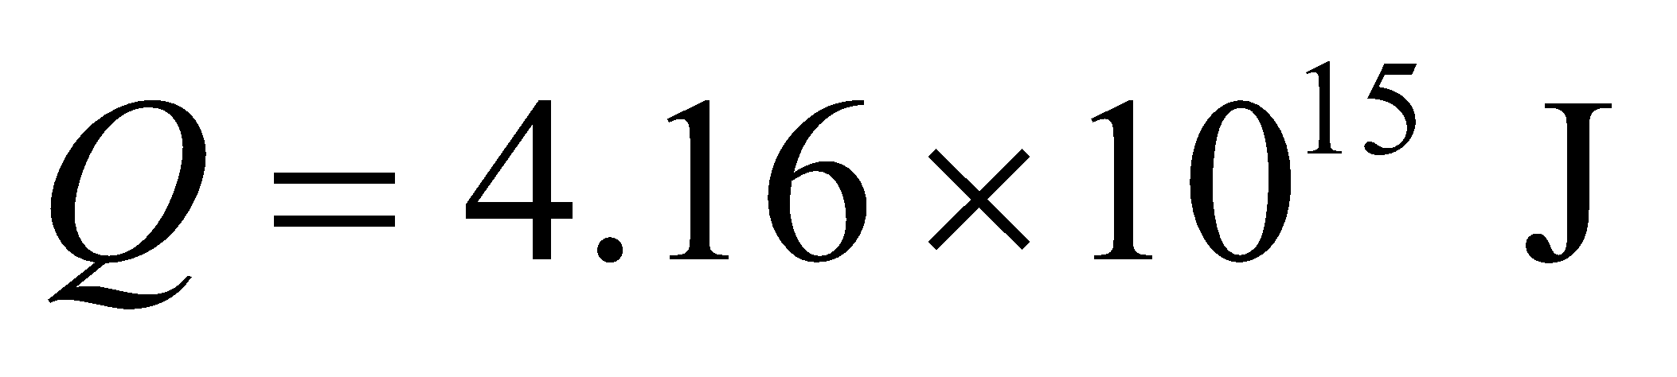 of energy. The heat of fusion for water is 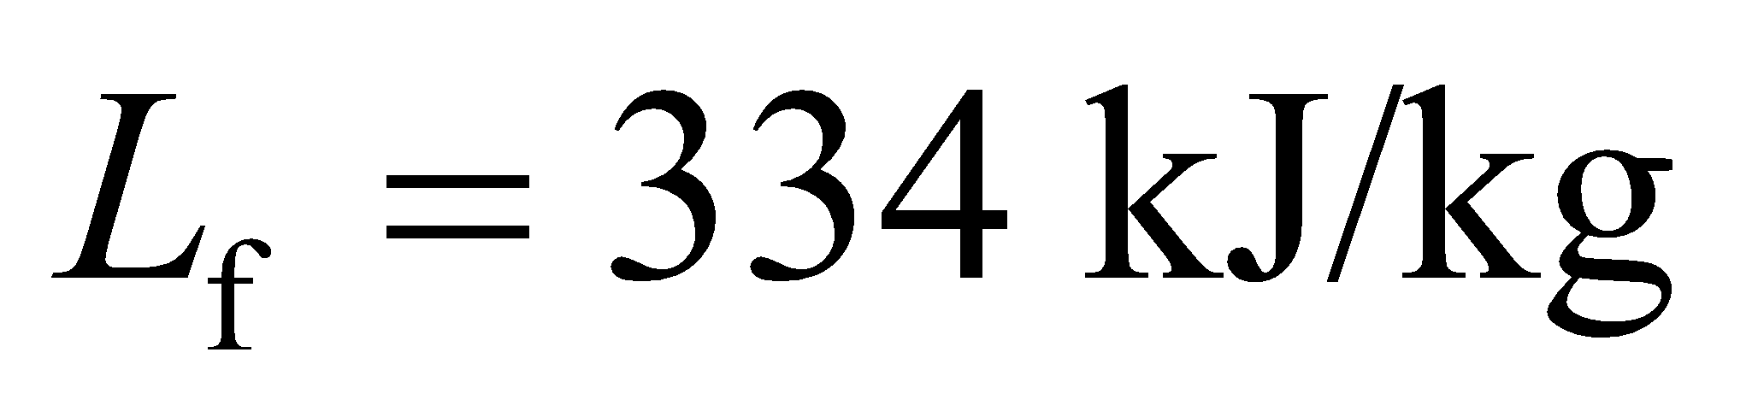, so we can use Equation 17.5 *Q* = *L*f*m* to find the mass m of ice that is melted.

**Evaluate** The amount of ice at the normal melting point of 0°C that melts is

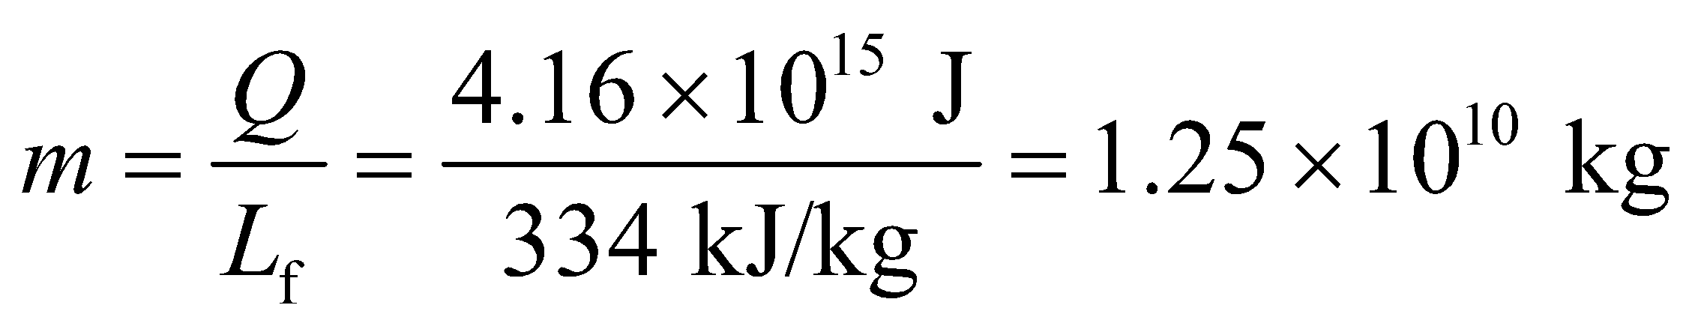

**Assess** The amount of ice melted by this explosion corresponds to a lake approximatley 100-m deep, 1-km long, and 100-m wide.

**43. Interpret** You want to know how long it will take your camping stove to melt snow. Note that the stove here is the same as the one in Problem 16.56 that was used to boil water.

**Develop** You can integrate the given power, *P*, to find the total heat that the snow has absorbed. You can then equate that to the amount of energy needed to melt the snow. Since the snow starts off around 0°C, it doesn't need to be warmed up to the freezing point. From Equation 17.5: 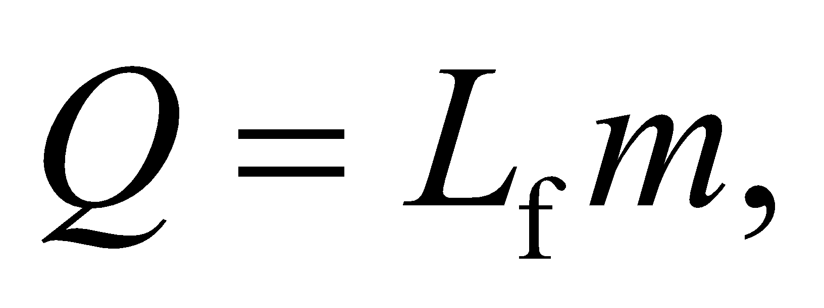 wherefrom Table 17.1.

**Evaluate** The heat absorbed by the snow over a given time is:

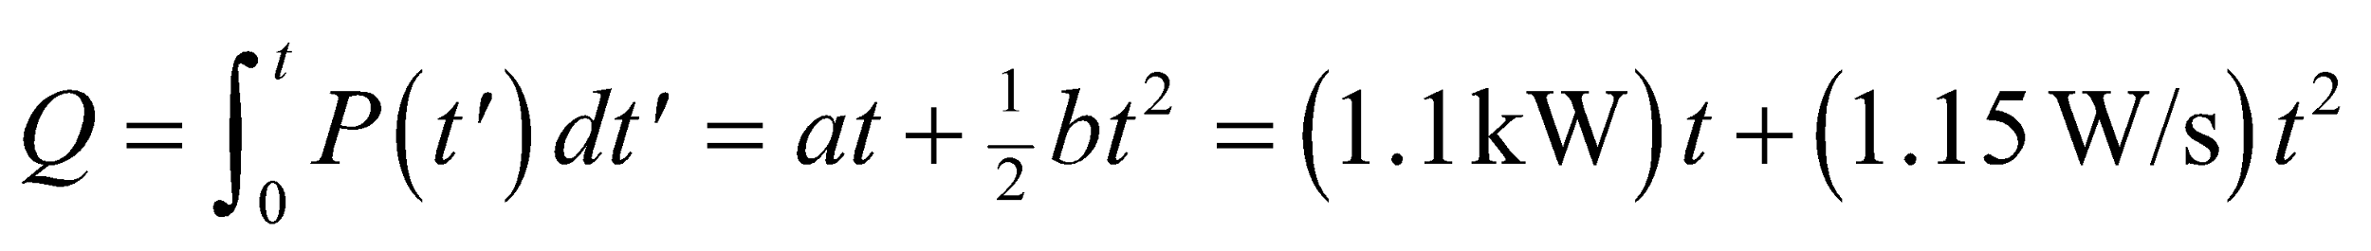

You want to know how long until this absorbed heat melts the snow

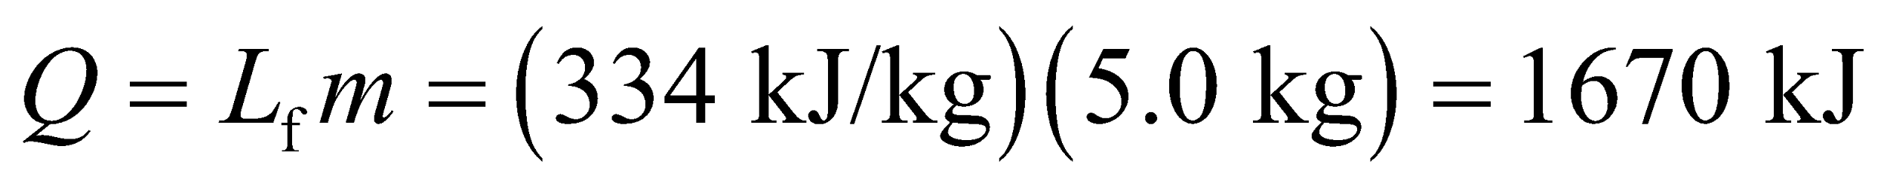

This requires solving a quadratic equation with the quadratic formula from Appendix A:

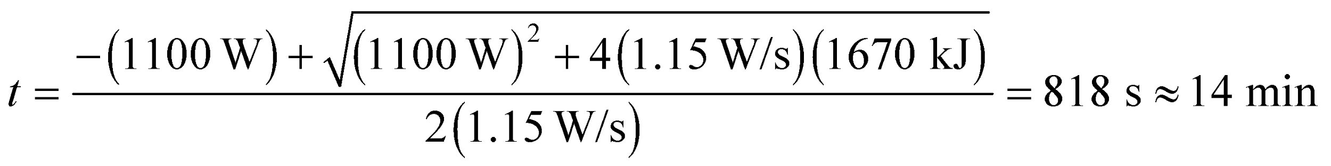

**Assess** In Problem 16.56, it took the same stove 9 minutes to boil water 2.5 kg of water. If we double this result, we see that it takes about 20% less time to melt snow than to boil the same amount of water.

**44. Interpret** This problem is about melting, so heat of fusion is involved. We want to know how much energy is needed to melt a given quantity of ice.

**Develop** We can look up the surface area of Lake Superior: 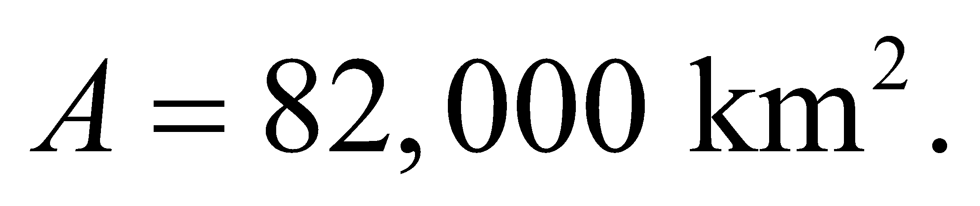 The total mass of ice is then



If we can assume the ice is initially at 0°C, the energy needed to melt it will be  wherefrom Table 17.1.

**Evaluate**  (a) Substituting the values, the heat required to thaw Lake Superior is:



Where we have used the prefix exa (1018).

(b) If the ice melts in three weeks, the average power must be

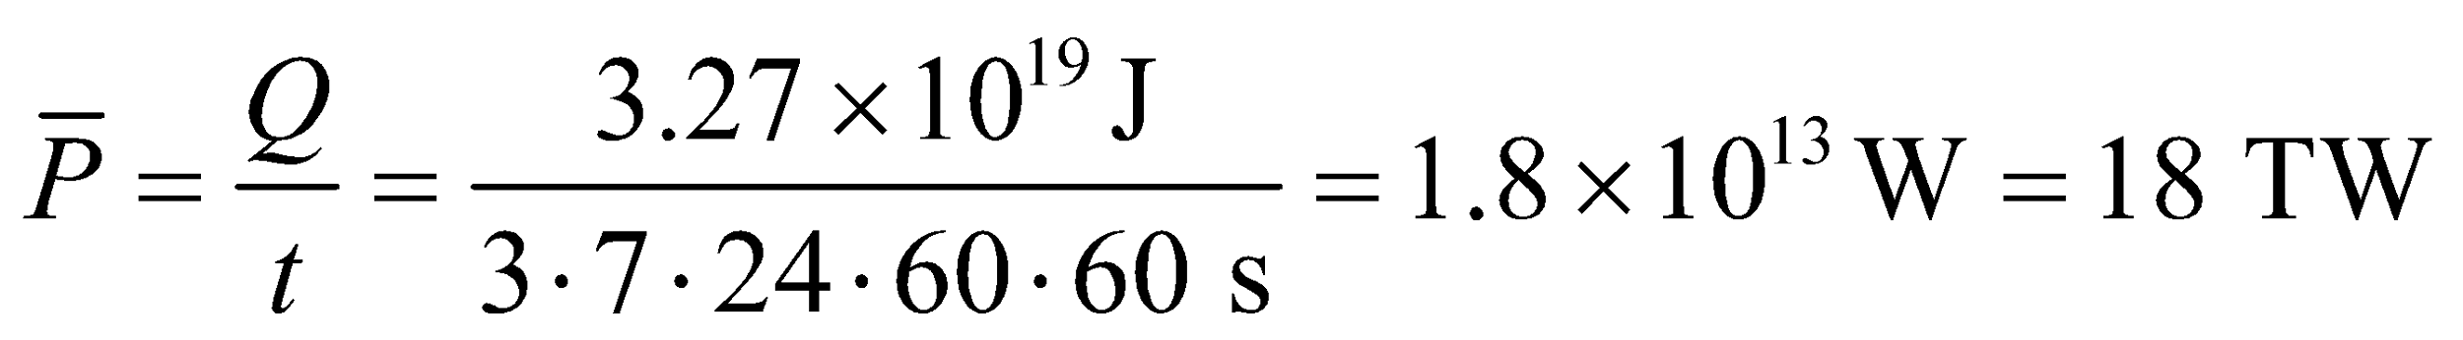

**Assess** The power per unit area (or intensity) in this case is 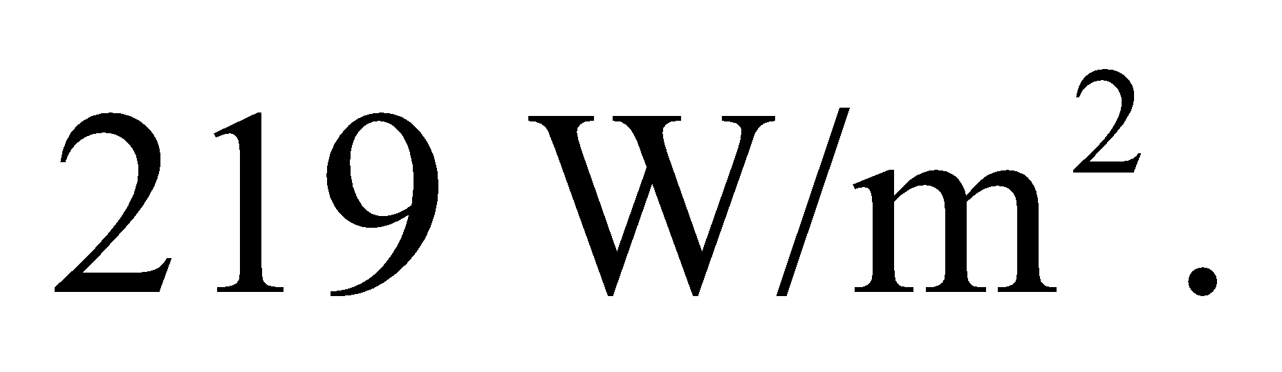 In Chapter 16, we learned that the Earth absorbs energy from the Sun at a rate of 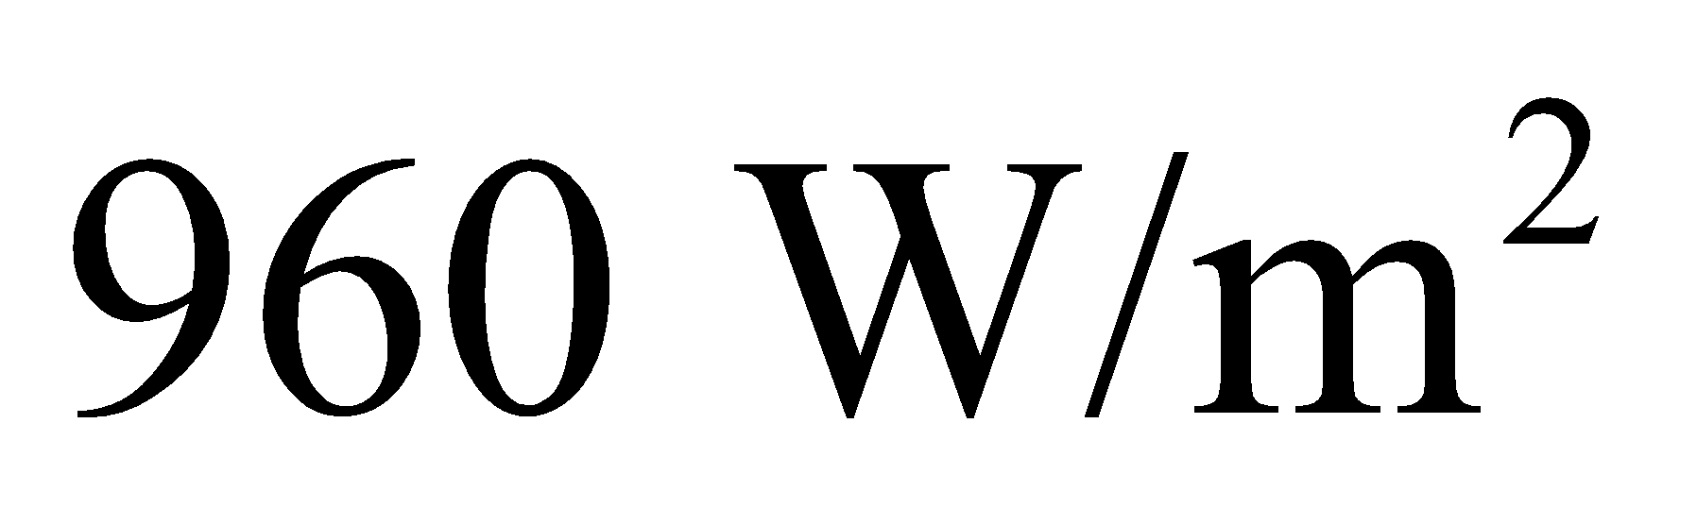averaged over its cross-sectional area. Considering that the Sun is shining on Lake Superior only a fraction of the three-week period, the calculated power is reasonable.

**45.** **Interpret** This problem involves the latent heat of fusion, with which we can calculate the time it takes to freeze water that is at 0°C if we remove energy a the rate given.

**Develop** From Equation 17.5, the refrigerator must extract the energy *Q* = *L*f*m*, where *m* = 0.75 kg and *L*f = 334 kJ/kg (from Table 17.1). At the rate *P* = *Q*/*t*, where *P* is the power applied by the refrigerator, it will take a time *t* = *Q*/*P* to freeze the water.

**Evaluate** Inserting the given quantities into the expression above gives

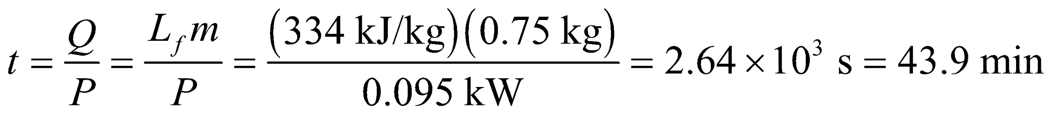

**Assess** This is a good figure to keep in mind if you need to make ice cubes for a party.

**46. Interpret** You're asked to determine if a highly absorbing black carbon can cause a layer of Arctic ice to completely melt.

**Develop** The ice has a thickness of 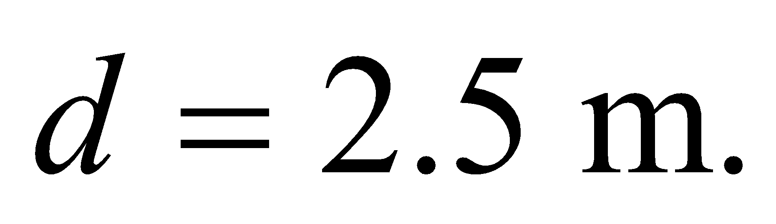You assume that the only energy input is from absorbed sunlight:

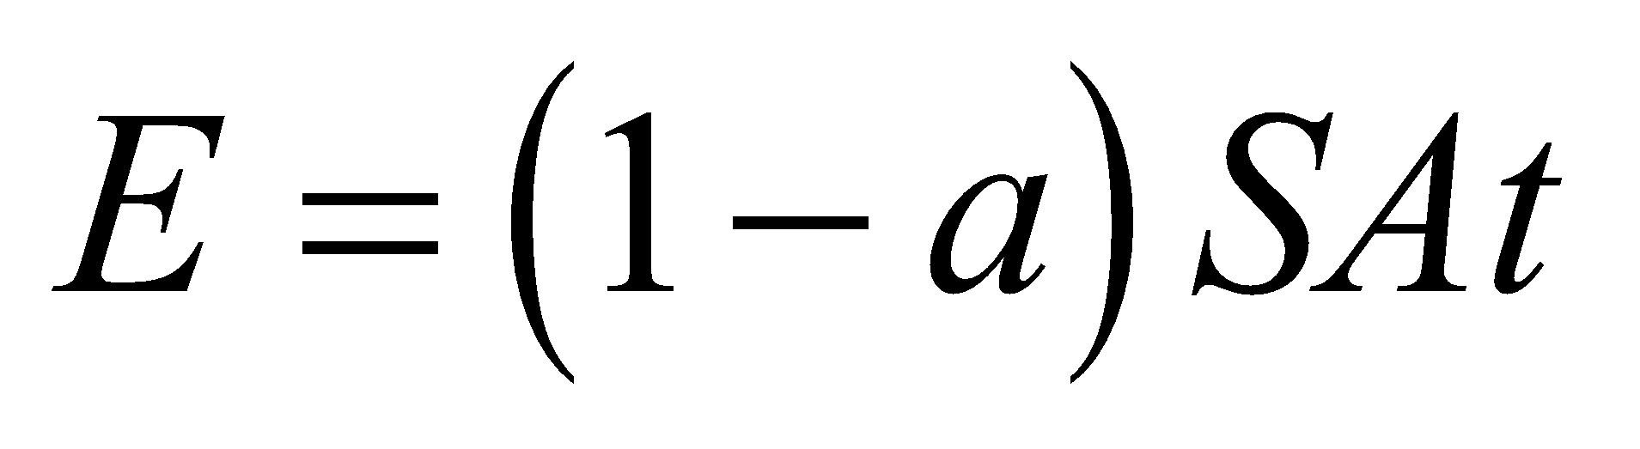

where *a* is the fraction of light reflected away,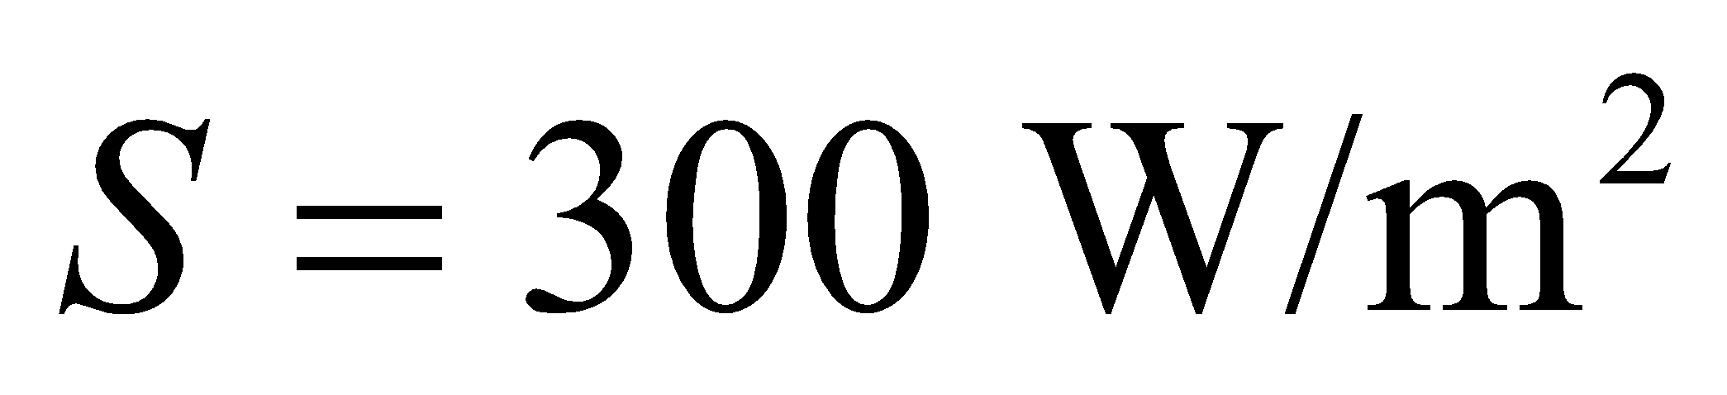is the solar intensity, is the exposed surface area of ice, and *t* is the time, which we will assume is a quarter of a year for the summer season. The ice will melt if 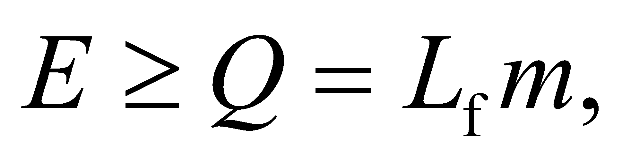where and 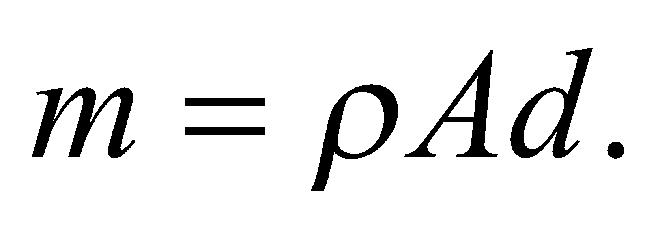

**Evaluate** Combining the above relations, the criteria for the ice to melt can be written as:

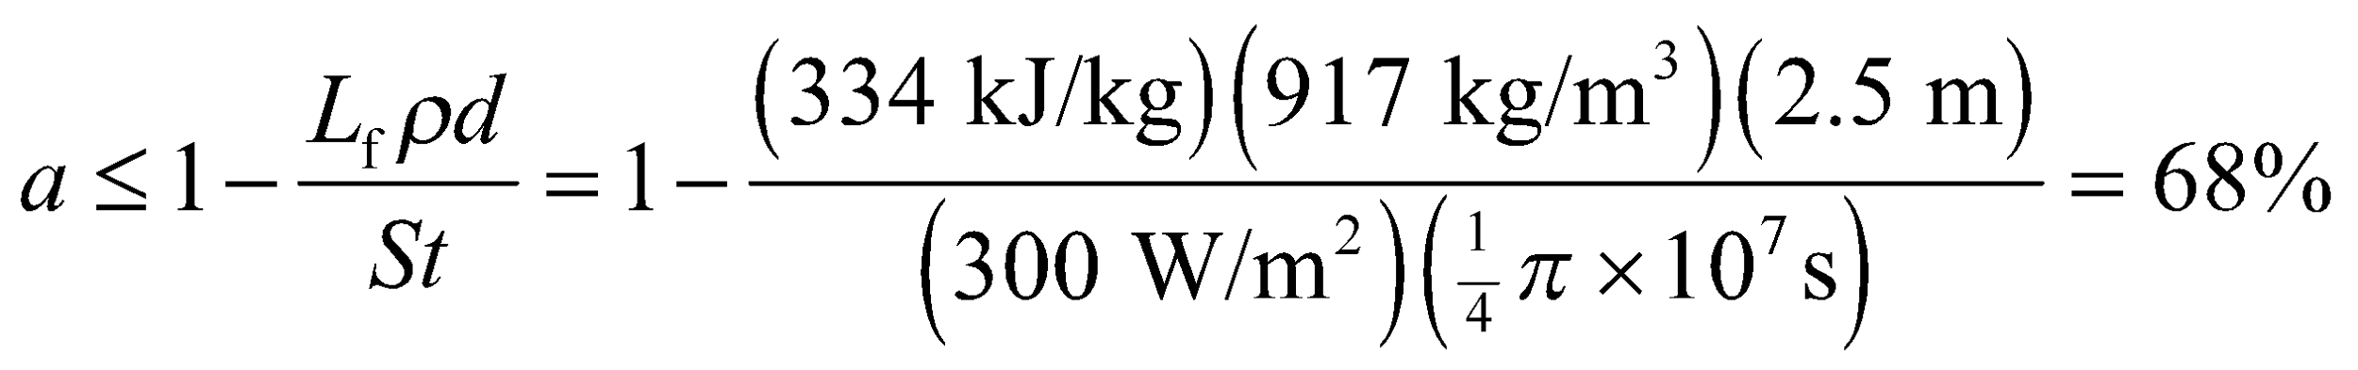

So the ice shouldn't melt completely under normal conditions when 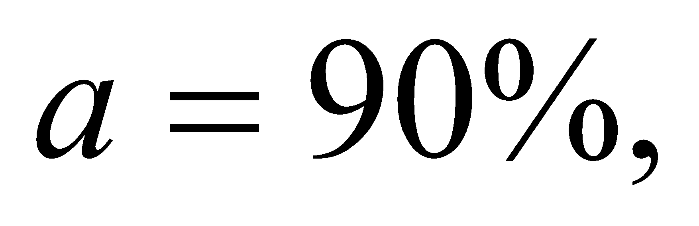but the presence of black carbon could cause complete melting, assuming 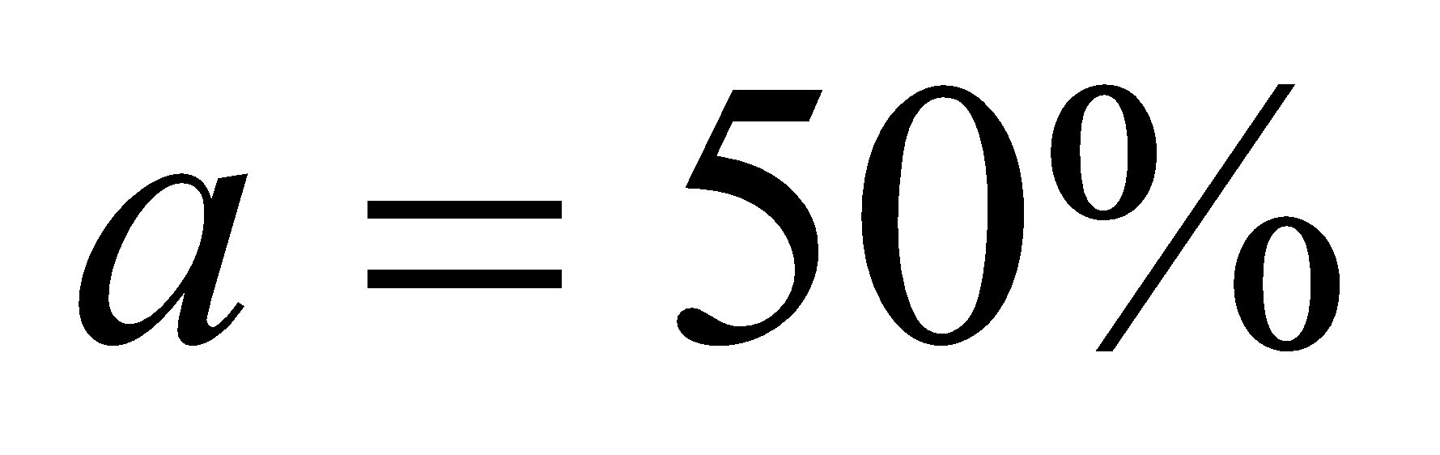in this case.

**Assess** The parameter *a* is called the albedo. An object with zero albedo would absorb all incoming radiation, like a perfect blackbody.

**47.** **Interpret** This problem involves a change in temperature and a phase change (solid to liquid). We will apply the concepts of specific heat and heat of fusion to find temperature of the system in equilibrium.

**Develop** From Example 17.4, we expect that the 50 g of ice at −10°C will completely melt in the 1.0 kg of water at 15°C. To find the equilibrium temperature, consider that the water must first warm the ice from −10°C to 0°C, which will require an energy *Q*1 = *m*ice*c*ice*ΔT*, with *ΔT* = 10 K, *m*ice= 0.050 kg, and *c*ice= 2050 J/(kg·K) (see Table 16.1). Next, the water will melt the ice, which costs an energy *Q*2 = *L*f*m*ice, with *L*f = 334 kJ/kg (see Table 17.1), and finally, the water will warm up the newly melted water from 0°C to the equilibrium temperature *T*, which will cost an energy *Q*3 = *m*ice*c*water*T*. The sum of these energies must equate to the energy *lost* by the water, or



where *T*0,water = 15°C and *c*water = 4184 J/(kg·K) (see Table 16.1).

**Evaluate** Solving the expression above for the equilibrium temperature T gives

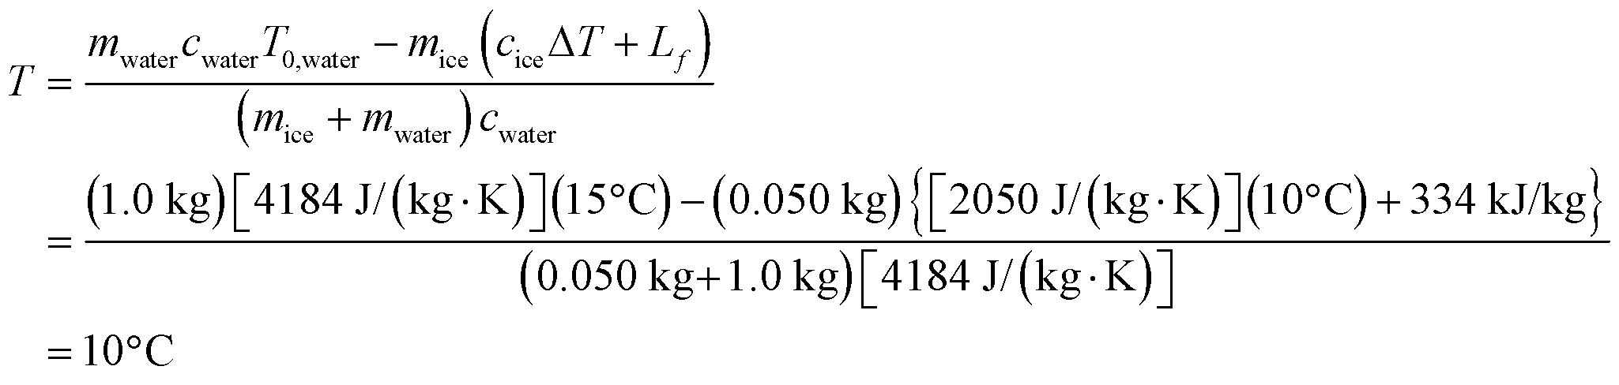

**Assess** As expected, the water has not reached 0°C, so all the ice melts and our initial assumption is confirmed.

**48. Interpret** This problem involves raising the temperature of ice to the melting point and then changing the phase, so both specific heat and heat of fusion are involved.

**Develop** The energy needed to raise the temperature is given by Equation 16.3, 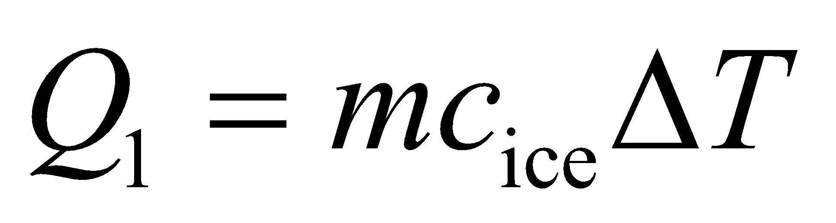, with *ΔT* = *T*final − *T*initial = 0°C − (−10°C) = 10°C = 10 K. Equation 17.5, 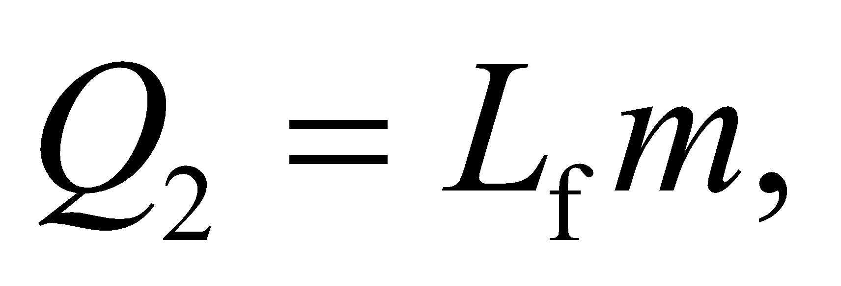 gives the heat of fusion required to change the phase from solid to liquid. Use Table 16.1 to find the specific heat *c*ice of ice and Table 17.1 to find the latent heat of fusion *L*f for water. The total energy required to go from ice at −10°C to water at 0°C is the sum of *Q*1 and *Q*2.

**Evaluate** Adding up the two energies, we obtain

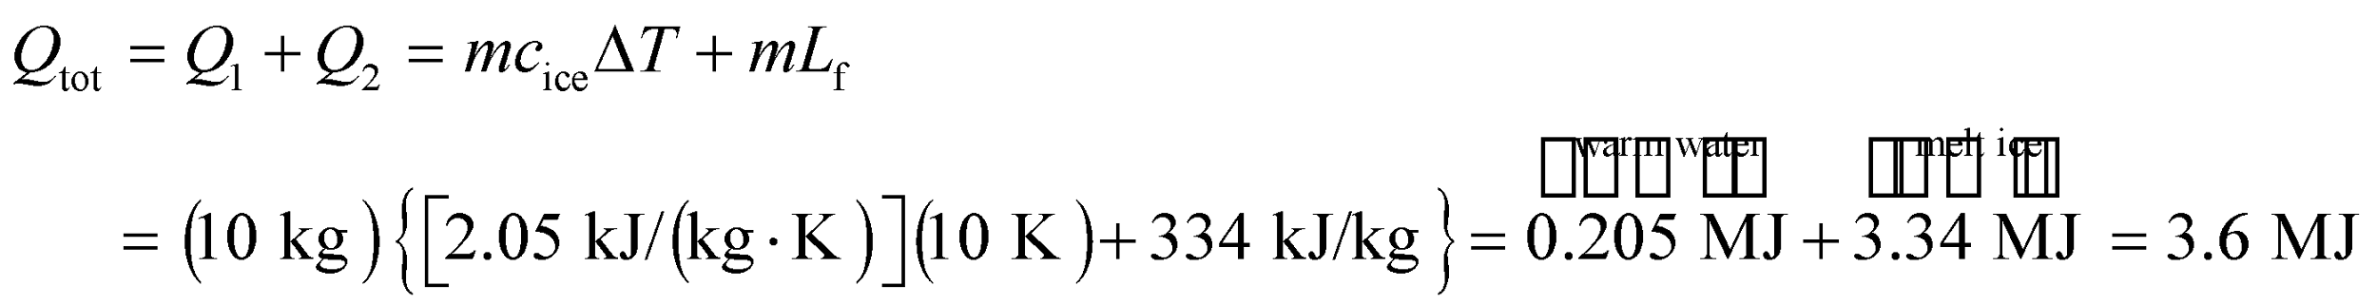

**Assess** About 94% of the energy is actually used to melt the ice, only 6% for raising the temperature.

**49.** **Interpret** This problem involves raising the temperature of water, which involves the specific heat of water, then changing its phase from liquid to gas, which involves the latent heat of vaporization. Using these two concepts, we are to find the initial temperature of the water given that the 90% of the energy needed to boil the water away is used to change the phase, with only 10% being used to raise its temperature.

**Develop** Equation 16.3 *Q*1 = *mcΔT* gives the energy needed to raise the water’s temperature, where *ΔT* = 100°C − *T* where *T* is the initial temperature of the water. The energy needed to boil the water (i.e., change it from the liquid phase to the gas phase) is *Q*2 = *mL*v. The quantities *L*v and *c* can be found in Tables 17.1 and 16.1, respectively. The problem statement says that *Q*1 = *Q*2/10, so

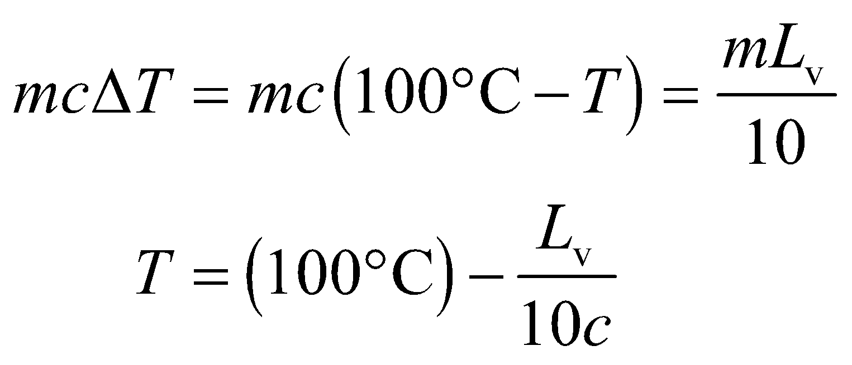

we can solve for the initial water temperature *T*.

**Evaluate** Inserting the specific heat and latent heat of vaporization into the expression above gives

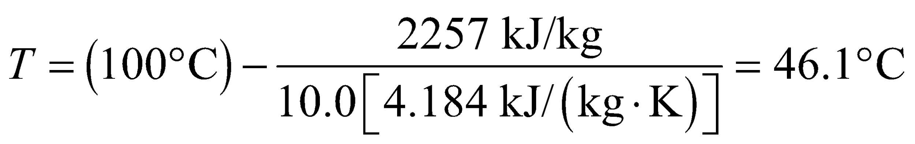

**Assess** Much more heat is required to boil the water away (i.e., change its phase from liquid to gas) than to raise its temperature from 46°C to 100°C.

**50. Interpret** The problem deals with both raising the temperature of water and vaporizing it, so both the specific heat and the latent heat of vaporization are involved.

**Develop** The energy needed to raise the temperature of water is given by Equation 16.3, 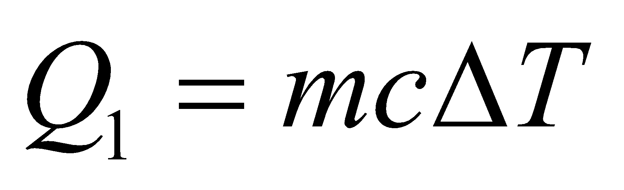. Equation 17.5, 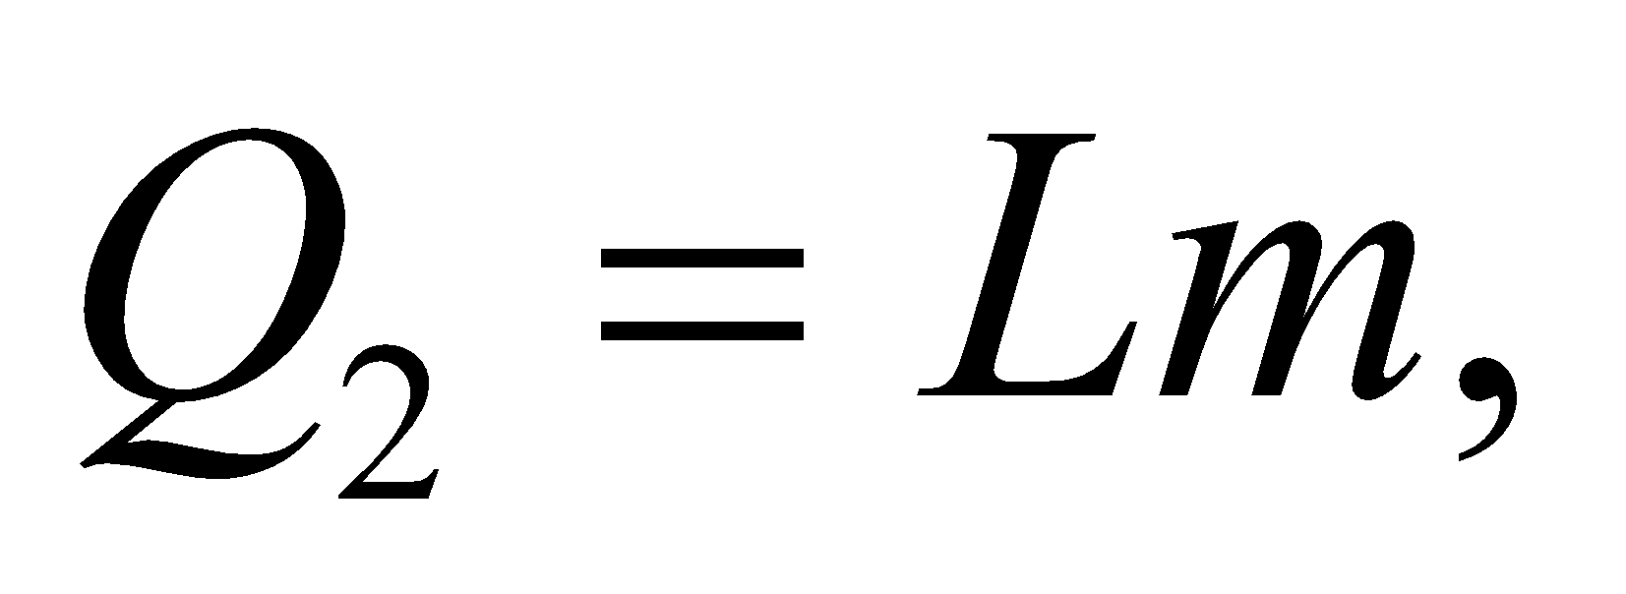 gives the energy for phase change. The total energy required is *Q*tot = *Q*1 + *Q*2. The mass of water involved can be calculated from the density of water; *m* = *ρV*, with *ρ* = 1.00 × 103 kg/m3. Given that the reactor provides energy at the rate *P* = 200 MW, the time t it takes to boil away the water is *t* = *Q*/*P*.

**Evaluate**  Thus, the amount of time *t* required is

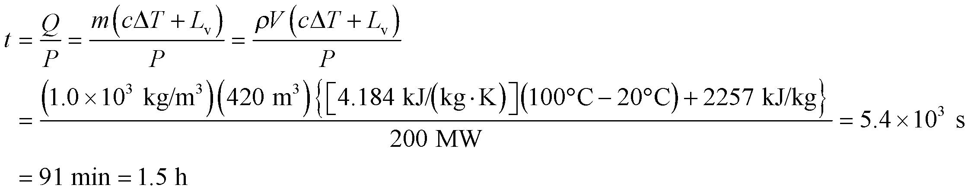

**Assess** Failsafe cooling systems are crucial for preventing nuclear meltdown.

**51.** **Interpret** This problem involves mixing ice with water and letting the mixture come to equilibrium. We are to calculate the minimum amount of ice needed so that the final equilibrium mixture is at 0°C. This calculation will involve the specific heat of water to calculate the energy required to raise the temperature of the ice to 0°C and the latent heat of fusion to calculate the energy required to melt the ice.

**Develop** For the final equilibrium temperature in Example 17.4 to be 0°C, the original 1.0 kg of water must lose at least 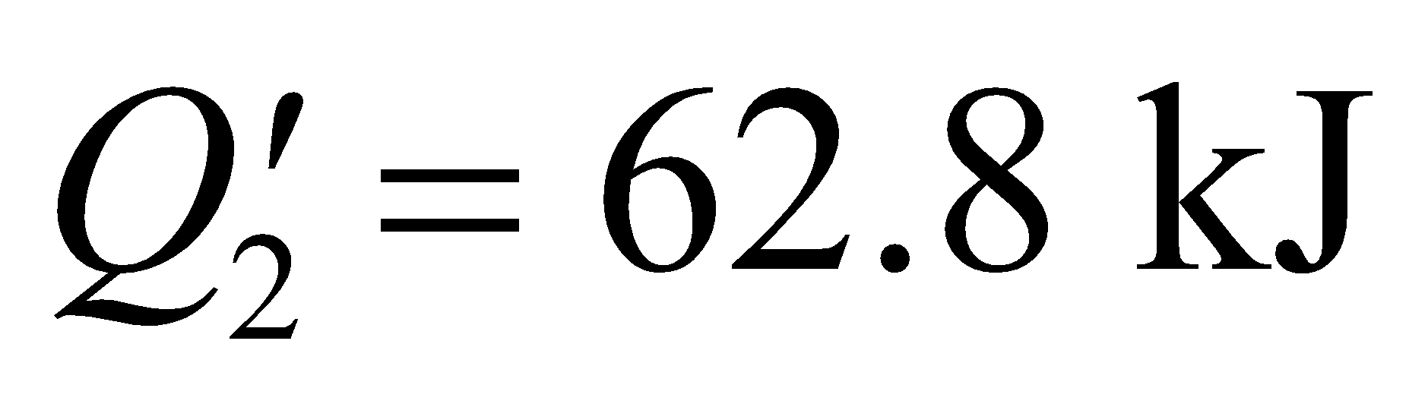 of heat energy (see Example 17.4). It could lose more energy, if some or all of it froze, but this would clearly require a greater amount of ice. The amount of ice needed to absorb this thermal energy and just melt, without exceeding 0°C, is given by summing the energy needed to raise its temperature to zero (*Q*1 = *mcΔT*, where *ΔT* = 10°C) and the energy needed to melt the ice (*Q*2 = *L*v*m*). Equating *Q*′2 with *Q*1 + *Q*2 gives

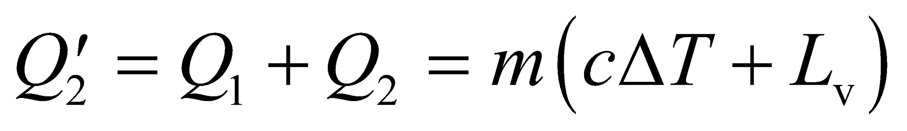

which we can solve for *m*.

**Evaluate** Solving for *m* gives

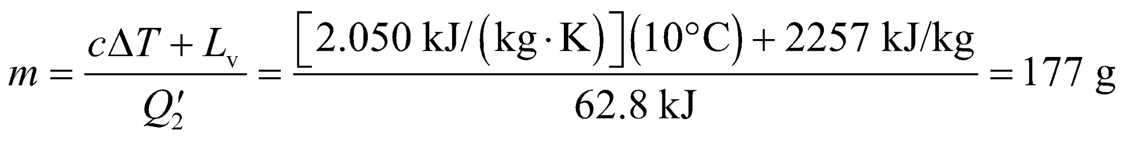

**Assess** The amount of original ice that could produce a final temperature of 0°C and freeze all the original water is

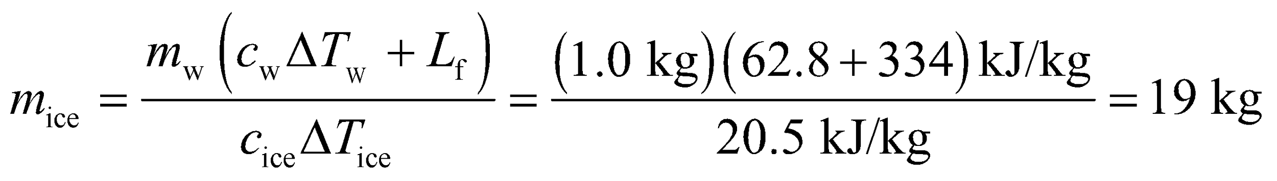

The amount of ice that would produce a final temperature of 0°C with none of the ice melted and none of the water frozen is

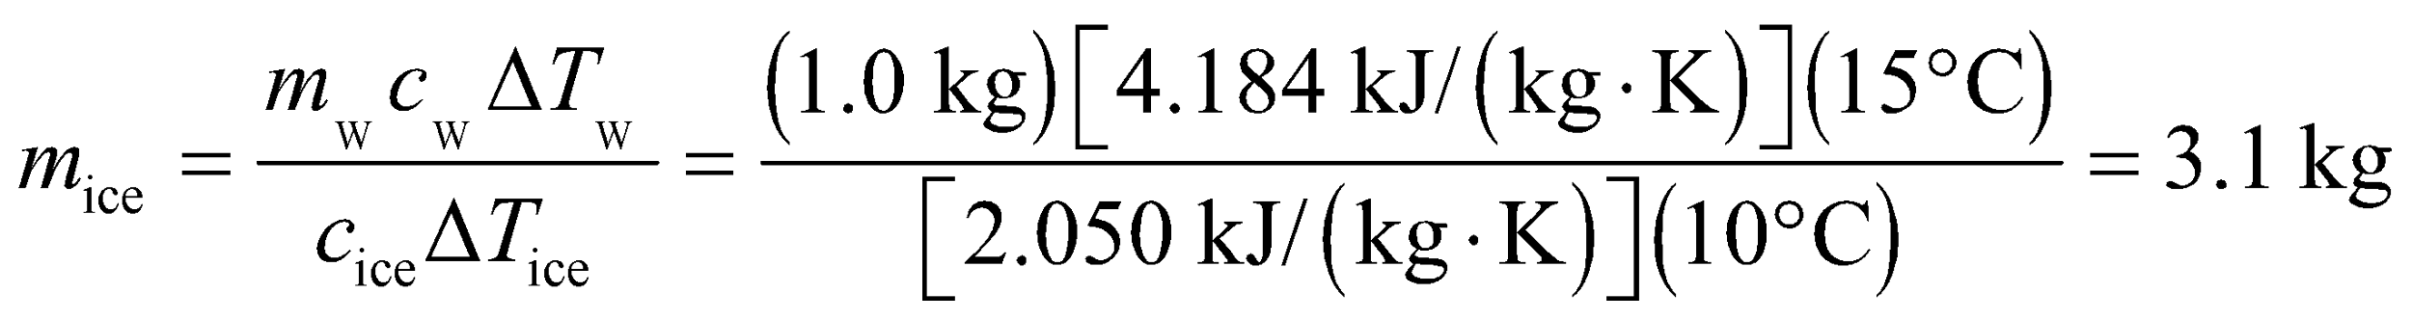

For 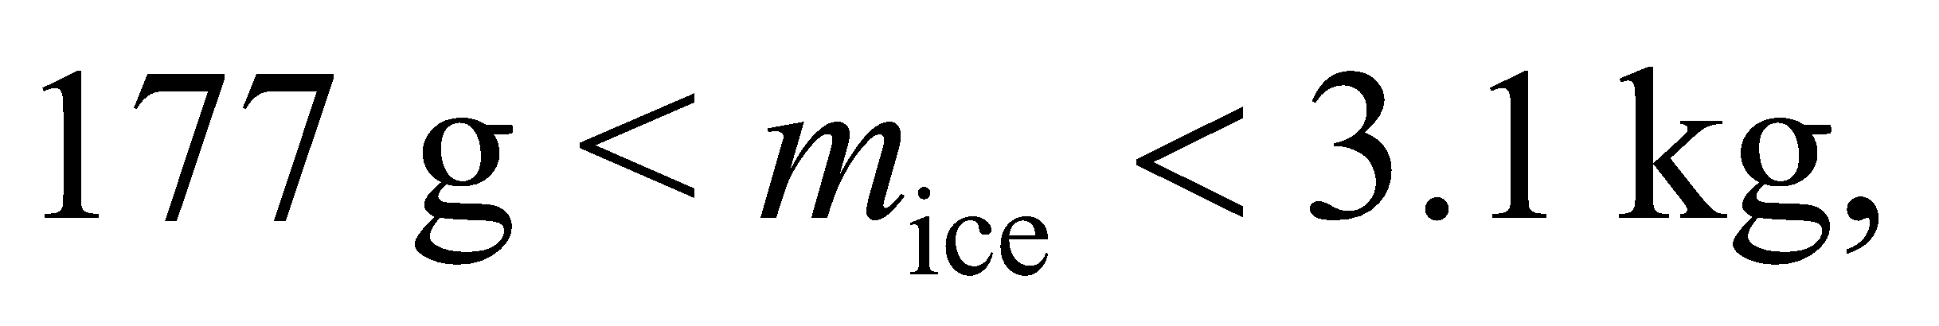 some of the original ice melts, and for 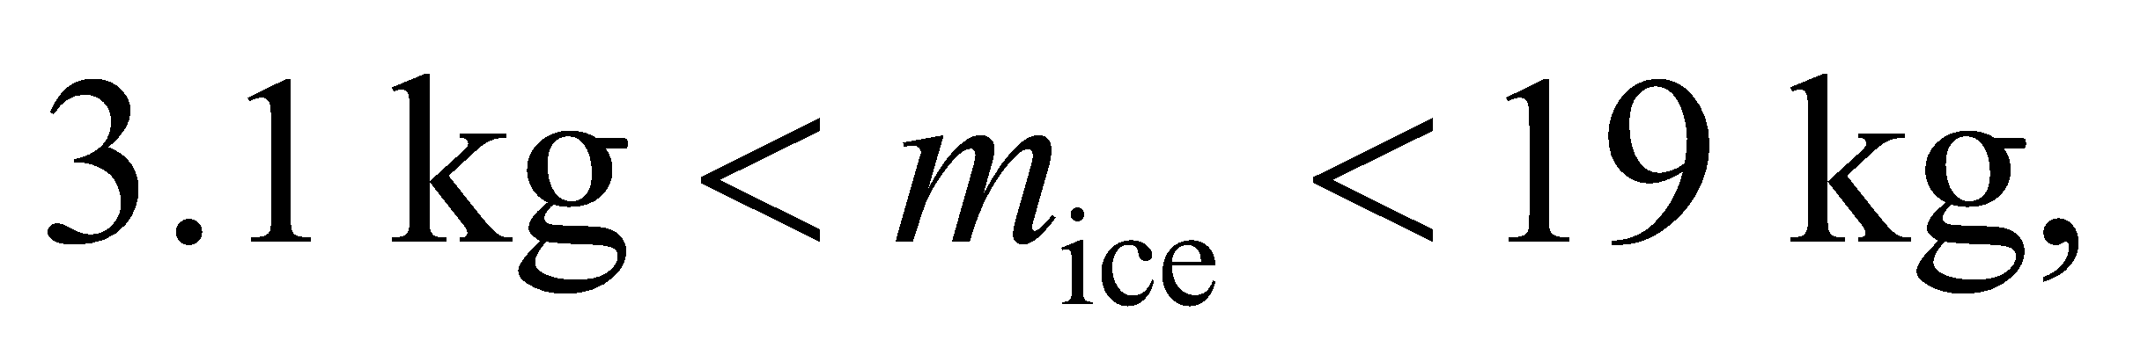 some of the original water freezes.

**52. Interpret** Our system consists of both ice and warm water. We want to know how much ice at 0°C is needed to bring the water to 0°C. This process involves cooling the water (i.e., using the specific heat of water) and melting the ice (i.e., using the latent heat of fusion of ice).

**Develop** Assume that the only heat transfer is between the water and the ice. To cool the water to 0°C, the amount of heat that must be extracted is (using Equation 16.3)



The amount of heat used to melt ice at 0°C is, from Equation 17.3, 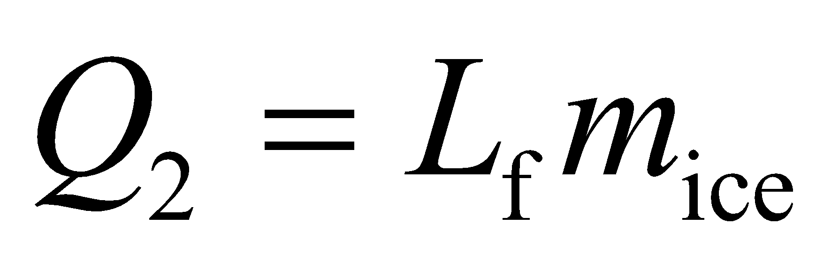. For the ice to just melt and not increase in temperature, we must have *Q*1 = *Q*2.

**Evaluate** To bring the water temperature down to 0°C, the minimum mass of ice needed is thus

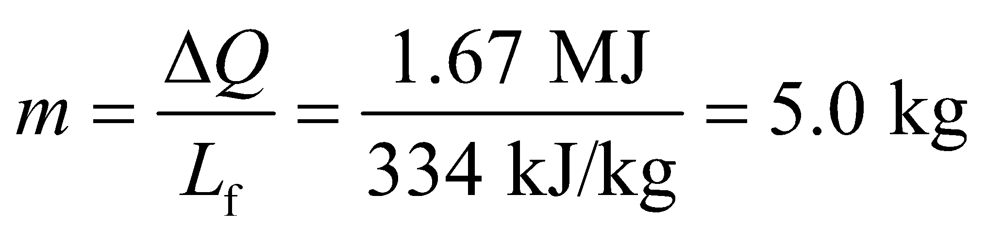

**Assess** Note that the punch would be diluted with 5.0 kg of melt-water. To avoid this dilution, you could use less ice at a temperature below 0°C.

**53.** **Interpret** This problem involves mixing an equal mass of ice and water and letting the mixture reach equilibrium. We are to calculate at what temperature the water must be if the final mixture is to contain equal amounts of ice and water.

**Develop** Assume that all the heat gained by the ice was lost by the water, with no heat transfer to the container or the surroundings. An equilibrium mixture of ice and water (at atmospheric pressure) must be at 0°C, and if the masses of ice and water start out and remain equal, there is no net melting or freezing. Thus any energy spent raising the temperature of the ice and melting it must be balanced by energy lost by the water as its temperature lowers and it freezes. These energies are given by Equations 16.3 (for the temperature change), *Q*1 = *mc* and (for the melting or freezing) *Q*2 = *L*f*m*. We can therefore sum these energies for both ice and water and equate the result, which gives

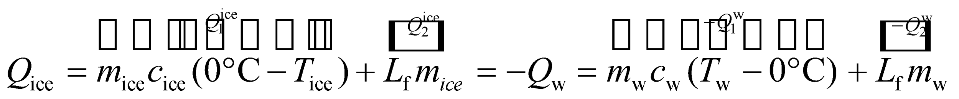

where *T*ice = −10°C. Given that *m*ice = *m*w, we can solve for the water temperature *T*w.

**Evaluate** Solving for *T*W and inserting the given quantities gives

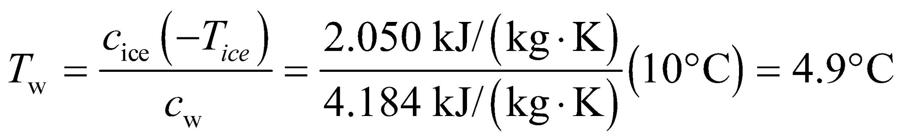

**Assess** Because any thermal energy spent melting the ice is balanced by freezing the water, only the specific heats of water and ice come into play.

**54. Interpret** The evaporation of sweat removes heat from the body. We're asked to find how much heat is removed from a marathon runner during a race.

**Develop** It takes 4.2 MJ to evaporate a kg of water, and we're told that a marathoner typically sweats 3 L per hour. We assume that all of this sweat is evaporated and that all of the needed heat comes from the marathoner's body.

**Evaluate** During a 3-hour marathon, the amount of heat expelled due to sweating is:

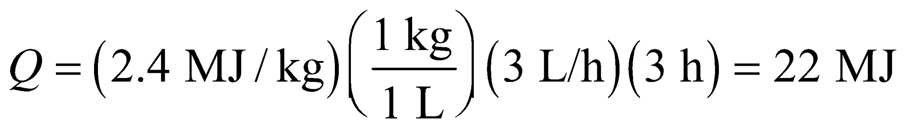

**Assess** This is equivalent to 5300 kilocalories. However, running for 3 hours should only burn about 2500 kilocalories. That would mean the marathoner is losing more than twice the amount of energy he/she is consuming. That wouldn't make sense, so we might assume that some of the sweat falls off before evaporating.

**55.** **Interpret** This problem involves the latent heat of fusion of water, which is the energy required per unit mass to change ice to water (or vice-versa, but with the opposite sign). We can use this concept to find the energy required to melt 20 kg of ice in 6 min, and from there find the power.

**Develop** If the melting occurs at atmospheric pressure and if the ice is at 0°C, the energy required to melt the ice is given by Equation 17.3, *Q* = *L*f*m*, where *L*f is the latent heat of fusion, which is given in Table 17.1. To melt the ice in a time *t* = 6 min would require a power *P* = *Q*/*t*.

**Evaluate**  The power required is

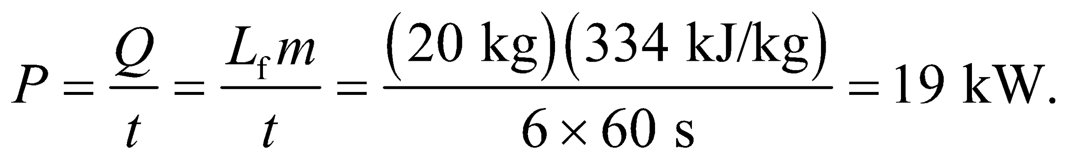

**Assess**  This is equivalent to the power needed to light 190 100-W bulbs.

**56. Interpret** This problem involves both a temperature rise and a phase change, so both the specific heat and the latent heat (of vaporization of water) will enter into the calculation. The object of interest is the water in the microwave oven.

**Develop** The energy needed to raise the temperature of the water is given by Equation 16.3, *Q* = *mcΔT*. Equation 17.5, *Q* = *L*v*m*, gives the heat needed to vaporize water. In 20 minutes, the total heat energy is transferred to the water (if we ignore energy absorbed by a container or lost to the surroundings) is



Out of this total energy, the energy consumed in raising the water’s temperature to the normal boiling point is



and the difference 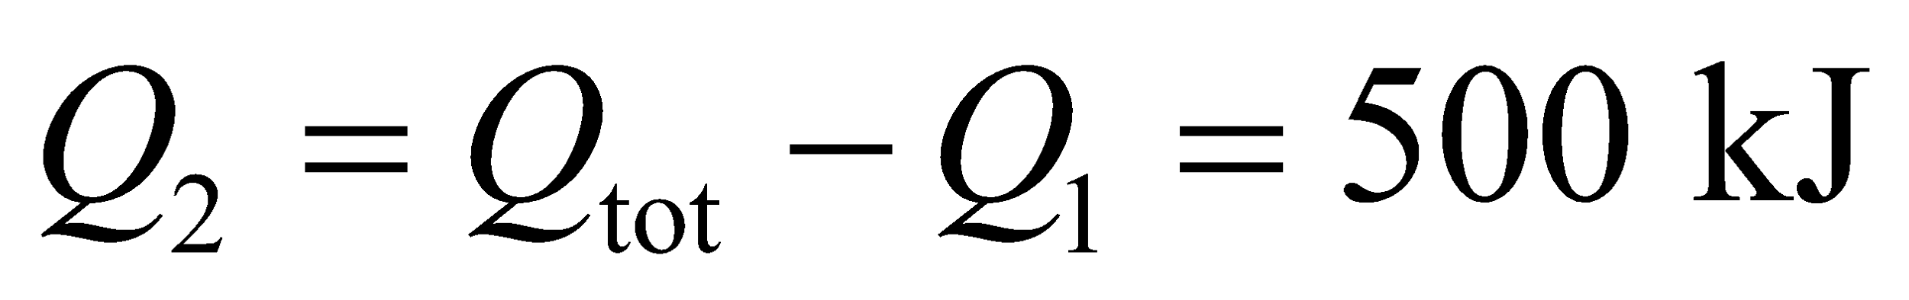 is left to vaporize some of the water. The amount of water vaporized can be found by using Equation 17.5, *Q*2 = *L*v*m*, where *L*v is the latent heat of vaporization from Table 17.1.

**Evaluate** Using Equation 17.5, the mass *m*v of water vaporized is

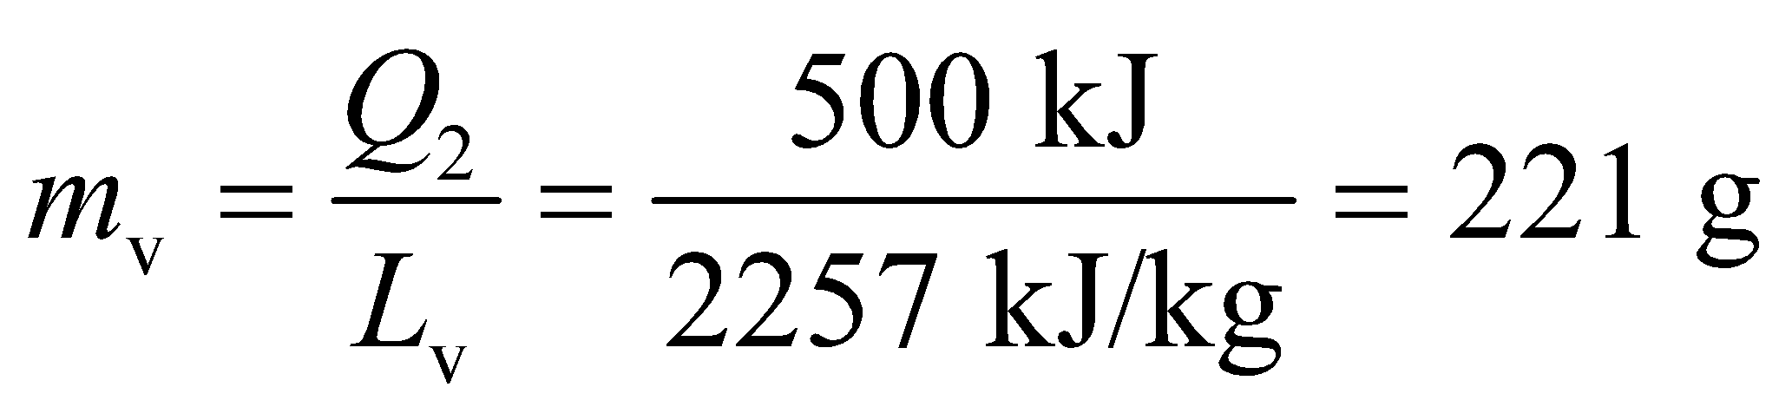

Therefore, only 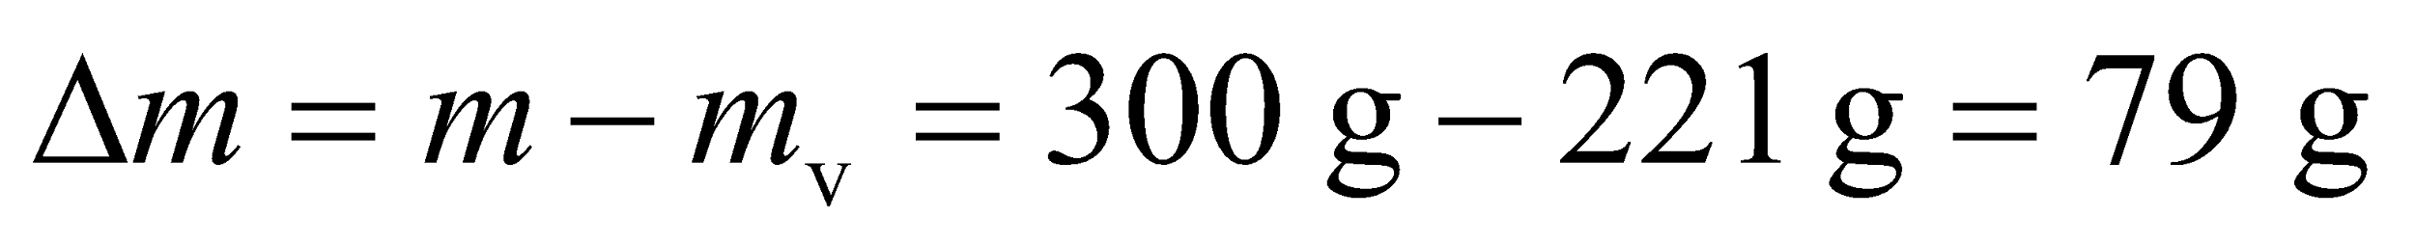 of boiling water (or less than 3 oz) is all that remains (to two significant figures).

**Assess** The excess heat from the microwave oven vaporizes the water. This is precisely what causes your food to dry out when you heat it in the microwave oven for too long.

**57.** **Interpret** This problem involves a change in temperature and phase (liquid to gas) for water, so both the specific heat and the latent heat of vaporization come into play. We use these to calculate how long it takes, given a constant input power of 200 MW, to boil away half of the water.

**Develop** The reactor must first raise the temperature of the water to the boiling point, which requires an energy



(Equation 16.3), where *ΔT* = 100°C − 10°C = 90 K. Next, half the water must be boiled off, which requires an energy

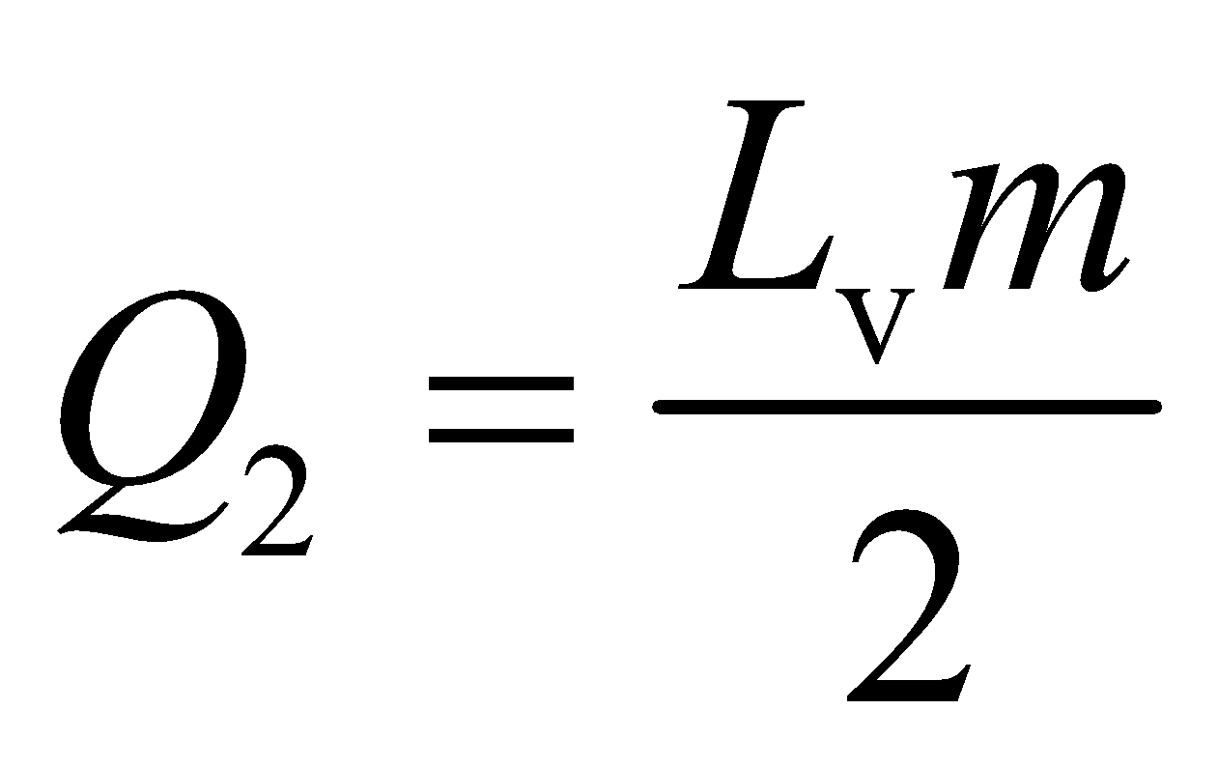

(Equation 17.5), where *L*v is the latent heat of vaporization (see Table 17.1). The total energy required is the sum of these two, so at the given power *P*, it will take a time *t* = (*Q*1 + *Q*2)/*P* to boil off half the water.

**Evaluate** Inserting the given quantities, we find



**Assess** For this solution, we have assumed that the water is heated uniformly, which may or may not be true depending on the geometry of the situation. If the water does not circulate well, it is possible that half the water boils off before the entire mass of water is heated to 100°C. In this case, the time would be less than we found above, which is therefore the maximum time it can take for half the water to boil off.

**58. Interpret** This problem involves heat transfer between ice and water. Some of the ice may melt and some of the water may freeze, which will involve the latent heat of fusion of water. In addition, the ice and the water will change temperature, so the specific heats of ice and water are involved.

**Develop** Assume that all the heat lost by the water is gained by the ice. The temperature of the water drops and that of the ice rises. If either reaches 0°C, a change of phase occurs, freezing or melting, depending on which reaches 0°C first. To cool to 0°C, the amount of heat the water would lose is



On the other hand, to warm the ice to 0°C, it would gain an energy



Evidently, the water reaches 0°C first, so we will assume it freezes and the ice simply warms up. Because all the energy lost by the water in cooling and then changing phase to ice is assumed to be gained by the ice, we must have *Q*i = *Q*w,1 + *Q*w,2, where *Q*w,2 = *L*f*m* (Equation 17.3) is the energy is takes to freeze the water. We can therefore solve for the mass *m* of water that is changed to ice.

**Evaluate**  Therefore, the mass of water *m* that freezes is

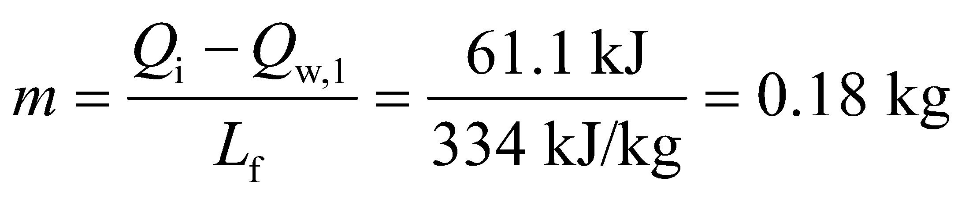

The final mixture is thus at 0°C and contains 1.183 kg of ice and 1.0 kg − 0.18 kg = 0.82 kg of water.

**Assess** The equilibrium temperature in this case is 0°C where water and ice coexist.

**59.** **Interpret** This problem involves the linear thermal expansion of steel. We are to find the temperature at which the hole in the steel plate will become large enough to allow the marble to pass through it.

**Develop** The diameter of the hole expands with the coefficient of linear expansion of steel. Using Equation 17.7

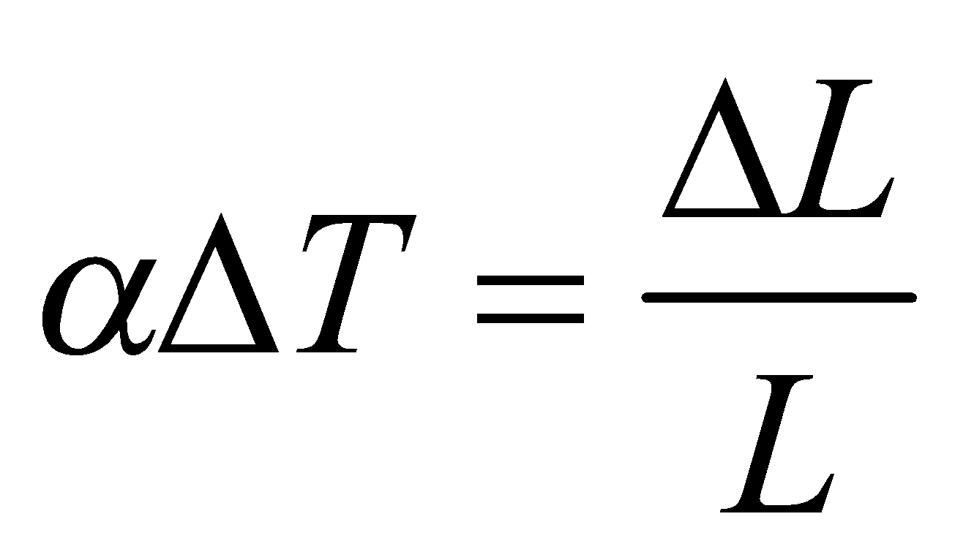

with *L* = 1.000, *L*0 = 0.997, we can solve for *ΔT*.

**Evaluate** Solving for T and inserting the given quantities gives

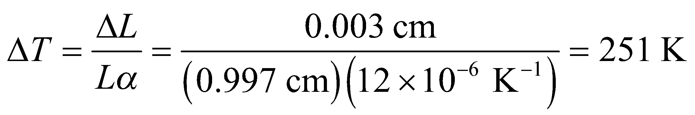

so the plate must be heated to 251 K above room temperature.

**Assess** Note that we have treated the problem as if we were considering a steel disk of initial diameter 0.997 cm, instead of a hole in a steel plate. The treatment is valid because such a hole must expand at the same rate as the disk because if we put the disk in the hole, it must fit at all temperatures.

**60. Interpret** This problem is about thermal expansion. Since it involves volume, the relevant quantity is the coefficient of volume expansion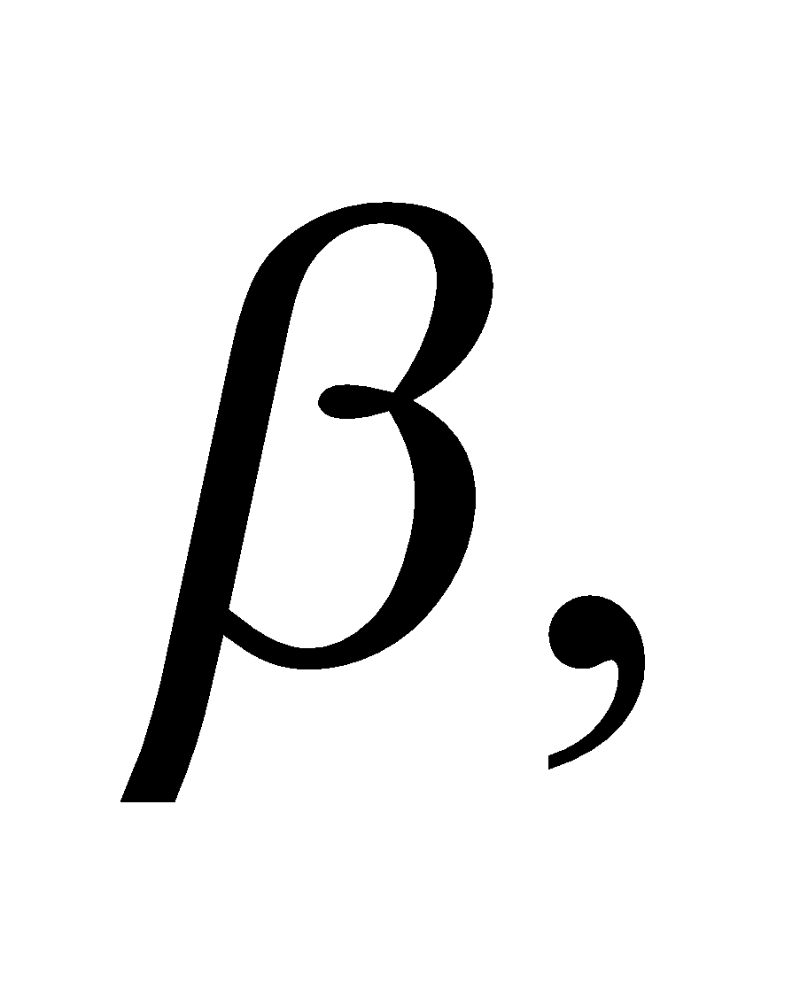whose value can be used to identify the substance in question.

**Develop** As in Example 17.5, we assume that the thermal expansion of the cylinder is negligible compared to that of the liquid. Then the entire change in volume is due to the liquid. The amount of volume change can be calculated from Equation 17.6,

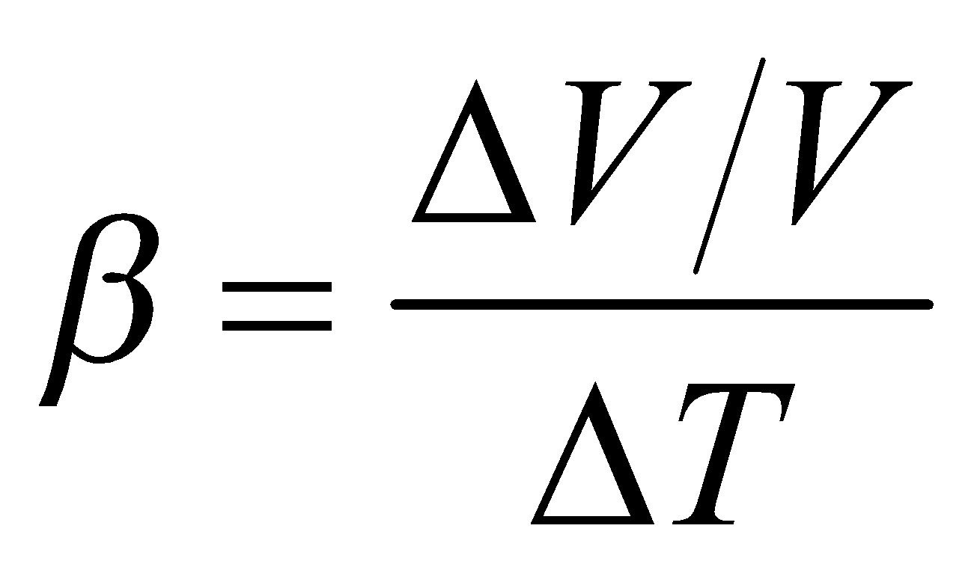

**Evaluate** Substituting the values given in the problem statement, we have

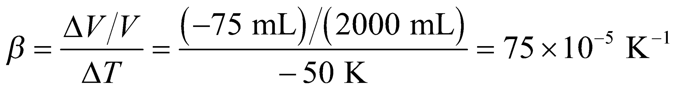

From Table 17.2, we see that this matches the coefficient for ethyl alcohol.

**Assess** The thermal expansion coefficient for ethyl alcohol is much greater than the material with which the cylinder is made, so our assumption is justified.

**61.** **Interpret** This problem involves the linear expansion of Pyrex and steel. We are to find the temperature at which the diameter of the Pyrex tube is 2 μm greater than the diameter of the steel ball.

**Develop** Since the coefficient of linear expansion of steel is greater than that of Pyrex glass, the unit must be cooled to provide clearance. The difference in the contraction of steel and Pyrex must be twice the given clearance on one side, so



which we can solve for *ΔT* (find the values for *α*steel and *α*pyrex in Table 17.2).

**Evaluate** Solving for *ΔT* and inserting the known quantities gives

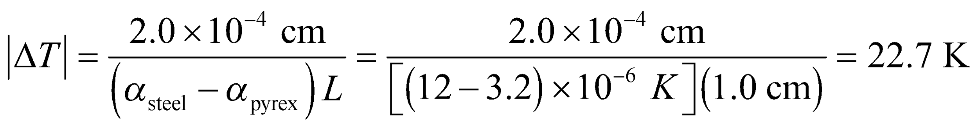

Since we must cool the system by this amount, the final temperature of the system will be T = 330 K − 23 K =   
307 K.

**Assess** Reversing this process is a good technique to create tightly fitted parts.

**62. Interpret** You're in charge of specifying the size of an expansion tank for a car's fuel system. This will involve calculating the thermal expansion of gasoline.

**Develop** The amount that a material expands due to an increase in temperature is given in Equation 17. 6: 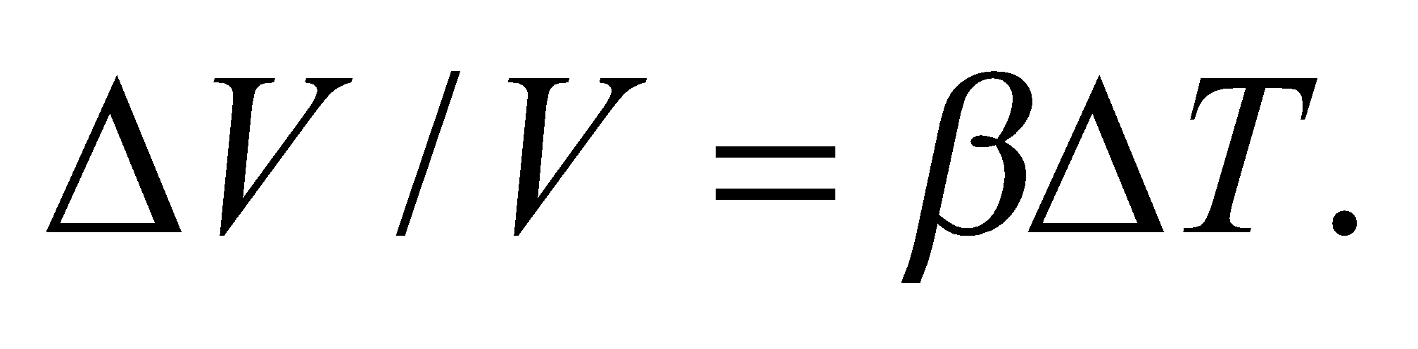For gasoline, the coefficient of volume expansion is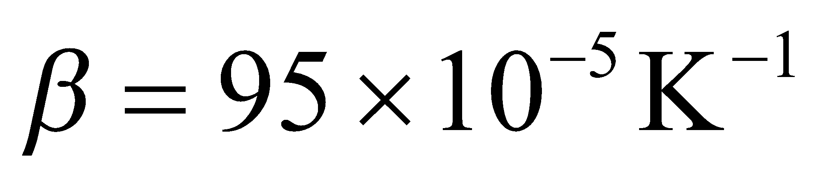 from Table 17.2.

**Evaluate** The car you are working on has a gas tank with a volume of 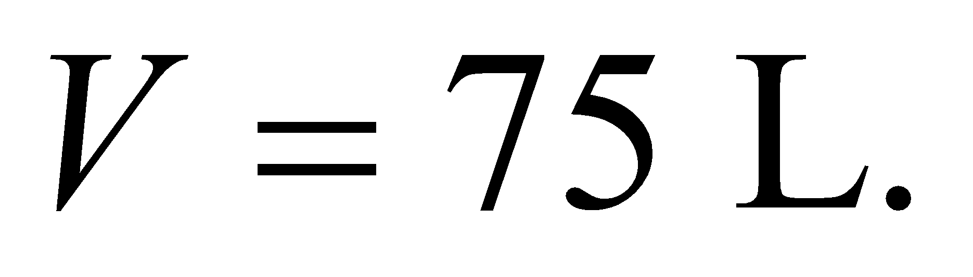You assume the tank is filled initially with gasoline at 10°C. Once the gasoline comes into equilibrium with the outside temperature of 35°C, the volume will have expanded by



Your expansion tank needs to be at least this big.

**Assess** The expansion tank size is a little over 2% of the main tank's size, which seems reasonable. Notice that gasoline has the highest coefficient of volume expansion of all the liquids in Table 17.2.

**63.** **Interpret** This problem involves the linear expansion of a rod as it is heated, so the coefficient of linear expansion will come into play. We are asked to calculate the height d of the apex of the triangle formed by the rod that cracks upon expanding because it is fixed between two immovable walls.

**Develop** If the two straight pieces in Fig. 17.11 are of equal length, the Pythagorean Theorem gives

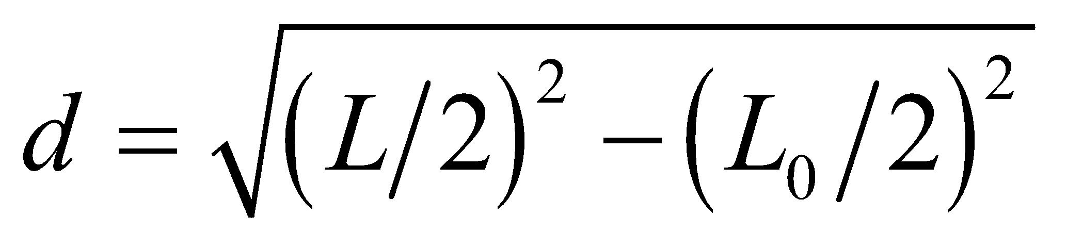

where 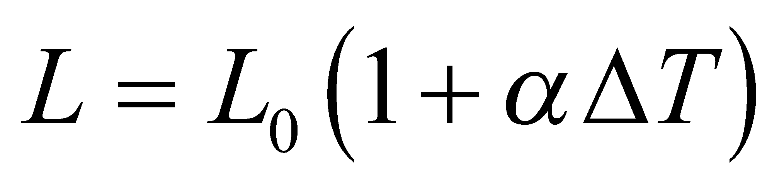 is the total expanded length of the rod.

**Evaluate** Inserting the expression for L gives

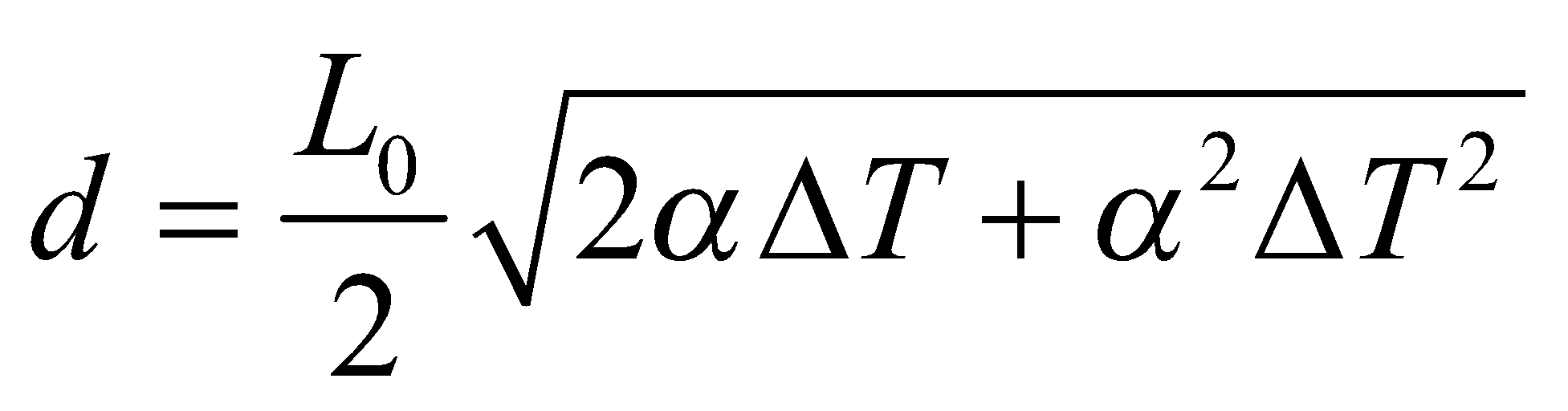

**Assess** Checking the limits, we see that for 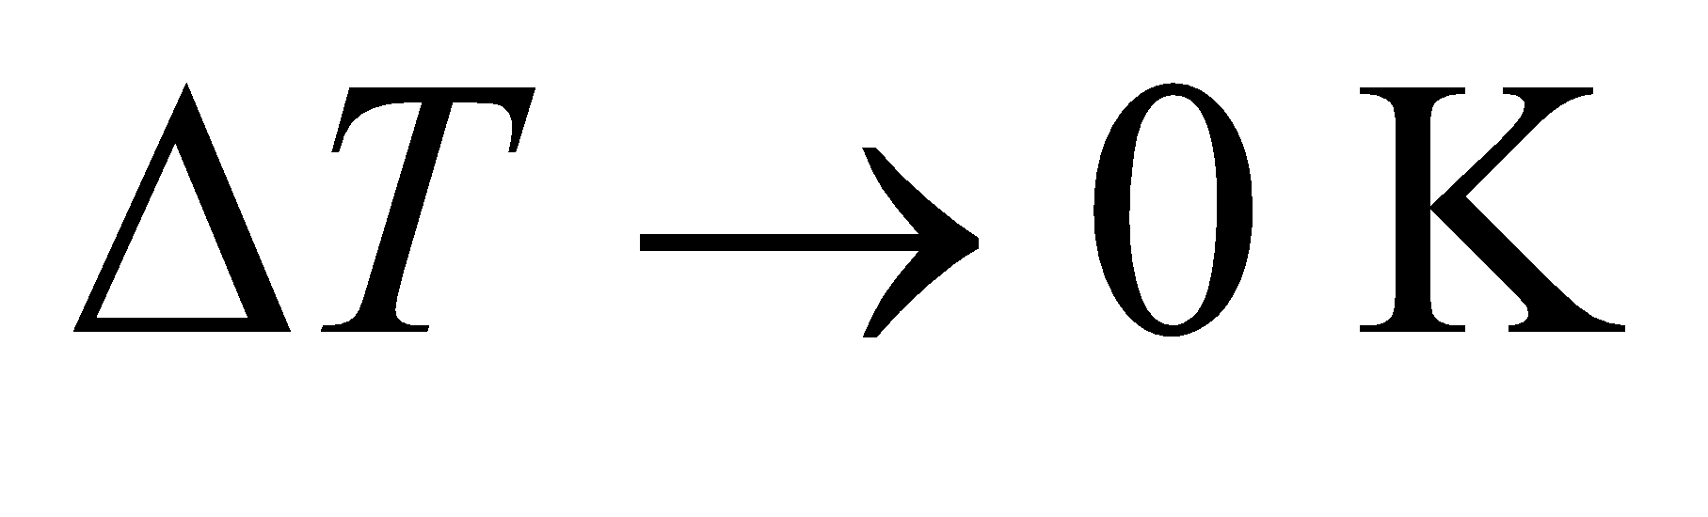, 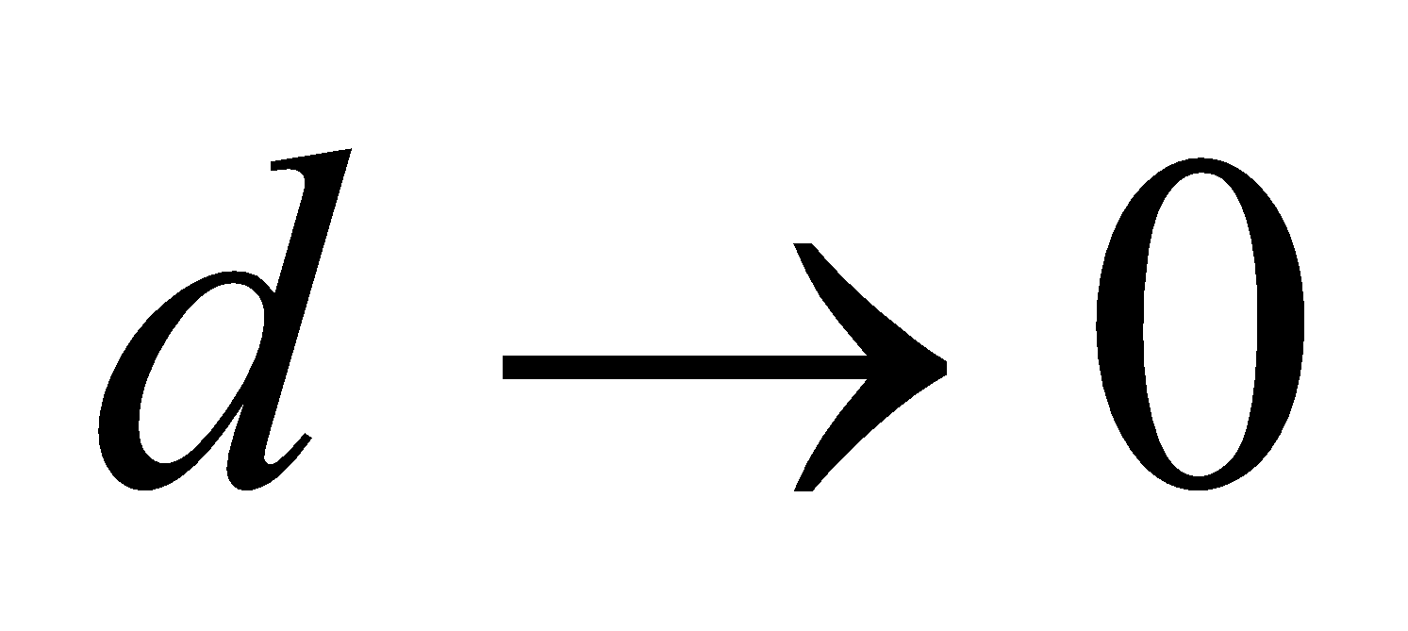, as expected.

**64. Interpret** You have to quickly calculate how much ice to buy to keep your parent's refrigerator from warming up during a temporary black out.

**Develop** For simplicity, let's imagine that you will be placing bags of ice along the interior walls of the refrigerator, as shown in the figure below. In this way, the heat from the outside room will flow directly into the ice at a rate of 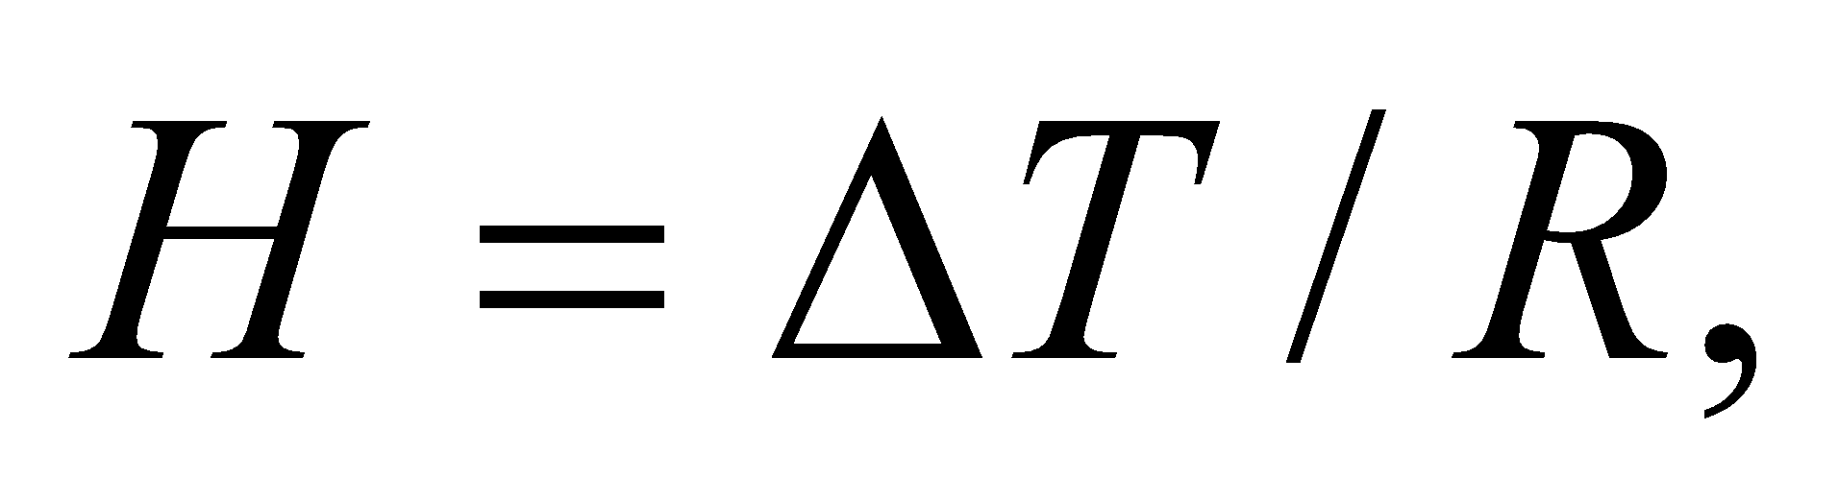 where 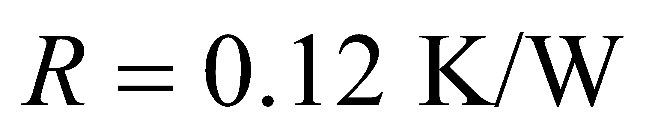is the thermal resistance of the fridge walls, and 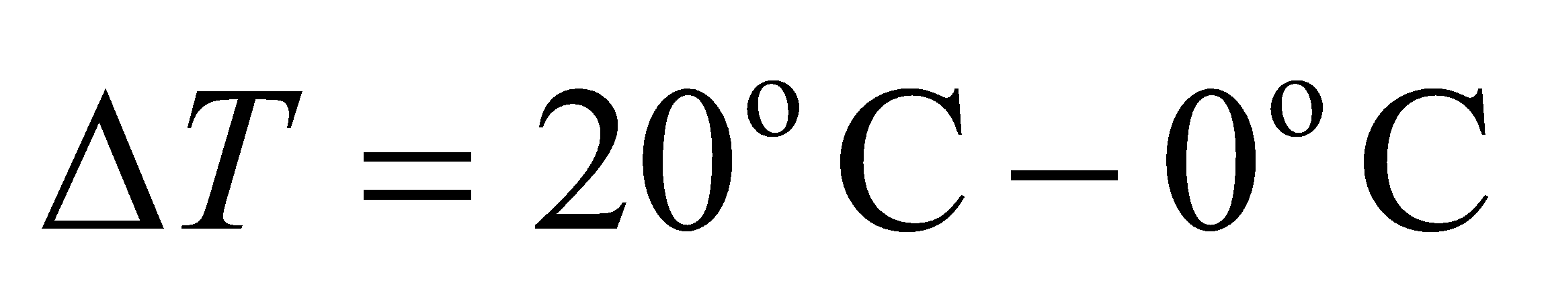 is the temperature between the room and the ice.



The heat will melt the ice in 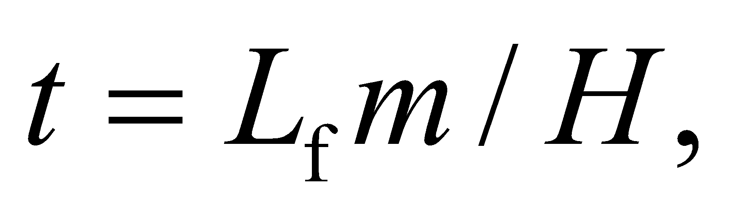so you want to buy enough ice that this time equals the 15 hours it supposedly will take to return the electric power to your home.

**Evaluate** Solving for the required mass of ice gives

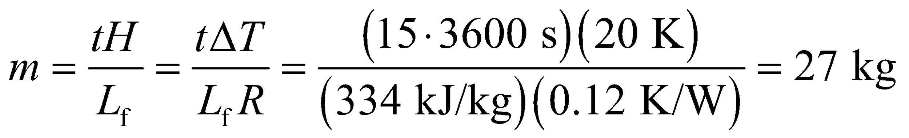

**Assess** You might have some difficulty stuffing 27 1-kg bags of ice in the fridge. Note that we haven't taken into account the fact that the fridge interior will not start out at 0°C, so some extra heat will flow between your food and the ice.

**65.** **Interpret** This problem involves the temperature change and phase change (solid-liquid) of Glauber salt. Given its thermal parameters, we are to calculate how long the salt takes to cool to 60°F, and how long the salt takes to solidify at 90°F.

**Develop** In cooling from 95°F to 90°F, the liquid expels a heat *Q*1 = *mc*liq*ΔT*liq (Equation 16.3). Changing phase at 90°F from liquid to solid expels a further amount *Q*2 = *L*f*m* (Equation 17.5). Finally, cooling the solid salt from 90°F to 60°F expels the heat *Q*3 = *mc*sol*ΔT*sol. Thus, the total heat expelled is



Given that the house loses heat at a rate of *P* = 20,000 Btu/h, the time *t* it takes to cool to 60°F is *t* = *Q*/*P*.

**Evaluate** (a) Inserting the given quantities gives

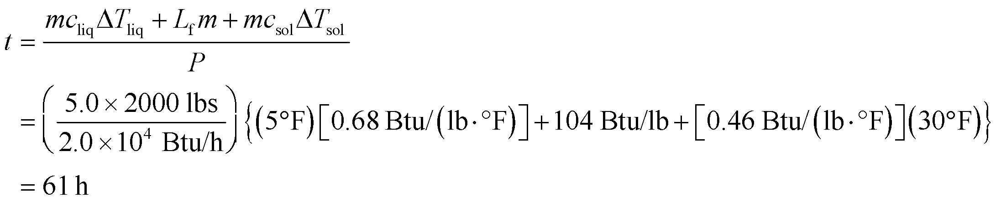

(b) The time spent during just the solidification at 90°F is

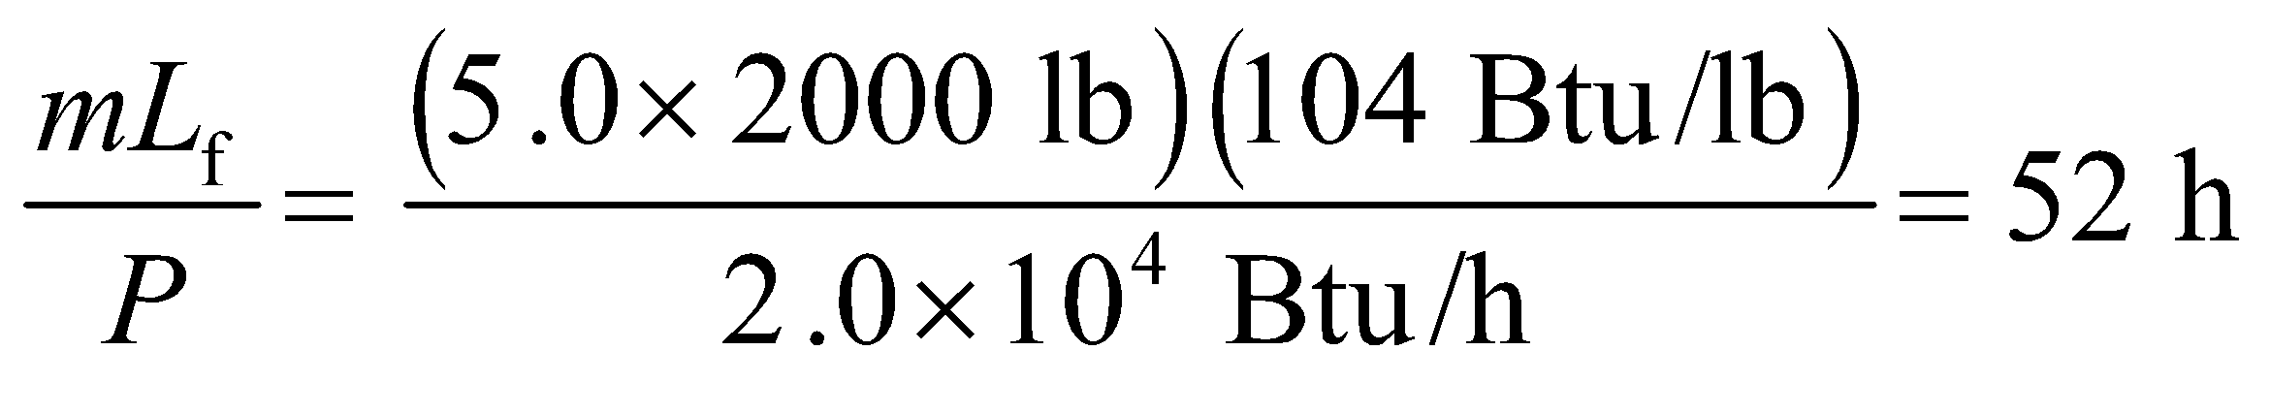

**Assess** Most of the time the salt is at 90° because the latent heat of fusion is much greater than the heat liberated by temperature change.

**66. Interpret**For this problem, we are to prove that the coefficient of volume expansion of an ideal gas at constant pressure is the inverse temperature in the Kelvin scale.

**Develop** As mentioned in the text following Equation 17.6, the coefficient of volume expansion *β* is defined in general as

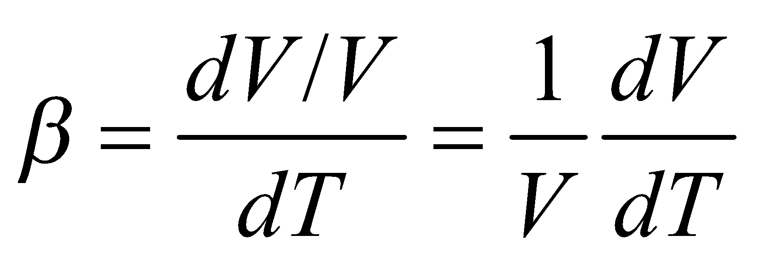

The ideal-gas law *pV* = *NkT* is given by Equation 17.1. The two equations can be combined to give the proof.

**Evaluate** For an ideal gas at constant pressure, *V* = *NkT*/*p*. This gives *dV*/*dT* = *nK*/*p*. Substituting the equation into the above expression for *β* gives

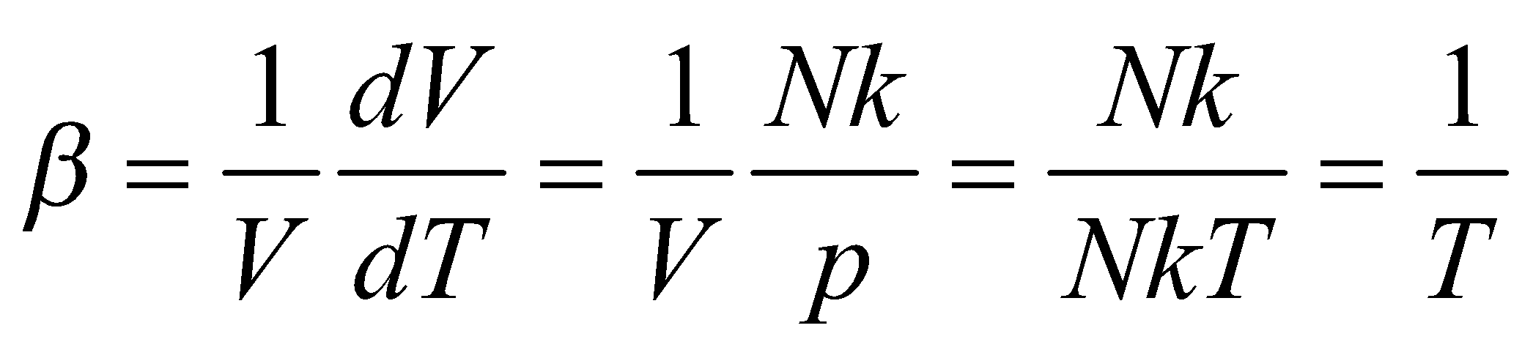

**Assess** The unit of *β* are K−1, which is the inverse temperature in the Kelvin scale.

**67.** **Interpret** For this problem, we are to show at what temperature between 0°C and 20°C water has its greatest density. We are given the expression for the coefficient of volume expansion as a function of temperature.

**Develop** We do not actually need to differentiate the density or the volume [*ρ*(*t*) = constant mass/*V*(*T*)] because Equation 17.6 shows that *dV*/*dT* = *βV* = 0 when *β*(*T*) = 0. Thus, the maximum density (or minimum volume) occurs for a temperature satisfying 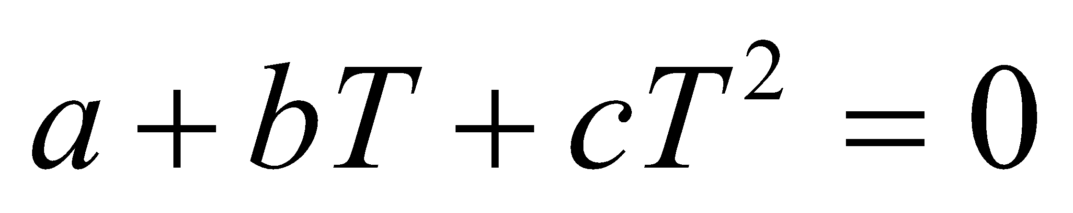, which allows us to solve for *T*.

**Evaluate** The quadratic formula gives

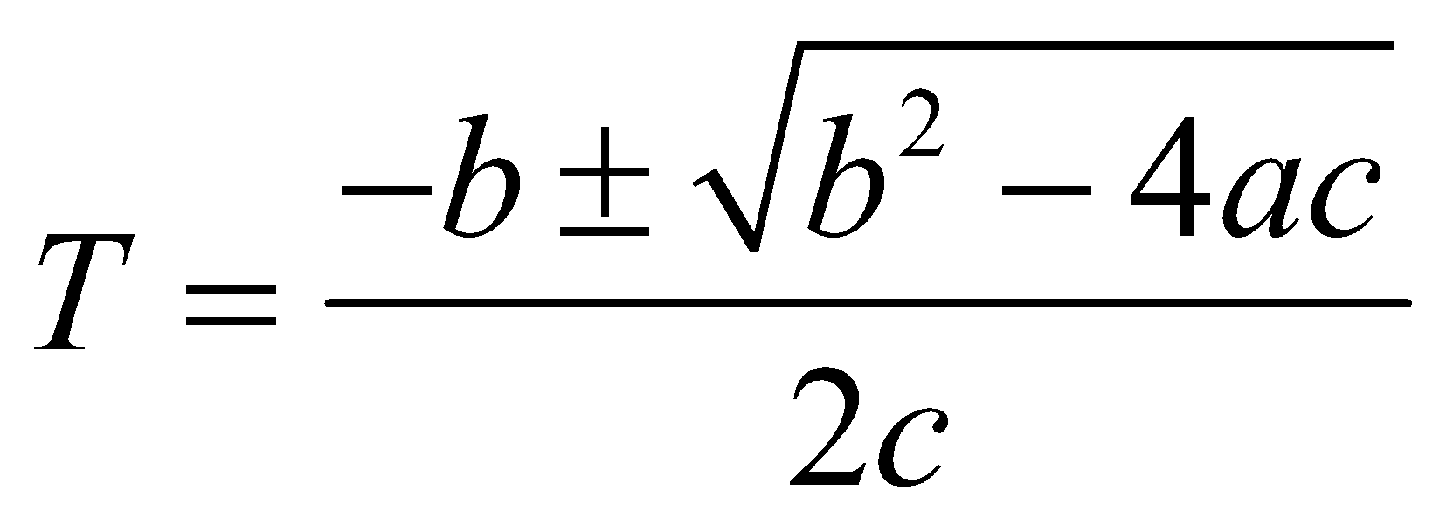

or, since both *a* and *c* are negative,

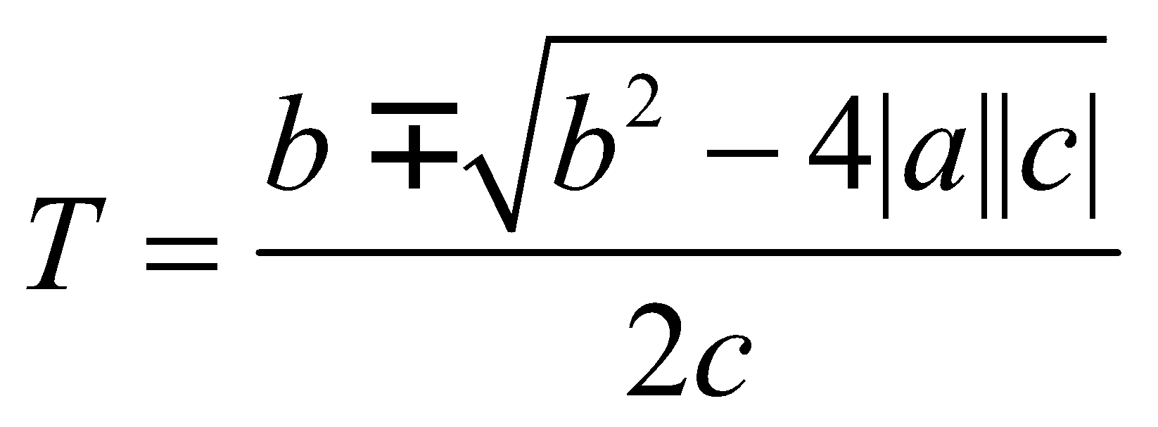

Canceling a factor of 10−5 from the given coefficients, we find

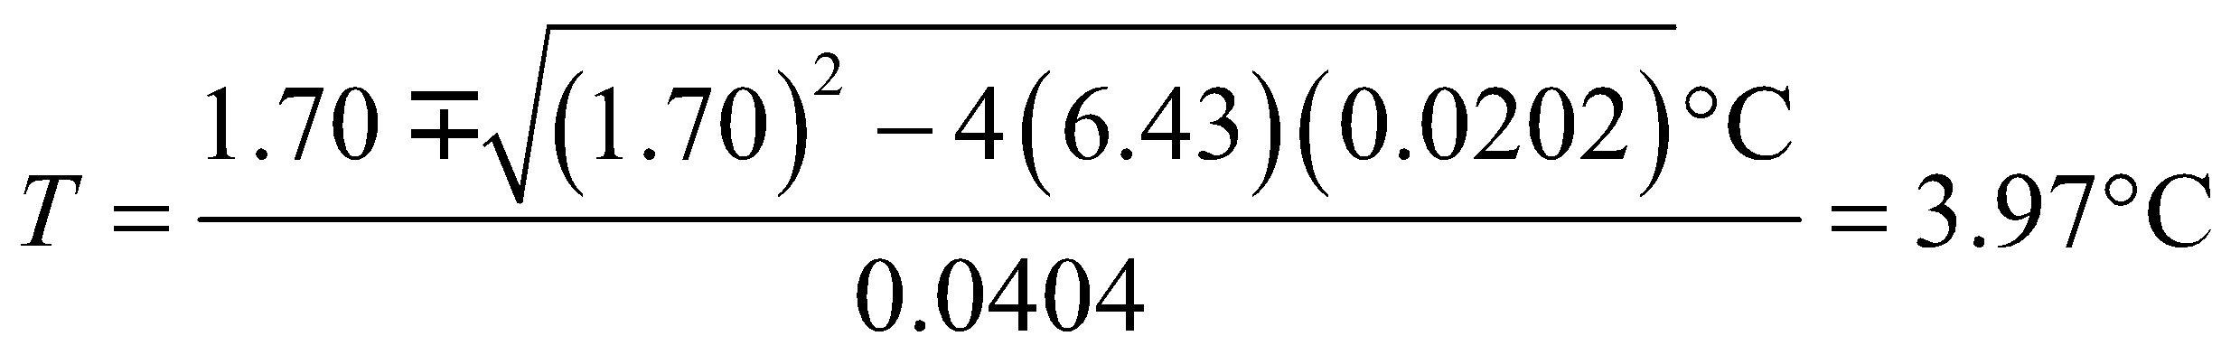

**Assess** The second root, 80.2°C, can be discarded because it is outside the range of validity, 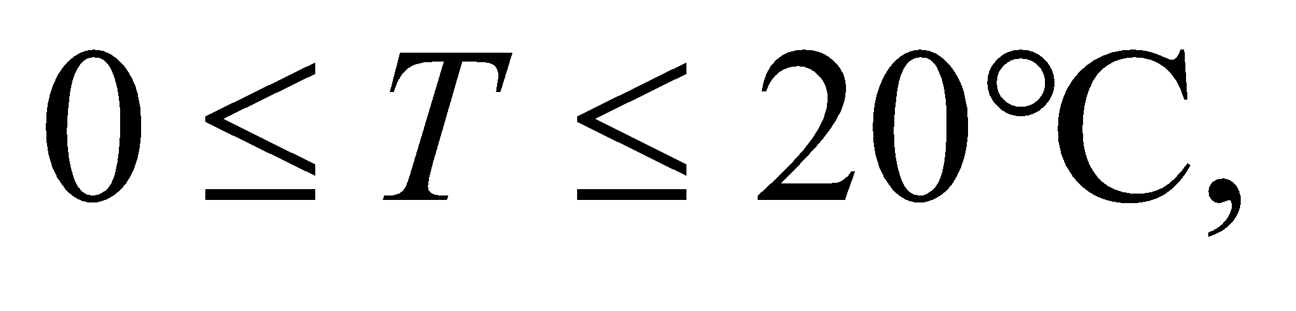 of the original function *β*(*T*). Thus, the maximum density of water occurs at a temperature close to 4°C. That this represents a minimum volume can be verified by plotting *V*(*T*), or from the second derivative,

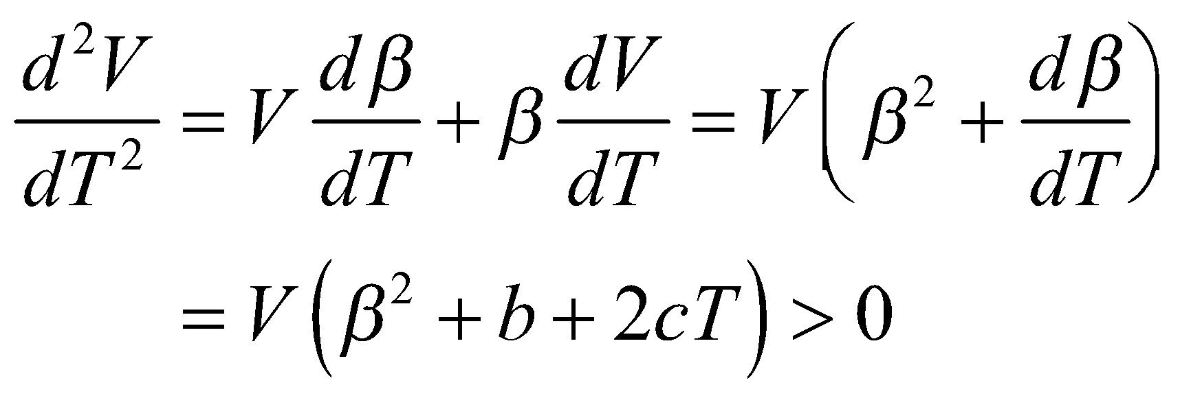

for *T* = 3.97°C.

**68. Interpret** The problem involves finding the volume of water at a given temperature, given its coefficient of volume expansion as a function of temperature.

**Develop** In Problem 68, we learned that water’s coefficient of volume expansion in the temperature   
range from 0°C to about 20°C is given approximately by 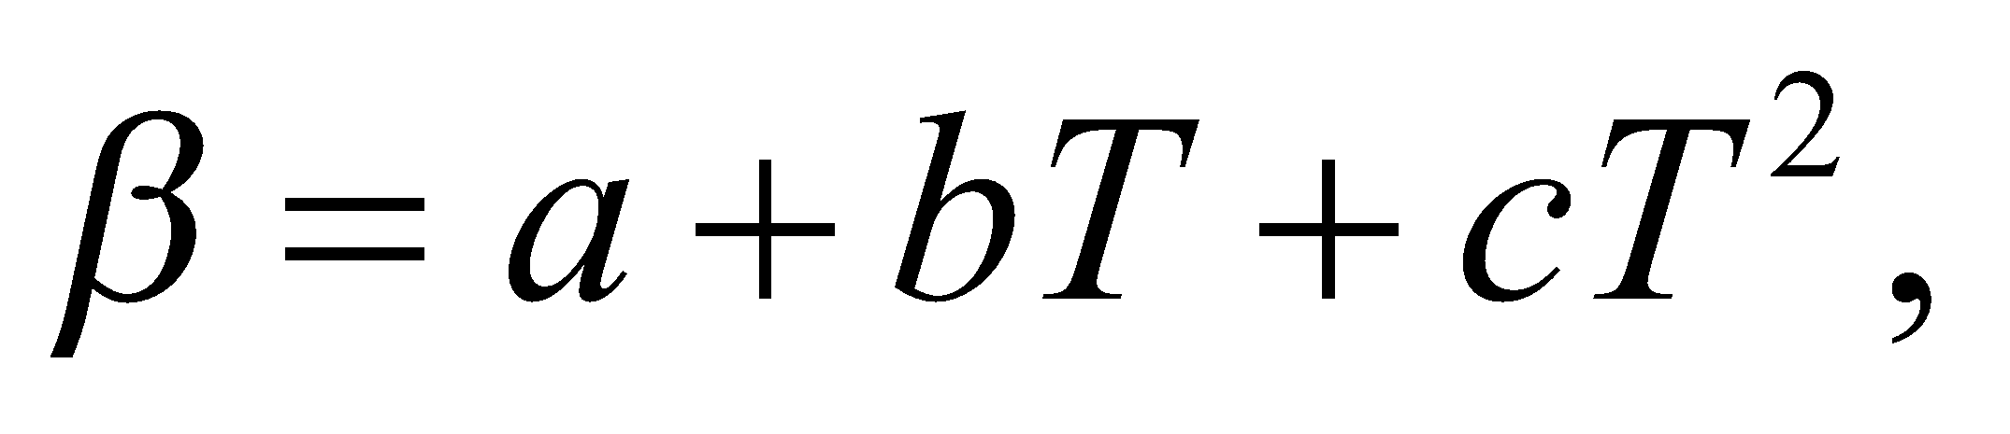 where *T* is in Celsius and 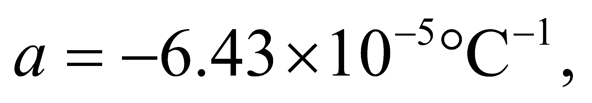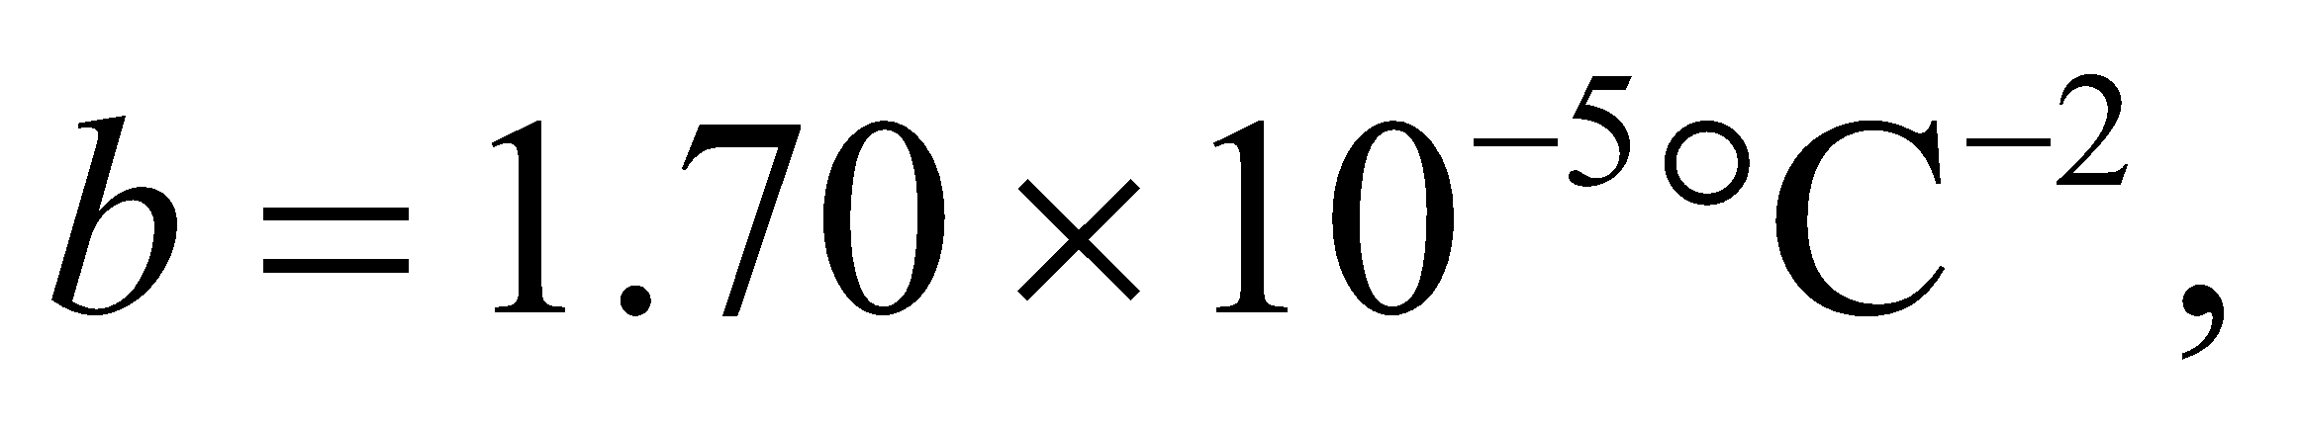 and 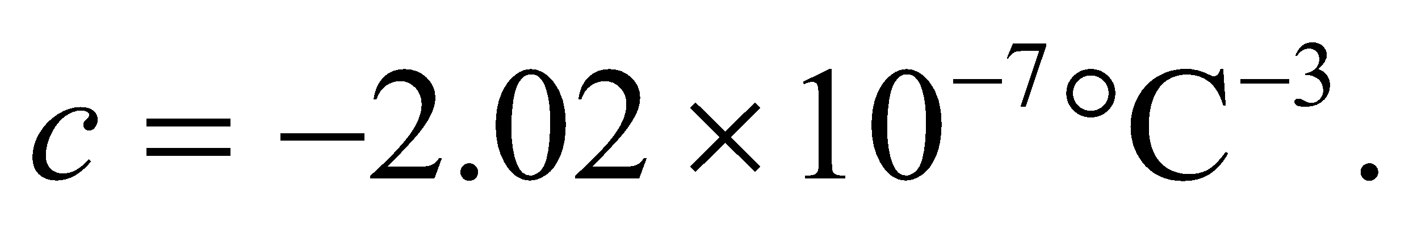 Thus, the volume as a function of temperature is

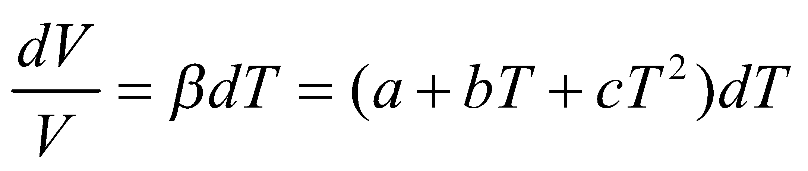

Integrate this expression and impose the boundary condition that V(0°C) = 1.00000 L to find the volume of water at 12°C.

**Evaluate** Integrating the expression above gives



For 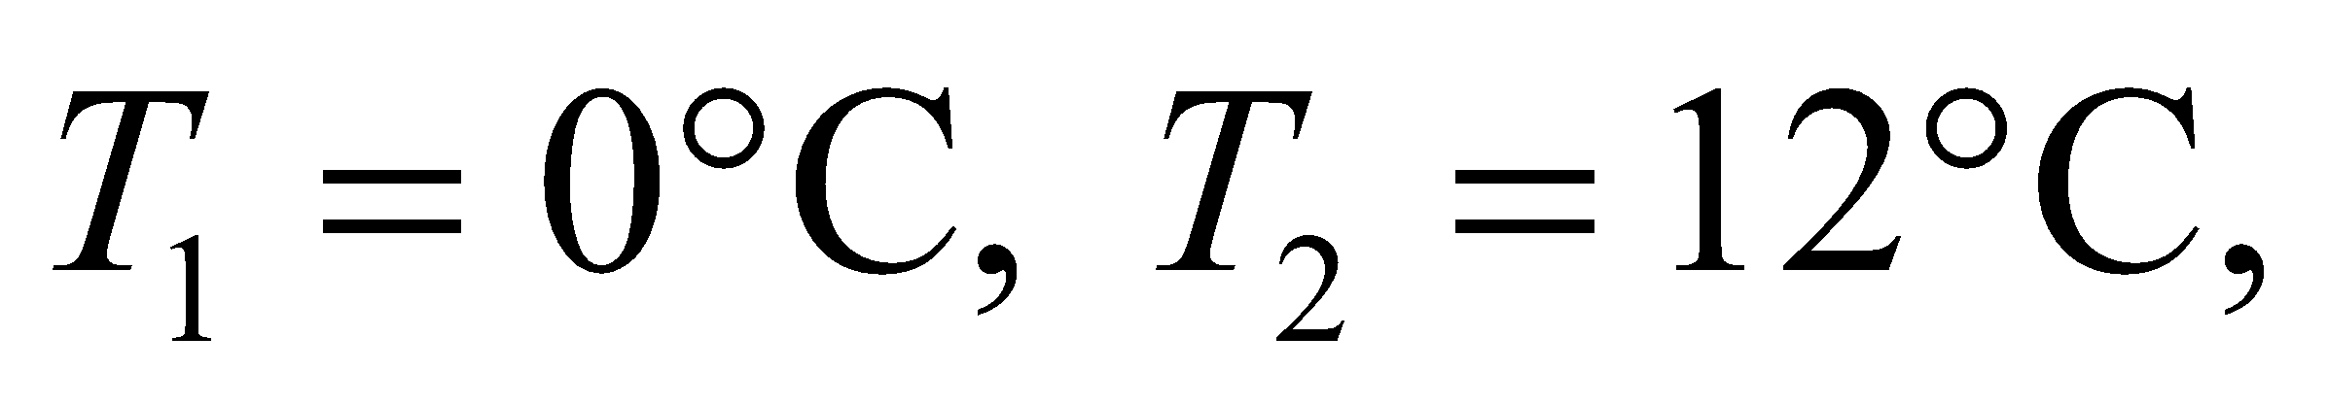 and coefficients *a*, *b* and *c* given above, the right hand side is 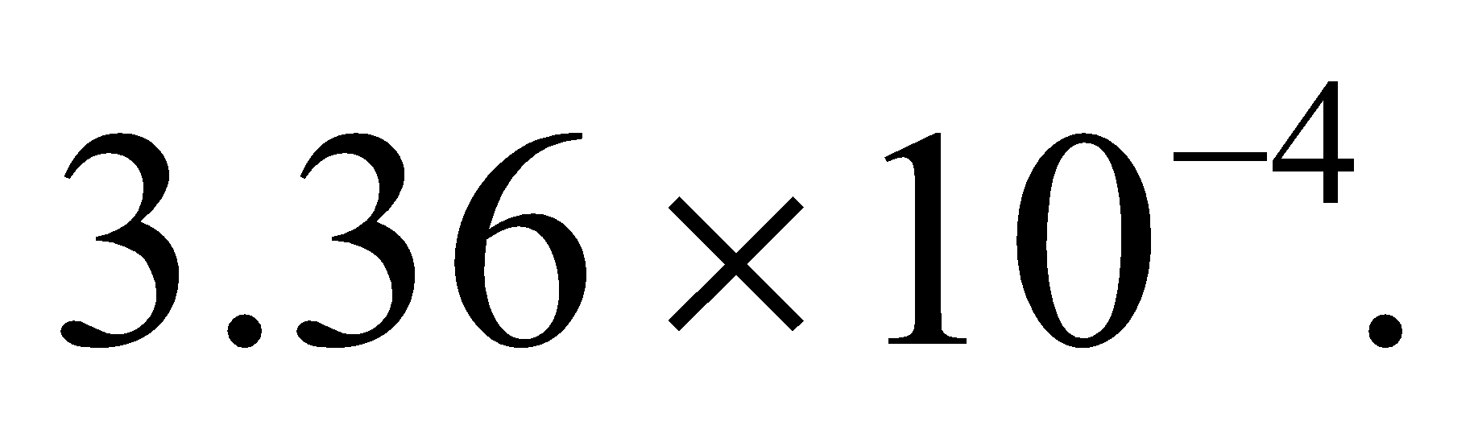 With

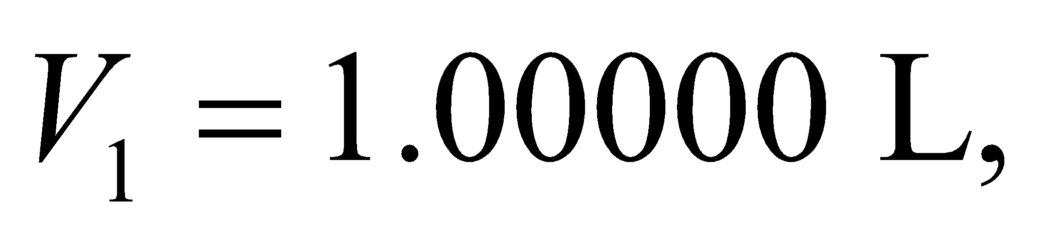exponentiation gives

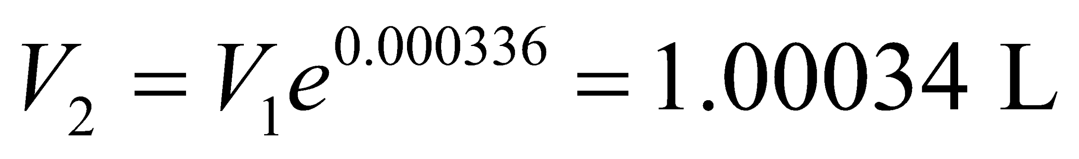

**Assess** The fraction of volume change is 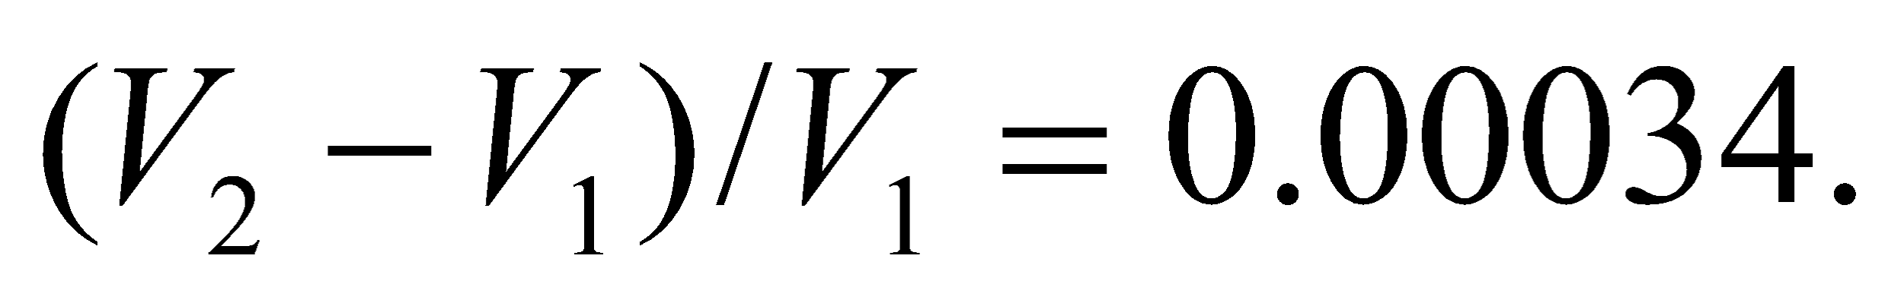

**69.** **Interpret** This problem involves the conversion of gravitational potential energy into thermal energy. We are to find the gravitational potential energy equivalent to the thermal energy needed to melt a falling ice cube on impact.

**Develop** The assumptions stated in the problem (no air resistance or heat exchange with the environment) imply that the change in the gravitational potential energy of the ice cube, per unit mass, must equal the heat of transformation of the ice cube. Expressed mathematically, this gives

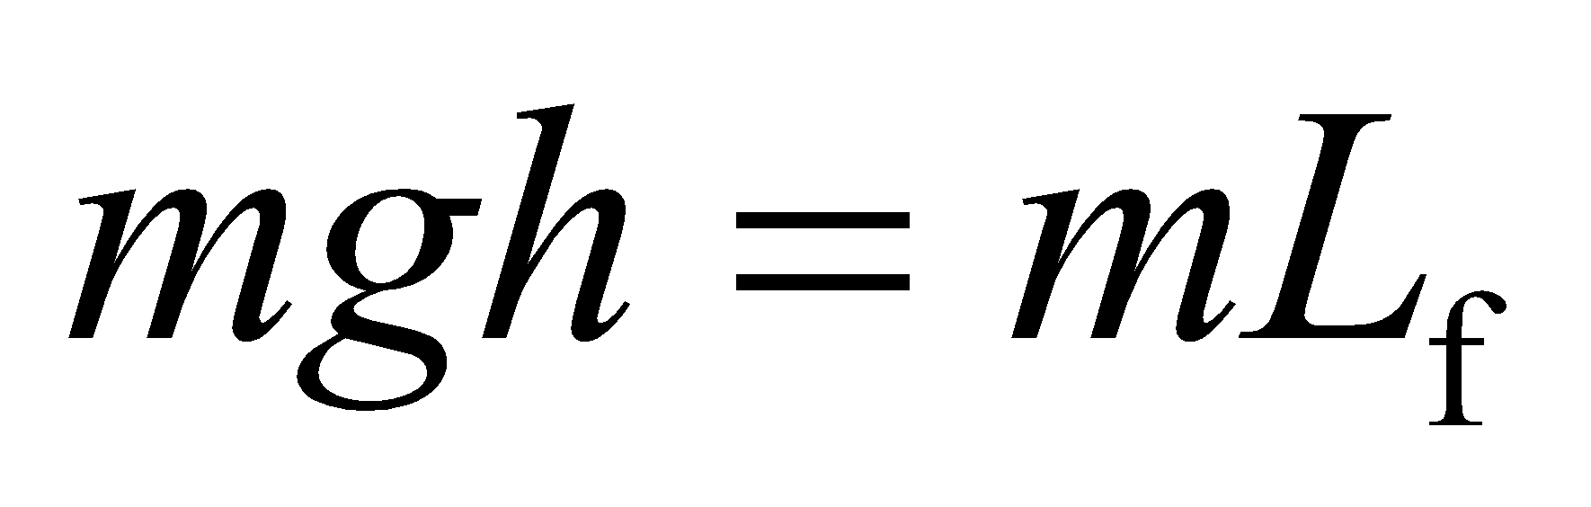

which we can solve for the height *h*.

**Evaluate** Solving for *h*, we find

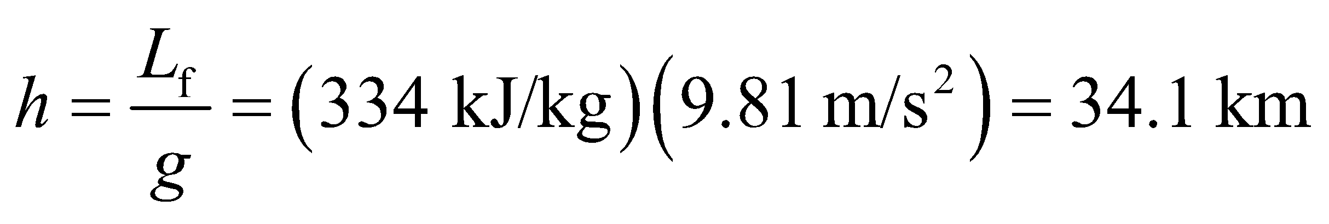

**Assess** Of course, the expression for potential energy difference, *mgh*, is not valid over such a large range, but 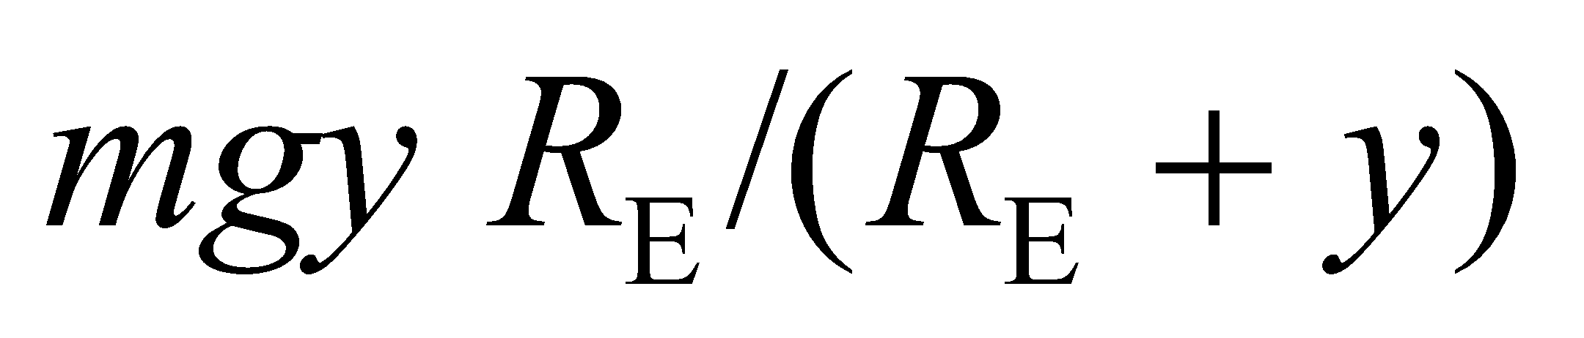 only changes this result to 34.3 km. The thermal energies of ordinary macroscopic objects are very large compared to their mechanical energies.

**70. Interpret** This problem deals with simple harmonic motion and the thermal expansion of a brass pendulum. The quantity of interest is the pendulum’s length, so the relevant quantity is the coefficient of linear expansion, *α*.

**Develop** *N* swings of a pendulum clock produce a time reading of 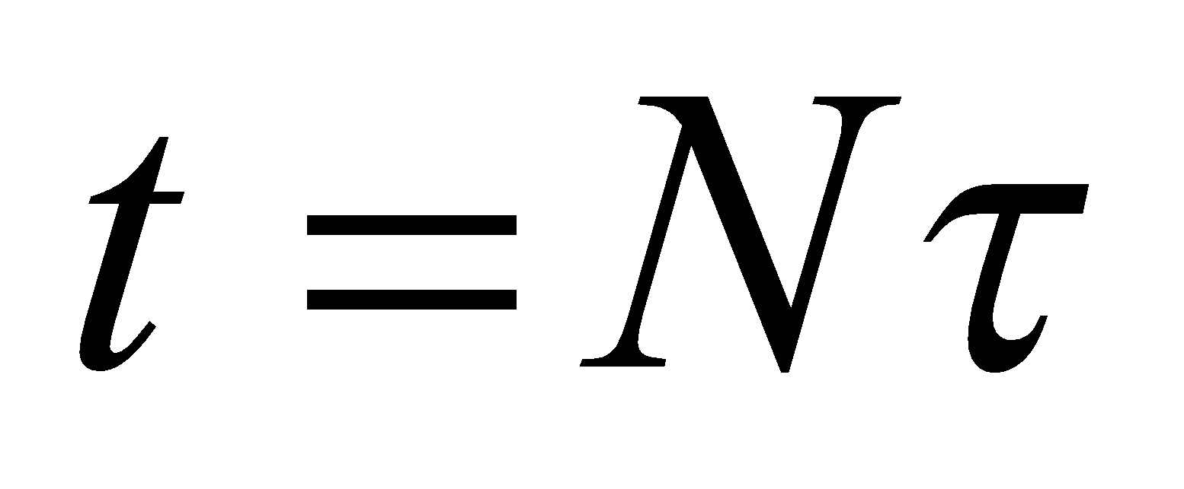 where 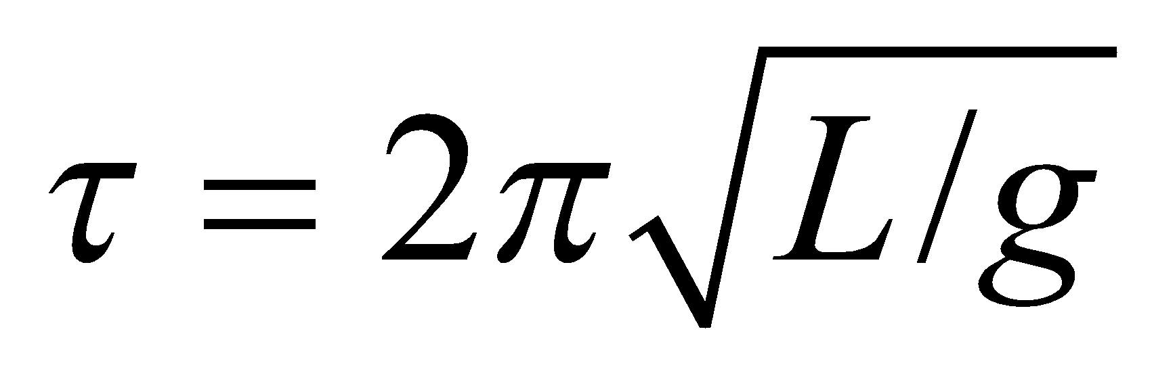 (Equation 13.15) is the period. If the clock is accurate at 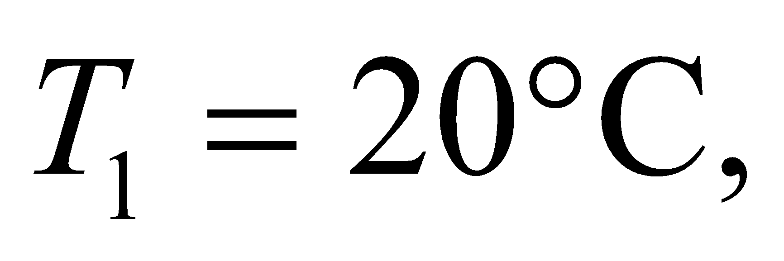 at some other temperature 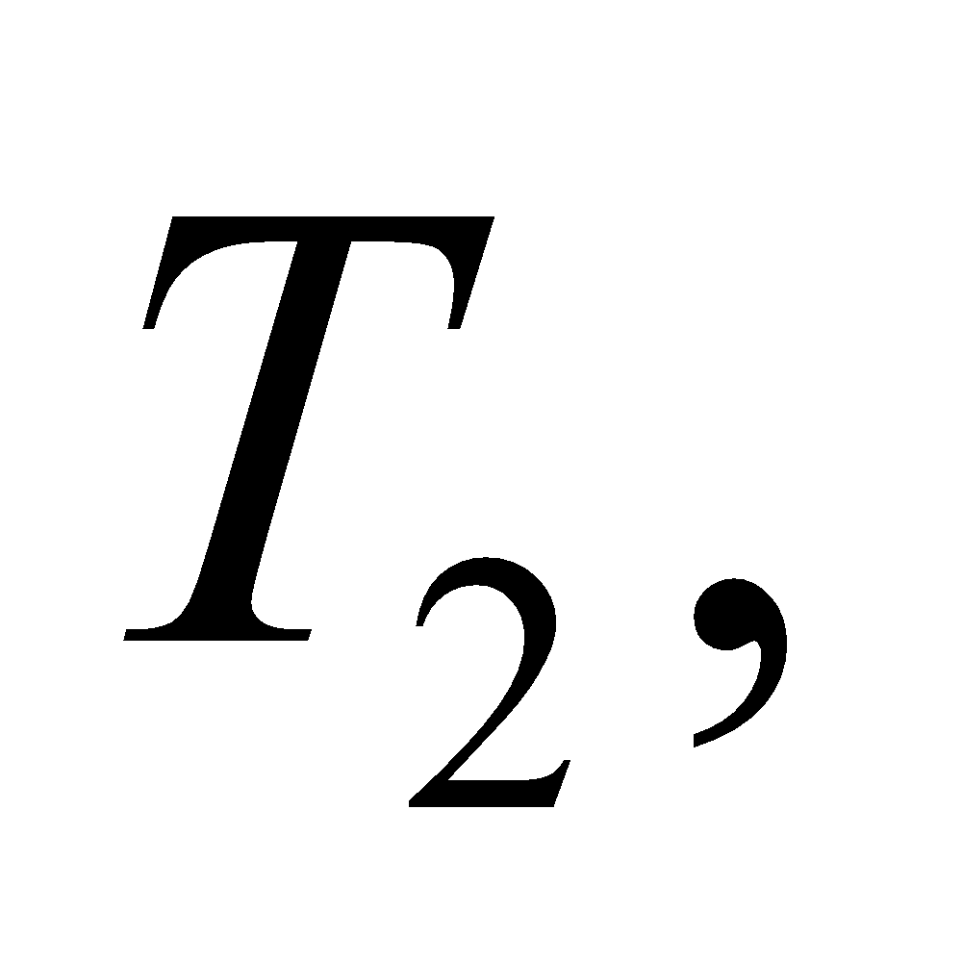 the length of the pendulum becomes 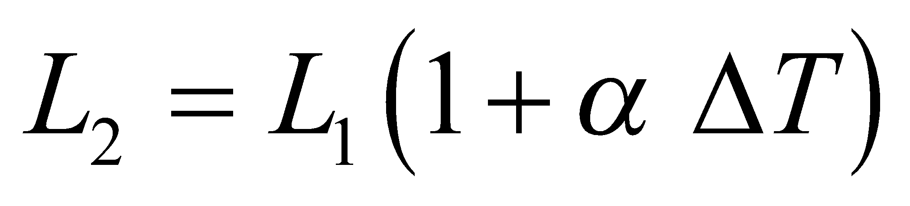, where *ΔT* = 18°C − 20°C = 2 K. Therefore, the ratio of the periods is

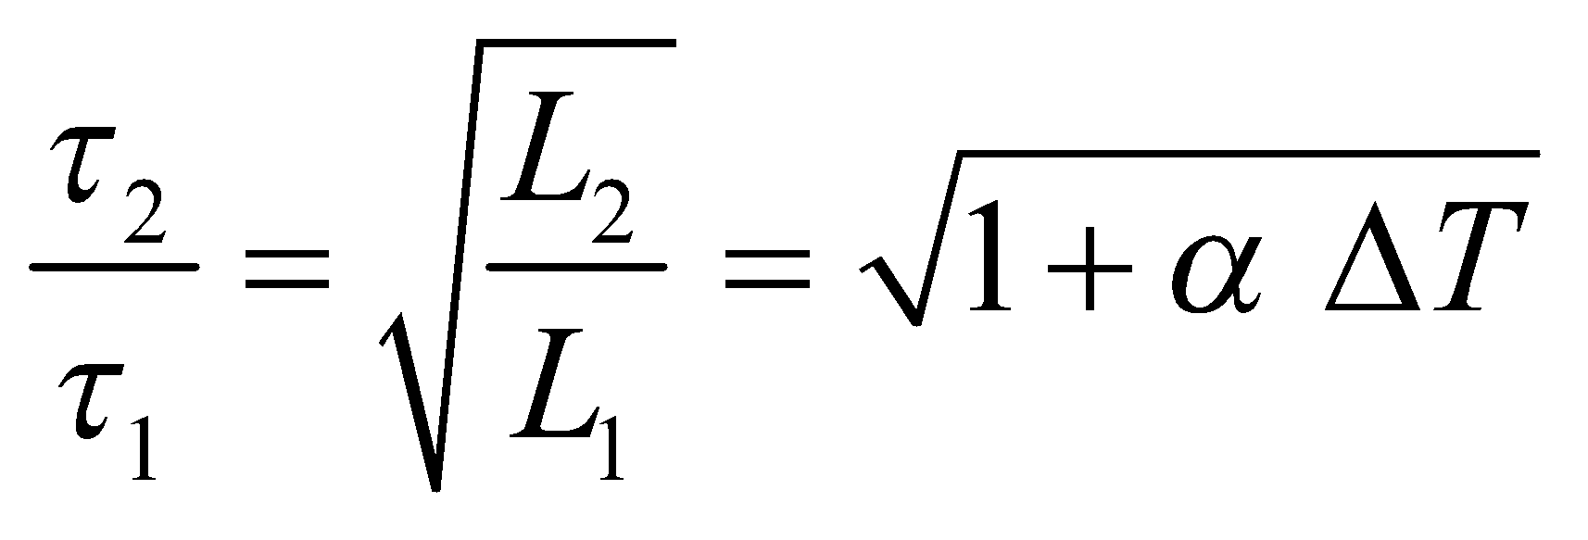

The error in the clock is the difference in its time-readings for *N* swings at *T*2, relative to *T*1:

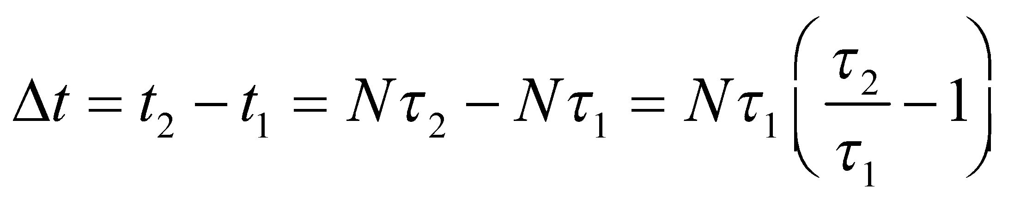

Solve this equation to find the time it takes for the clock to err by 1 minute.

**Evaluate** Substituting the ratio of the periods into the expression for *Δt* and solving for *t*1 gives

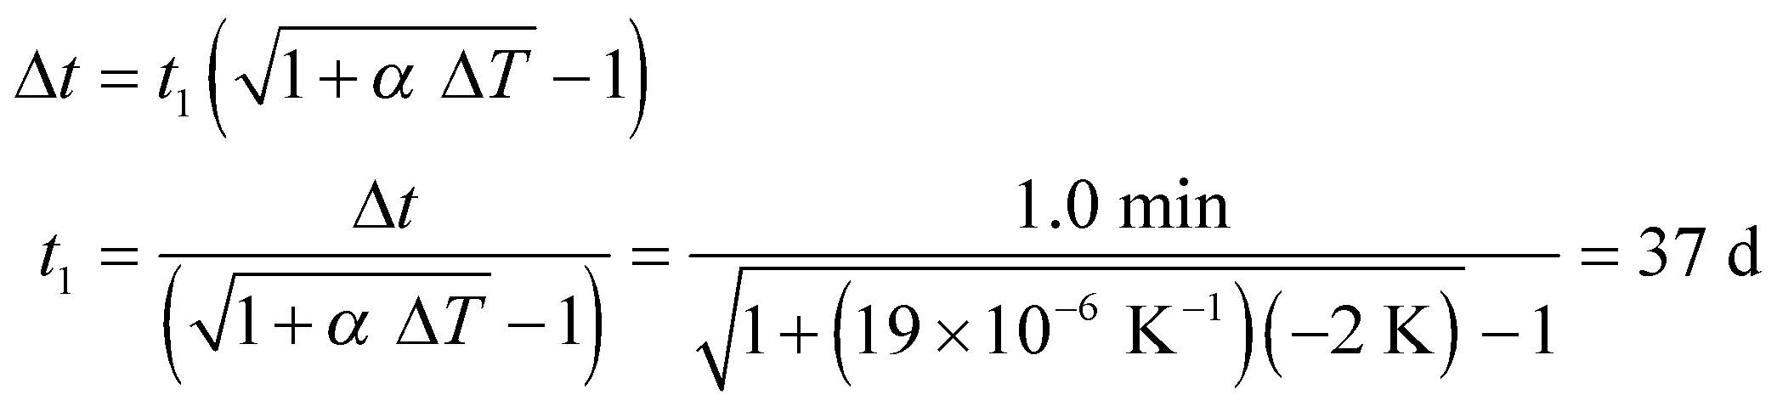

where we used *α* = 19 × 10−6 K−1 for brass from Table 17.2. Because 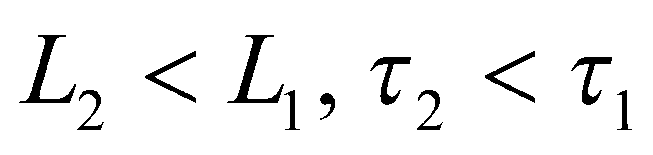, 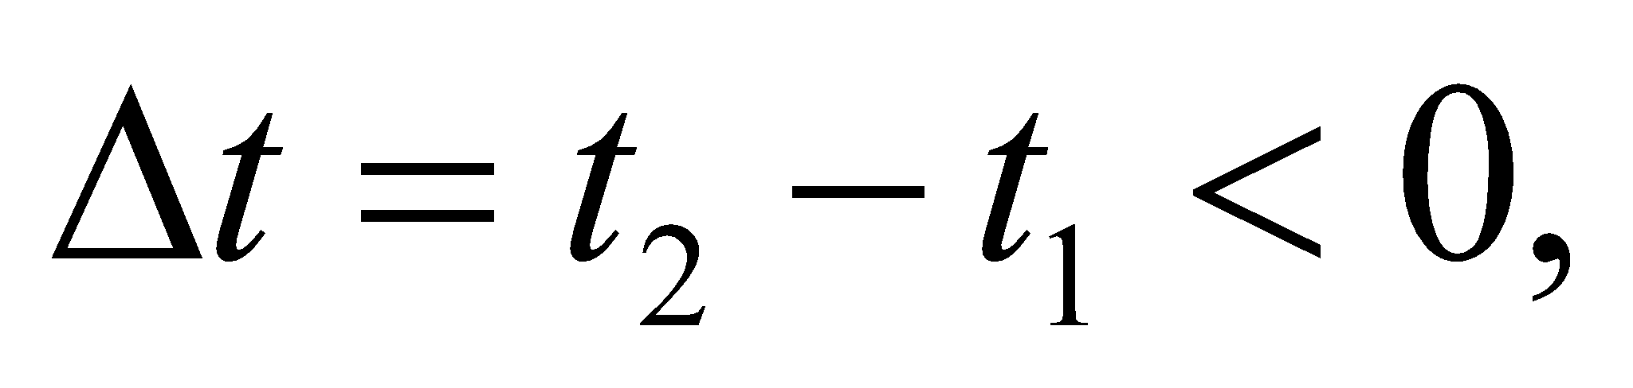 and the clock at 18°C is fast.

**Assess** The period of a pendulum, 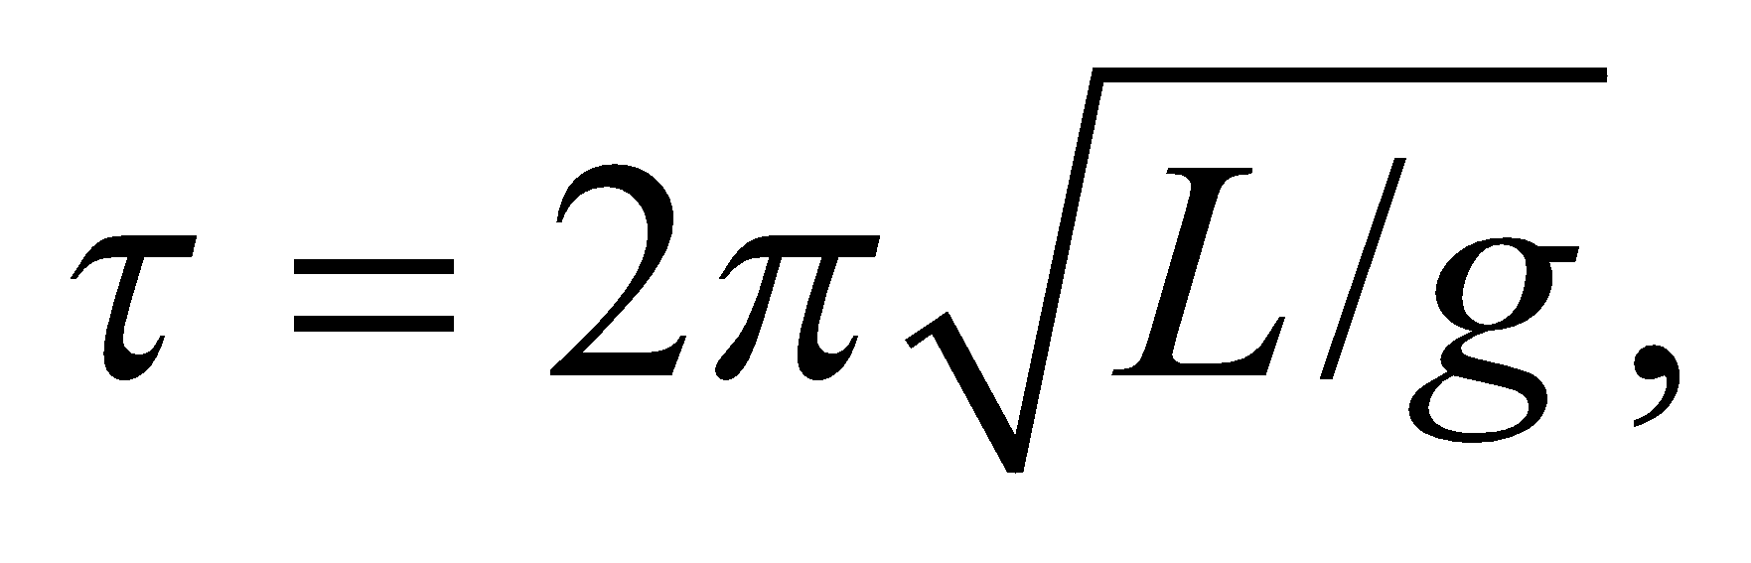 increases with its length *L*. Due to thermal expansion, the pendulum length at 20°C is greater than that at 18°C, and consequently, its period is longer.

**71.** **Interpret** We are asked to derive the given equation for the volume expansion coefficient *β*.

**Develop** Equation 17.6 gives the volume expansion coefficient as

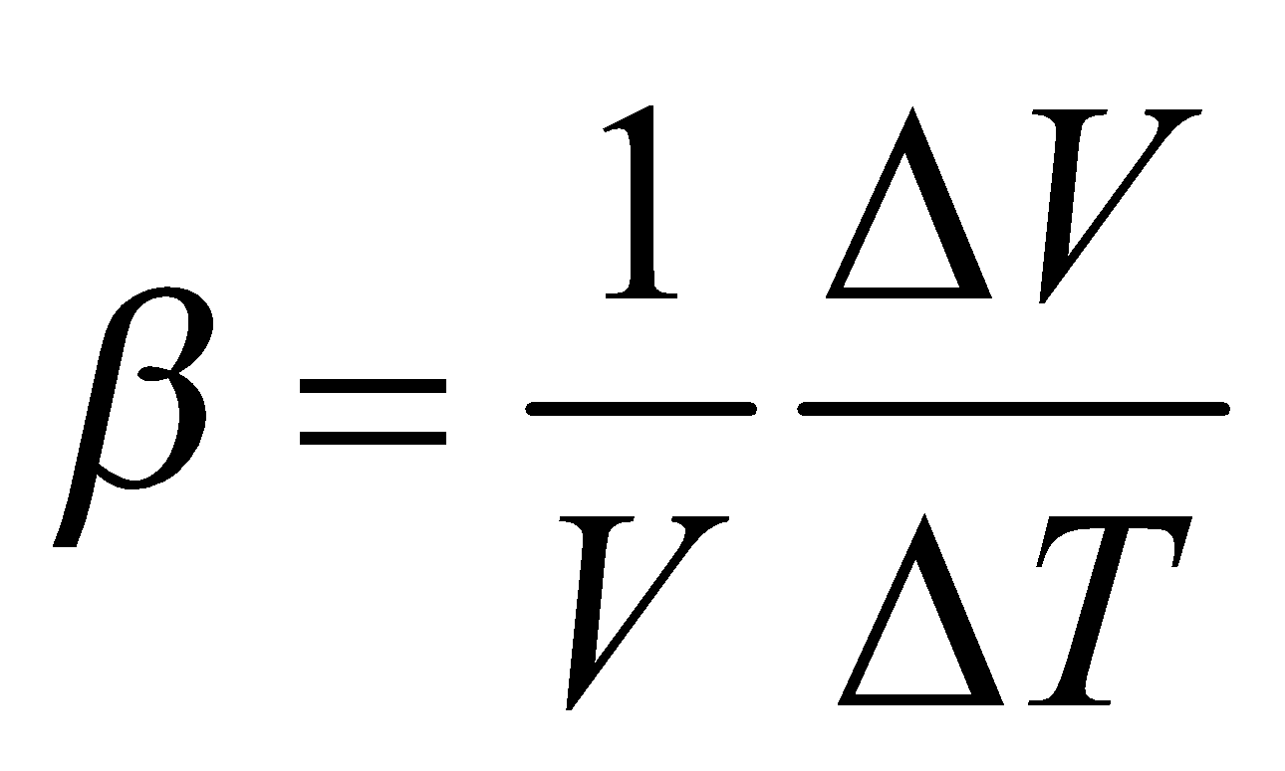

For infinitesimally small changes, this becomes

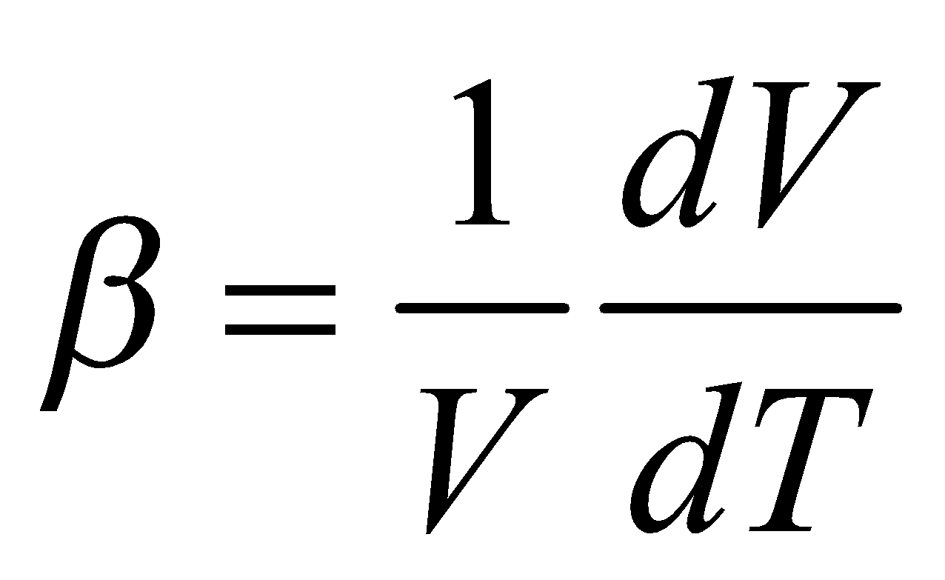

Using the chain rule in the expression for *β* gives

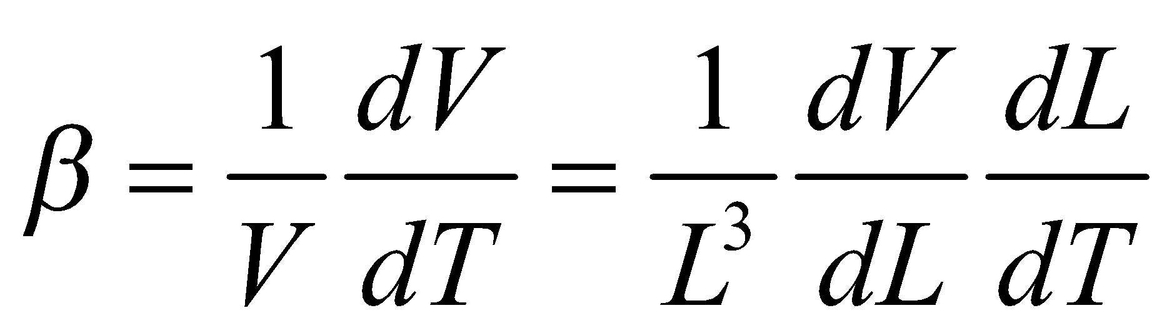

Given that

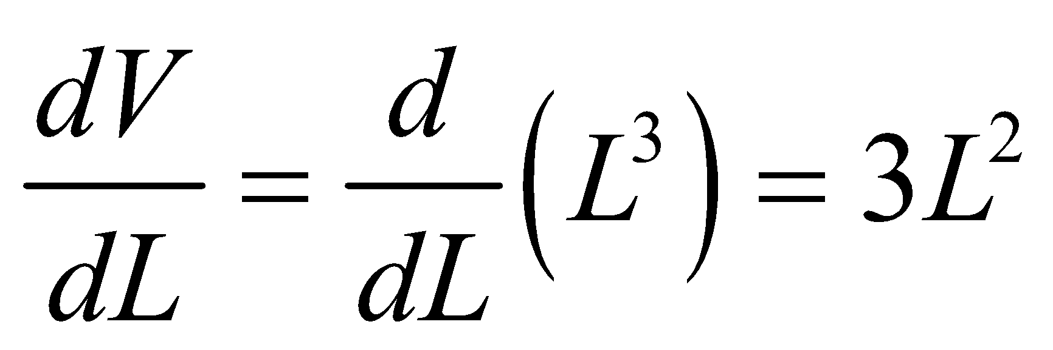

and, from Equation 17.7,

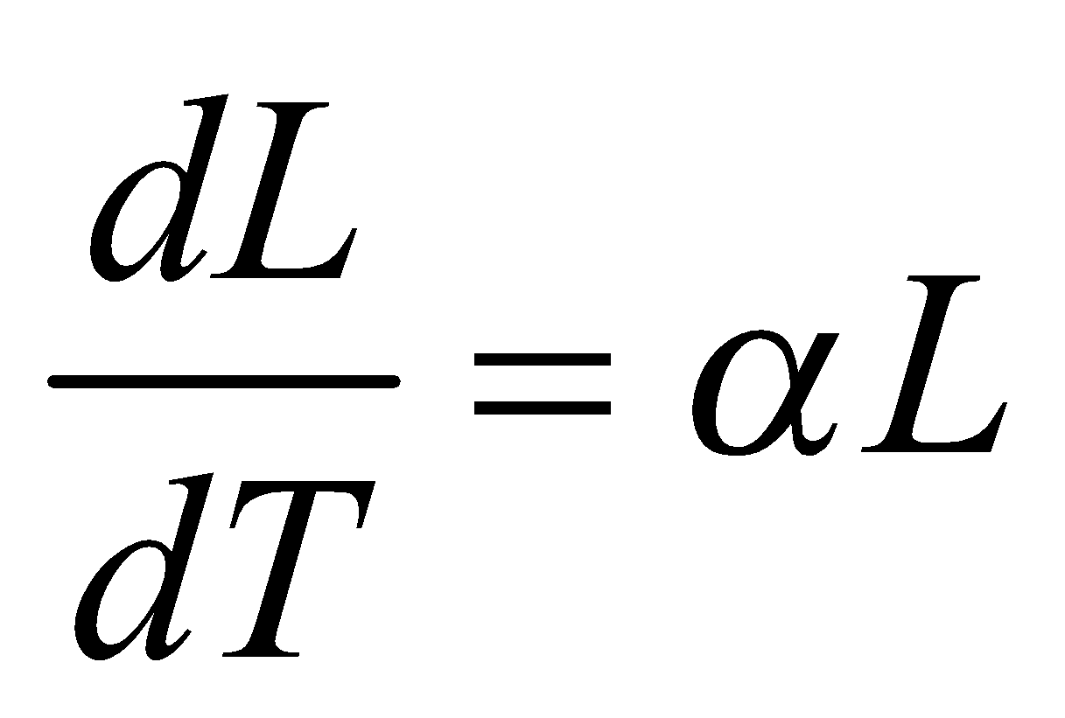

we can evaluate the chain-rule expression for *β* in terms of *α*.

**Evaluate** Inserting the expressions above for the derivatives gives volume expansion coefficient as

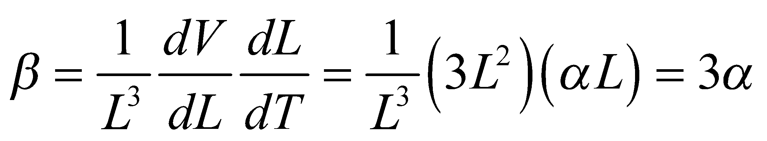

**Assess** Alternatively, use the binomial approximation for 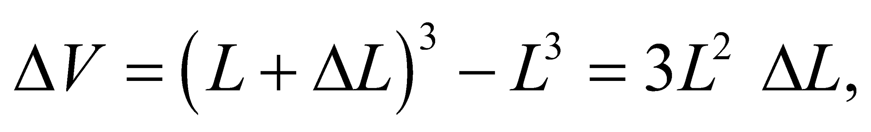 keeping only the lowest order term in *ΔL*. Since 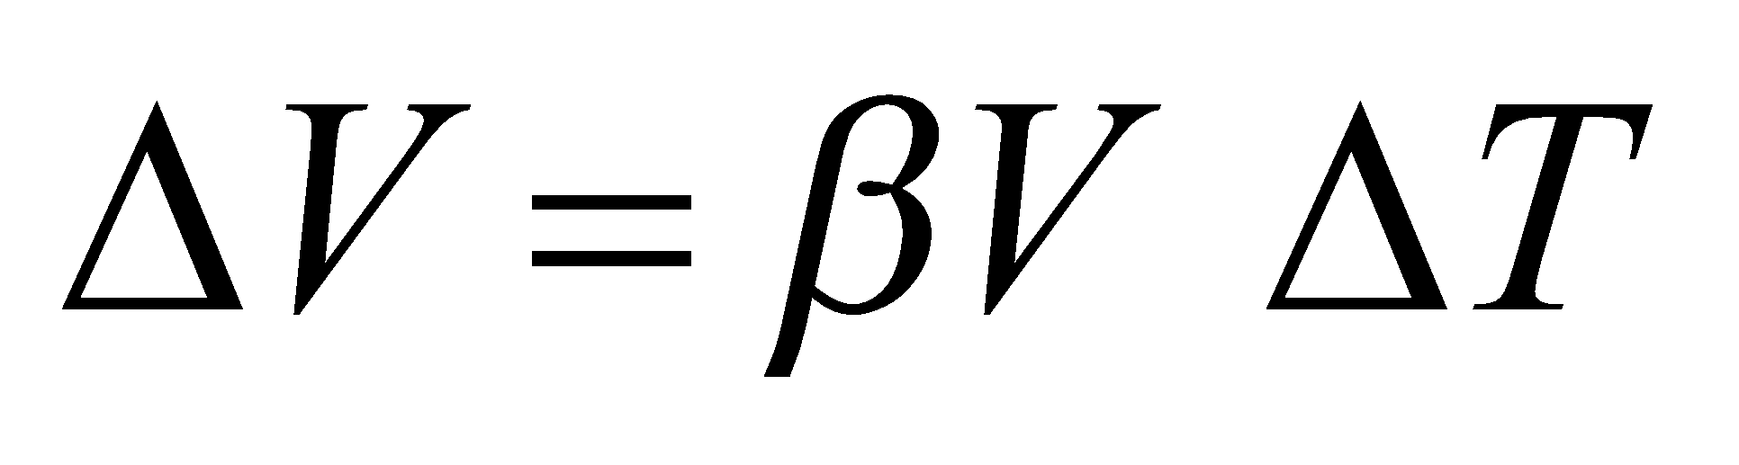 and 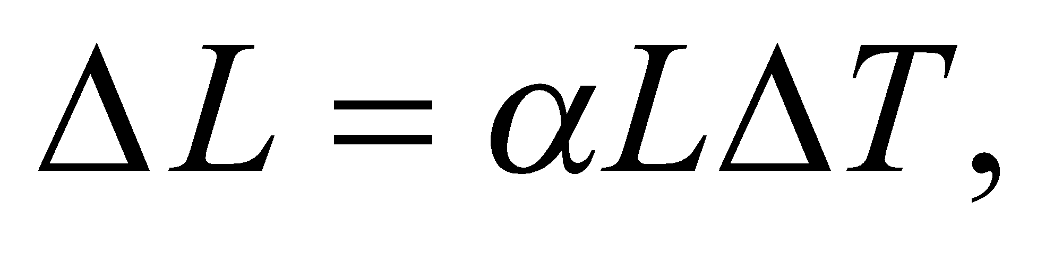 one finds 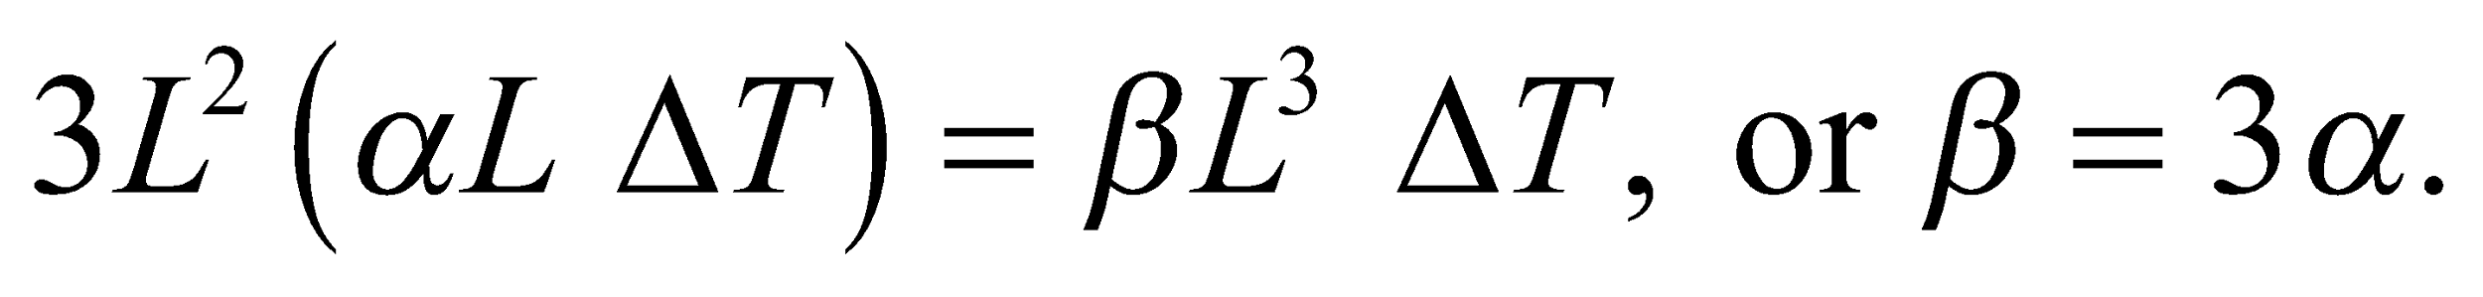

**72. Interpret** This problem involves pressure, temperature, and volume. We will assume that the ideal-gas law applies and use it to find the volume of one mole under the given conditions.

**Develop**In terms of moles, the ideal-gas law (Equation 17.2) is *pV* = *nRT* where 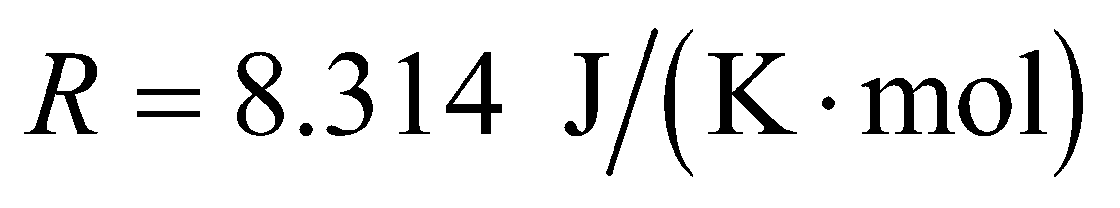. The pressure is *p* = 90 atm, the temperature is *T* = 730 K, and we are interested in the volume of 1 mole, so *n* = 1.0. We want to find the volume of one mole of gas, and see if this volume is less than 1 L.

**Evaluate**Inserting the given quantities into the ideal-gas law gives

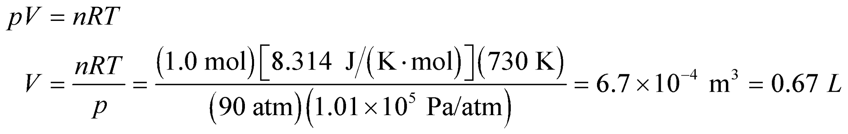

**Assess**This design will work, as one liter contains more than a mole at this pressure and temperature.

**73. Interpret** We consider what goes on inside a pressure cooker.

**Develop** The line connecting the triple point to the critical point in Figure 17.9 (the liquid-gas boundary) designates all of the situations where the combination of pressure and temperature is right for water to boil.

**Evaluate** If the pressure is higher than normal in a pressure cooker, then the temperature at which water boils will be higher as well. By definition, this combination of elevated pressure and temperature must lie on the line connecting the triple point to the critical point.

The answer is (b).

**Assess** If we started with boiling water at normal atmospheric pressure, and suddenly increased the pressure, the water would stop boiling. This corresponds to moving vertically upwards from the liquid-gas boundary in the phase diagram of Figure 17.9. For the water to start boiling again, the temperature will have to increase until the (*p*, *T*) combination is again located on the liquid-gas boundary.

**74. Interpret** We consider what goes on inside a pressure cooker.

**Develop** We can use the ideal-gas law to compare the density of steam under atmospheric pressure to the density of steam in a pressure cooker.

**Evaluate** The density of steam,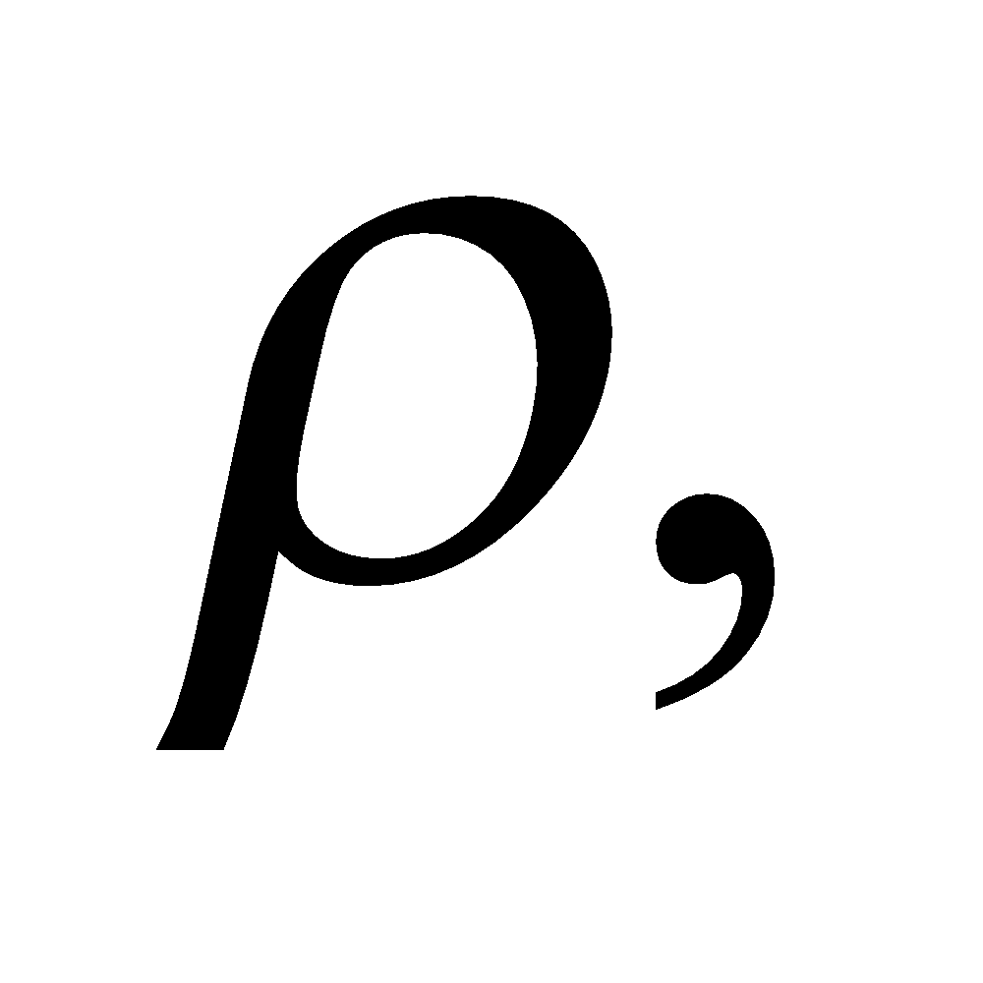is equal to the mass of an individual water molecule, *m*, multiplied by the number density of water molecules in the vapor state: 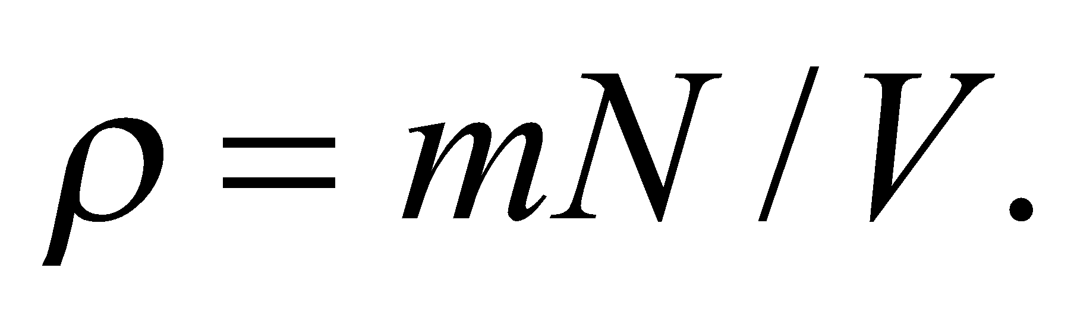 The number density is related to the temperature and pressure by the ideal-gas law: 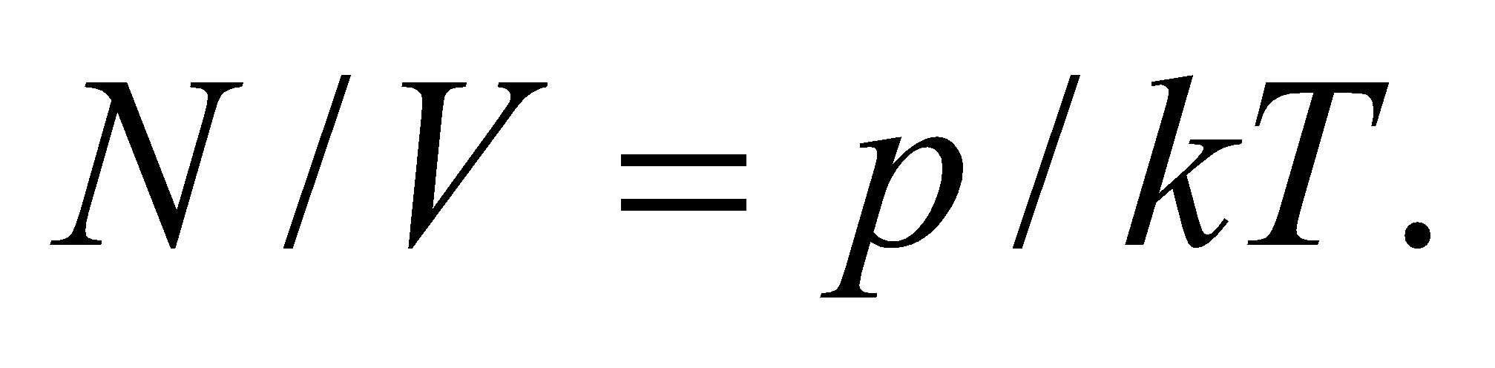 Therefore, the ratio of the steam density in a pressure cooker to normal pressure is

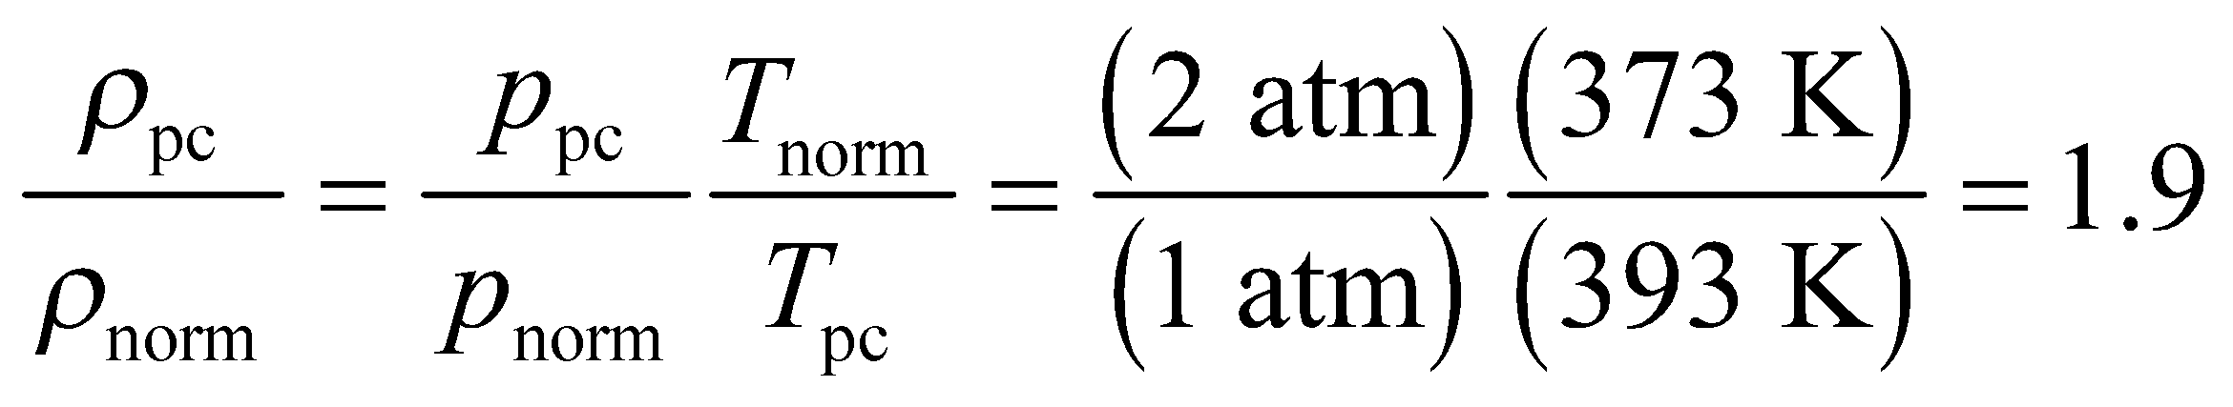

The answer is (c).

**Assess** The increased gas density is due to the fact that more of the water molecules have left the liquid to join the vapor.

**75. Interpret** We consider what goes on inside a pressure cooker.

**Develop** From the information given we can estimate the slope of the line marking the liquid-gas boundary.

**Evaluate** Between 1 and 2 atm, the average slope of the line is 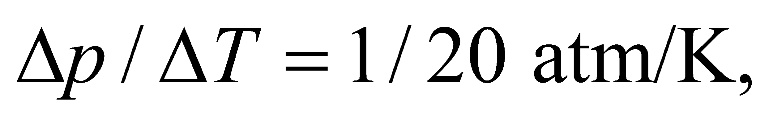whereas between 2 and 3 atm, the average slope is 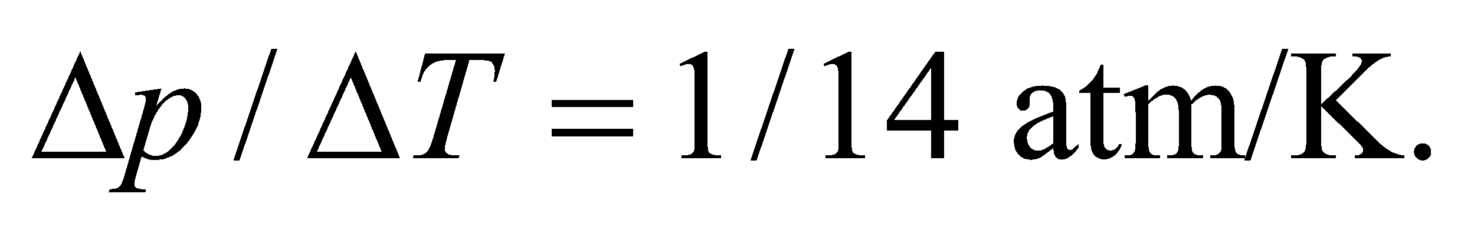Since the slope is getting larger as we move to the right on the graph, the line should be concave upward.

The answer is (a).

**Assess** If the boundary line were a straight line, i.e. 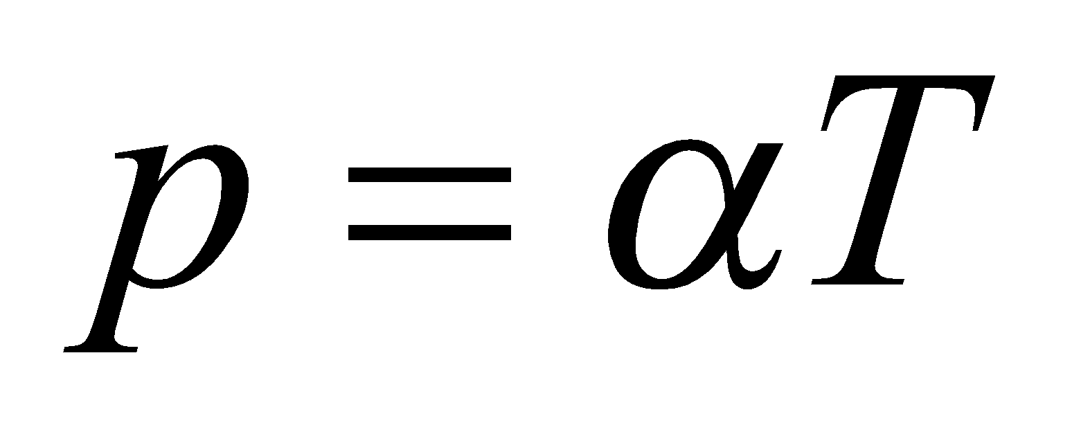for some constant 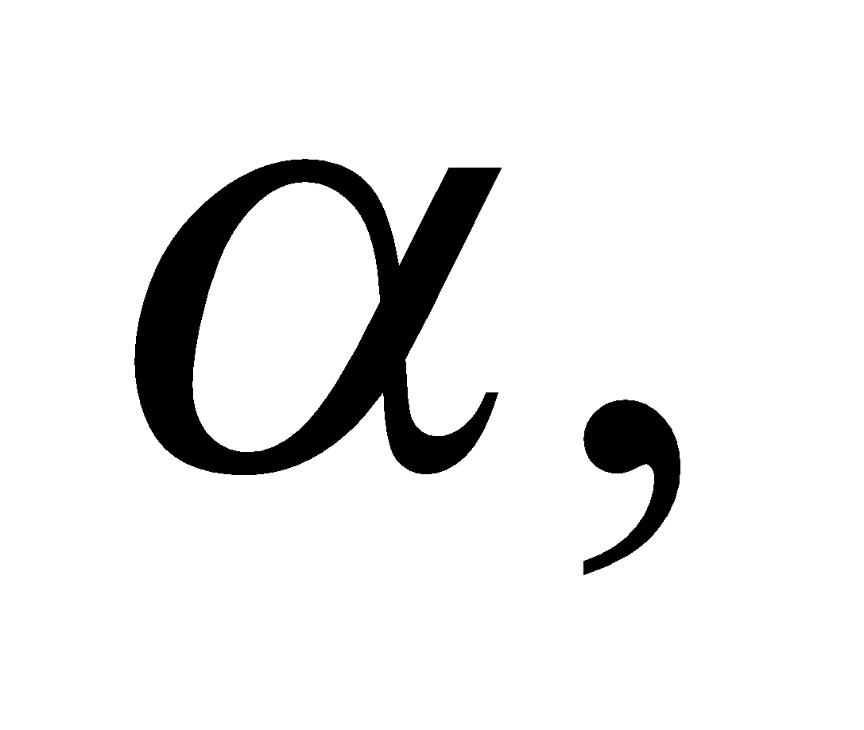this would imply that the gas density remains constant as the temperature and pressure increase (see the previous problem). In fact, the gas density increases, reflecting a higher number of water molecules in the gas phase at higher pressures.

**76. Interpret** We consider what goes on inside a pressure cooker.

**Develop** As the water boils, more and more water molecules go from the liquid to the gaseous state. If the release mechanism is clogged, those additional water molecules will have nowhere to go, so the gas density will rise and pressure in the cooker will rise. If more and more steam is created, then the density inside the cooker will rise. As we showed in Problem 17.74, the density is proportional to the pressure, so the pressure will rise. If the pressure goes up, then the boiling temperature will also go up.

**Evaluate** As we showed in Problem 17.74, the gas density is proportional to the pressure, so a clogged mechanism will lead to an increase in pressure, as we'd expect. Now, if the temperature somehow remained constant, the system would no longer be at a boiling point in the phase diagram. However, since heat is constantly being supplied through the burner, the water temperature would eventually have to rise until it reached a new boiling point specified by the elevated pressure. Therefore, both the pressure and temperature would continue to rise.

The answer is (c).

**Assess** This increase in pressure can't last forever. Eventually something will blow. This is why pressure cookers have a reputation for being dangerous. Modern designs incorporate multiple safety valves to deal with the risk of clogging.